
PATHFINDER
Your travel partner in progress.

NAMES OF THE STUDENTS
M F M Ziyan
E W P Kalindu Nimsara
T D Sithmi Uththarsha
I Hiruni Sassrika Wijerathna
A.G Roshini Hansika Bandara

GROUP 02

A PROJECT SUBMITTED TO
INTERNATIONAL COLLEGE OF BUSINESS AND TECHNOLOGY (ICBT)
IN PARTIAL FULFILLMENT OF THE REQUIREMENTS
FOR THE
HD in Computing and Software Engineering

January 2025

ACKNOWLEDGMENT
We would like to express our deepest gratitude to everyone who played a significant role in the successful completion of our Pathfinder.lk assignment. This endeavor has been an inspiring journey, and we are truly grateful for the support and guidance we received throughout the process.
First and foremost, we extend our heartfelt thanks to our esteemed lecturers, whose continuous support, constructive feedback, and valuable insights were instrumental in guiding us during this assignment. Their expertise and encouragement greatly enriched our work and learning experience.
We also express our sincere appreciation to our seniors and the authors of research papers and similar sources whose contributions served as key references in shaping this project. Their work and shared experiences provided us with the knowledge and perspective needed to address the challenges involved.
A special mention goes to our team members, whose dedication, collaboration, and hard work turned this assignment into a shared success. Each member’s unique contributions and tireless efforts played a vital role in achieving our objectives.
We are equally thankful to our parents and loved ones for their unwavering support and understanding during the demanding phases of this project. Their encouragement and patience gave us the strength to stay focused and determined.
Lastly, we extend our gratitude to everyone who supported us, directly or indirectly, in completing this assignment. Your assistance and belief in our mission have been invaluable, and we are deeply grateful for your contributions.
Thank you all for being an integral part of this journey.

Contents
CHAPTER 01 5
1.1 INTRODUCTION 5
1.2 PROBLEM STATEMENT 5
Gaps Identified in Travel Planning Platforms and Pathfinder.lk's Solutions 5
• The Growing Complexity of Travel Planning 6
Conclusion 6
1.3 LITERATURE REVIEW 6
1.3.1 Introduction: Overview of the Tourism & Service-Based Business Landscape in Sri Lanka 6
1.3.2 Sri Lanka’s Tourism Industry: Growth, Trends, and Economic Impact 9
1.3.3 Technology’s Role in Transforming the Tourism Industry 12
1.3.4 Competitor Landscape: Key Players in the Sri Lankan Tourism and Service Sector 13
1.3.5 Consumer Behavior and Changing Preferences in Sri Lanka’s Tourism Market 16
Conclusion 19
1.3.6 Challenges and Barriers in the Sri Lankan Tourism Market 19
Conclusion 20
1.3.7 Marketing and Branding in the Digital Era 21
Conclusion 23
1.3.8 The Impact of Social Media & User-Generated Content 23
Conclusion 26
1.3.9 Opportunities for Growth in the Global Market 26
Final Thoughts 26
1.4 RESEARCH GAPS & OBJECTIVES 27
1.4.1 Research Gaps for Pathfinder.lk 27
1.4.2 Research Objectives for Pathfinder.lk 28
Conclusion 30
1.5 PROPOSED SOLUTION 30
1.5.1 Objective: 30
1.5.2 Technology Stack: 32
1.5.3 Marketing Strategy: 33
1.5.4 SEO & Social Media Strategy: 33
1.5.5 Email Marketing: 33
1.6 FUNCTIONALITIES & NON-FUNCTIONALITIES OF THE SYSTEM 1.6.1 FUNCTIONALITIES OF THE SYSTEM 34
1.6.2 Non-Functionalities of the System: 36
1.7 SOFTWARE DEVELOPMENT METHODOLOGY 38
1.7.1 Agile Framework Overview: 38
1.7.2 Key Agile Principles Applied to Pathfinder.lk: 38
1.7.3 Agile Phases for Pathfinder.lk Development: 39
1.7.4 Agile Tools: 40
1.7.5 Sprint Planning and Agile Team Roles: 40
Conclusion: 41
Chapter 02 41
2.1.1 Technical Feasibility 41
2.1.2 Operational Feasibility 42
2.1.3 Economic Feasibility 43
2.1.4 Legal Feasibility 43
2.2 Requirement Gathering for Pathfinder.lk 45
2.2.1 Stakeholder Identification 45
2.2.2 Functional Requirements 46
2.2.3 Non-Functional Requirements 48
2.2.4 User Requirements 48
2.2.5 System Requirements 49
2.2.6 Functional and Non-Functional Requirement Prioritization 49
2.2.7 Stakeholder Feedback & Iteration 50
2.2.8 Conclusion 50
2.3 Refined Resource Identification for Pathfinder.lk 50
2.3.1 The development of Pathfinder.lk, a web-based platform, will be handled by a focused team consisting of the following roles: 50
2.3.2 Technological Resources 52
2.3.3 Financial Resources 53
2.4 Work Breakdown Structure (WBS) for Pathfinder.lk 55
2.4.1 Project Management 55
2.4.2 Requirements & Analysis 55
2.4.3 Design & Prototyping 55
2.4.4 Development 56
2.4.5. Testing & Quality Assurance 56
2.4.6. Deployment & Launch 56
2.4.7 Post-Launch & Maintenance 57
Summary of WBS for Pathfinder.lk: 57
2.5 Risk Analysis for Pathfinder.lk 57
2.5.1 Technical Risks 57
2.5.2 Operational Risks 58
2.5.3 Business Risks 59
2.5.4 External Risks 60
Conclusion 61
Chapter 03 62
Design of the system 62
System Design 66
User interfaces/ Navigations 71
Chapter 04 79
User Manual 109
Chapter 05……………………………………………………………………………………………..89
Chapter 06 113
6.1 Limitations of the Project 114
6.2 Lessons Learned 117
6.3 Future Recommendations 118
References: 120
Appendix 122
Supervisor log sheets 126
Other Documents 126

CHAPTER 01

1.1 INTRODUCTION
Traveling has always been a rewarding experience, allowing individuals to discover new places, engage with diverse cultures, and create cherished memories. However, the methods of planning and experiencing travel have dramatically evolved in the 21st century due to rapid technological advancements. The internet has become a cornerstone in providing travelers with tools and resources to organize their journeys efficiently. From researching destinations to comparing prices and booking accommodations, technology has made travel planning more streamlined and accessible. Despite these innovations, modern travelers still face significant hurdles in organizing their trips.
Many travelers encounter difficulties in crafting effective itineraries, managing their budgets, and selecting the best travel options. Navigating unfamiliar destinations can be overwhelming due to limited knowledge about local attractions, transportation systems, and cultural norms. Solo travelers, in particular, may struggle to find companions or arrange group activities, which can deter them from pursuing their travel goals. While traditional travel agents provide assistance, their services are often costly, and many mobile applications fail to offer comprehensive solutions. This is where Pathfinder.lk emerges as an innovative platform designed to simplify the travel planning process.
Pathfinder.lk is a web-based travel planning tool developed to cater to both local and international travelers. Unlike many mobile applications, Pathfinder.lk prioritizes accessibility and affordability through its web platform, allowing users to plan their trips from any device with ease. The platform includes a range of features, such as automated itinerary generation, cost estimation, and personalized destination recommendations. These tools empower travelers to make informed decisions and create seamless travel experiences tailored to their preferences and budgets. Pathfinder.lk goes beyond conventional travel planning tools by offering solutions that are both practical and forward-thinking.
A key highlight of the platform is its ability to deliver personalized suggestions based on user preferences. Whether travelers seek adventure, cultural immersion, or relaxation, Pathfinder.lk ensures their itineraries align with their interests. The platform also addresses the needs of solo travelers by facilitating shared travel opportunities, allowing users to connect with like-minded individuals for group experiences. This feature not only enhances the social aspect of travel but also makes trips more cost-effective and enjoyable. Furthermore, Pathfinder.lk emphasizes simplicity and affordability, making it an ideal choice for travelers looking for convenient, budget-friendly solutions.
Pathfinder.lk is also committed to supporting Sri Lanka’s tourism industry, a crucial pillar of the nation's economy. By providing a platform that simplifies travel planning for both locals and international visitors, Pathfinder.lk helps promote Sri Lanka as a premier travel destination. The platform’s user-friendly interface and practical features ensure that users can effortlessly plan their journeys, making it a reliable companion for their adventures. From discovering nearby attractions to managing expenses and itineraries, Pathfinder.lk serves as a comprehensive travel guide, encouraging users to explore Sri Lanka and beyond.
In summary, Pathfinder.lk is more than just a travel planning platform; it is a comprehensive solution designed to address the challenges faced by today’s travelers. By integrating advanced technology with intuitive features, the platform simplifies the complexities of trip planning, making travel more accessible, enjoyable, and efficient. Pathfinder.lk exemplifies the transformative potential of digital innovation in the travel industry, offering a forward-thinking solution for travelers seeking unforgettable experiences.
1.2 PROBLEM STATEMENT
Traveling has always been an exhilarating pursuit, offering individuals a unique opportunity to explore diverse destinations, immerse themselves in unfamiliar cultures, and create cherished memories. However, the evolution of travel planning has not kept pace with the increasing demands and expectations of modern travelers. While technology has revolutionized various industries, the travel sector still faces critical gaps that hinder seamless trip planning and execution. Travelers are often left juggling multiple platforms and applications to organize their journeys, leading to fragmented experiences and unnecessary frustration. Pathfinder.lk emerges as a groundbreaking solution to these challenges, addressing the core pain points identified through extensive research and industry analysis.

Gaps Identified in Travel Planning Platforms and Pathfinder.lk's Solutions
- Gap in Collaborative Travel Planning (Private/ Public choosing option)
Research has highlighted a significant deficiency in collaborative tools for group travel planning. The study, "Structure of Travel Planning Processes and Information Use Patterns," points out that current platforms lack real-time collaboration features essential for group travel. Pathfinder.lk directly addresses this gap by introducing an innovative team collaboration feature. This enables users to co-plan itineraries, share ideas, and coordinate effectively with their travel companions in real-time, fostering seamless group travel experiences.

- Gap in Integrating Budget Tracking and Financial Management
The research paper, "On the Need for Configurable Travel Recommender Systems: A Systematic Mapping Study," underscores the absence of robust budget tracking tools in existing platforms. Managing travel expenses is a critical aspect of trip planning, yet travelers often face difficulties in staying within their financial limits. Pathfinder.lk incorporates an intuitive budget tracker that not only monitors expenses but also provides real-time financial insights, ensuring users can plan trips within their budgets and avoid overspending.
- Gap in Capturing and Analyzing Feedback for Future Trips
User feedback is a valuable resource for refining travel planning experiences, yet it is often overlooked by existing platforms. The research paper "On the Need for Configurable Travel Recommender Systems: A Systematic Mapping Study" identifies this gap, emphasizing the need for systems that use feedback to enhance future recommendations. Pathfinder.lk introduces a comprehensive feedback system, allowing users to review their experiences and contribute to improving the platform’s recommendations for others.
- The Growing Complexity of Travel Planning
The travel planning process has become increasingly complex, requiring travelers to navigate multiple stages:
- Pre-Trip: Researching destinations, booking accommodations, and creating detailed itineraries.
- Mid-Trip: Coordinating transportation, navigating unfamiliar locations, organizing activities, and accessing on-ground support.
- Post-Trip: Reviewing experiences, sharing memories, and conducting post-travel analysis.
Current solutions often rely on disconnected tools and services for each stage, leading to fragmented and inefficient experiences. Pathfinder.lk consolidates these stages into a unified platform, simplifying the journey for travelers.

Conclusion
Pathfinder.lk represents a paradigm shift in travel planning, addressing the long-standing gaps in existing solutions. By combining innovative technology with practical, user-focused features, the platform simplifies the complexities of trip planning, making travel more accessible, enjoyable, and efficient. Whether it’s for solo adventurers or group travelers, Pathfinder.lk empowers users to create seamless, memorable journeys, redefining the way we experience the world.

1.3 LITERATURE REVIEW

1.3.1 Introduction: Overview of the Tourism & Service-Based Business Landscape in Sri Lanka
Sri Lanka, often called the Pearl of the Indian Ocean, has long been recognized for its immense natural beauty, rich culture, and diverse ecosystems. From pristine beaches to historical temples, the island has been a favored destination for travelers from across the globe. Its blend of scenic landscapes, rich cultural heritage, and warm hospitality has helped position Sri Lanka as a prominent player in the global tourism market.
Tourism in Sri Lanka: The Renaissance Post-Pandemic
The global pandemic, while it disrupted global economies, also transformed the tourism sector, with travelers shifting their preferences and priorities. In the wake of the pandemic, Sri Lanka's tourism industry is undergoing a revival as the country gradually reopens to international visitors. The resurgence of tourism has been somewhat slow but steady, and industry experts predict that the tourism market will grow significantly in the next decade.
Sri Lanka, once known for its traditional appeal as a beach destination, is now increasingly becoming a hotspot for experiential tourism, which includes niche travel segments like wellness tourism, adventure tourism, and cultural tourism. According to the Sri Lanka Tourism Development Authority (SLTDA), Sri Lanka is expected to see up to a 7% growth rate in tourist arrivals annually over the next five years.
This presents a unique opportunity for service-based businesses, particularly those that can provide unique, personalized, and culturally immersive experiences for tourists. Businesses like Pathfinder.lk can seize this opportunity by offering tailored services that cater to the evolving needs of tourists, particularly as travel behaviors shift.

1.3.1.1 The Diverse Appeal of Sri Lanka’s Tourism Sector
Sri Lanka’s tourism sector is broad and multifaceted, offering a variety of experiences that cater to all kinds of travelers. Some of the key categories within Sri Lanka’s tourism market include:
- Cultural Tourism: Sri Lanka is home to a rich historical and cultural heritage, with ancient cities, sacred temples, and UNESCO World Heritage sites. This attracts tourists interested in history, archaeology, and religious experiences.
- Eco-Tourism & Nature Tours: The island's varied ecosystems—from the rainforests of Sinharaja to the dry zone in the north—attract eco-conscious travelers. Sri Lanka is one of the most biodiverse countries in Asia, home to unique flora and fauna, including leopards, elephants, and exotic birds.
- Wellness & Ayurveda: Sri Lanka’s wellness tourism sector has grown, with many seeking traditional Ayurvedic healing, yoga retreats, and spa experiences. This niche market is ideal for businesses that can blend health and relaxation experiences into travel packages.
- Adventure Tourism: Sri Lanka is emerging as an adventure tourism destination, with opportunities for trekking, hiking, water sports, and safaris. The country's diverse terrain offers the perfect backdrop for those seeking adrenaline-pumping experiences.
- Luxury & Exclusive Experiences: Sri Lanka also offers high-end resorts and boutique hotels, catering to those looking for luxurious getaways. Exclusive culinary experiences, private yacht charters, and luxury safaris are also in high demand.

1.3.1.2 The Demand for Personalized Travel Experiences
The trend towards personalized travel is one of the most prominent shifts in the tourism industry today. Independent travelers, especially younger generations such as millennials and Gen Z, are no longer satisfied with cookie-cutter itineraries or typical tour packages. They seek experiences that are tailored to their interests, preferences, and values.
For these travelers, Pathfinder.lk offers a unique opportunity. Rather than offering one-size-fits-all solutions, the platform can provide customized, curated itineraries that align with tourists' individual desires—whether it's a culinary adventure in Sri Lanka’s southern coast, a wellness retreat in the hill country, or an immersive cultural exploration of the ancient kingdoms in the North.
This demand for personalization is not just about creating a more enjoyable trip but about offering something more profound—creating memories, providing authentic local experiences, and ensuring that every tourist feels they are getting something uniquely theirs. This is where Pathfinder.lk can come in, combining local knowledge with cutting-edge technology to deliver these individualized experiences.

1.3.1.3 Technology as a Catalyst in Service-Based Tourism
The tourism sector is increasingly being driven by technology, especially in terms of how businesses deliver services. Mobile applications, online booking platforms, and real-time information dissemination have fundamentally transformed how tourists engage with destinations.
Platforms like Pathfinder.lk can leverage technology to bridge the gap between traditional hospitality services and modern traveler demands. Digital interfaces that enable online booking and instant communication are crucial to meeting the expectations of today's tech-savvy traveler. Furthermore, as tourists are often armed with mobile devices and seek convenience, seamless integration of location-based services, instant notifications about weather, transportation, and curated recommendations can elevate their travel experience.
The ability to offer on-the-go personalized travel suggestions based on user behavior, preferences, and even local events can significantly enhance the value proposition of a service like Pathfinder.lk. This trend ties into the growing appeal of smart tourism—using technology not just for booking and logistics, but for enhancing every stage of the tourist's journey.

1.3.1.4 Sustainable and Localized Tourism
As the tourism industry evolves, there is a marked shift towards sustainability. The impact of mass tourism on the environment and local communities has led to a rise in sustainable tourism. Tourists today are more environmentally conscious and prefer to support businesses that promote sustainability, eco-friendly practices, and ethical tourism.
Sri Lanka, with its natural beauty and biodiversity, has a unique opportunity to become a leading destination for eco-tourism. This trend, paired with Pathfinder.lk’s potential to promote local products, support community-based tourism initiatives, and minimize the environmental impact of travel, could significantly contribute to the island's tourism sector while preserving its ecosystems.
Local immersion is another growing demand among tourists, with travelers seeking more authentic experiences that allow them to connect with local communities and cultures. Pathfinder.lk can work with local artisans, small businesses, and community-driven projects to provide immersive, off-the-beaten-path experiences. This approach not only benefits tourists but also helps support the local economy and preserve Sri Lanka’s cultural heritage.

1.3.1.5 Opportunities for Growth and Innovation in Service-Based Tourism
Given the evolving nature of global tourism trends, the Sri Lankan tourism sector presents multiple opportunities for innovation and growth. Service-based businesses like Pathfinder.lk have the potential to leverage current market trends and gaps. Some of the opportunities include:
- Specialized Travel Packages: Focusing on niche markets such as eco-tourism, wellness, and luxury tourism allows Pathfinder.lk to target specific traveler profiles and deliver unique packages.
- Digitized Local Experiences: With mobile apps and platforms becoming the main interface for consumers, there is a growing demand for digital solutions that simplify trip planning, booking, and execution. Pathfinder.lk can offer real-time booking for activities, transport, and even local guides, allowing tourists to create dynamic and flexible itineraries.
- Multi-Lingual Support: Sri Lanka's tourism sector attracts travelers from various parts of the world. Offering multi-lingual services or guides can be a key differentiator, especially as tourist demographics diversify.
The growing global trend of sustainable travel, combined with technological advancements and shifting consumer preferences, creates fertile ground for businesses like Pathfinder.lk to thrive in Sri Lanka’s tourism and service sectors. By combining the island's natural beauty, rich cultural heritage, and the power of technology, Pathfinder.lk can position itself as a market leader in providing exceptional, locally immersive, and personalized travel experiences.

1.3.2 Sri Lanka’s Tourism Industry: Growth, Trends, and Economic Impact

1.3.2.1 Tourism as a Major Pillar of Sri Lanka’s Economy
Tourism has been one of the most significant contributors to Sri Lanka’s economy, generating revenue, creating employment, and promoting cultural exchange. The Sri Lanka Tourism Development Authority (SLTDA) has long identified the sector as a key driver of economic growth. Before the COVID-19 pandemic, Sri Lanka consistently saw over 2 million tourists annually, with figures fluctuating based on global trends and seasonal factors. The economic impact of tourism was substantial, contributing more than 5% to the country’s GDP. This figure represents not just the direct revenues from hospitality, transportation, and services but also the broader economic ecosystem, including local businesses and industries such as agriculture, crafts, and retail, which benefit from tourism-related spending.
Tourism in Sri Lanka is highly diverse, with tourists flocking to the island to experience everything from stunning beaches and biodiversity to cultural heritage sites and adventure tourism. The sector supports thousands of jobs in a variety of fields:
- Hospitality: Hotels, resorts, guesthouses, and eco-lodges cater to a wide range of tourists, from luxury travelers to budget-conscious backpackers.
- Tourism Services: Guided tours, transportation, and bespoke local experiences are in demand, especially among visitors who seek customized, authentic travel.
- Local Artisans and Small Businesses: Sri Lankan artisans, whether creating handcrafted jewelry, local textiles, or traditional souvenirs, rely heavily on the tourism industry for income. Additionally, restaurants, street food vendors, and local markets benefit from increased tourist footfall.
Despite the growth prior to the pandemic, the tourism industry experienced a dramatic downturn due to COVID-19, which led to a significant loss of revenue and jobs. However, with Sri Lanka gradually reopening its borders and adopting health protocols, there has been a slow but steady recovery.

1.3.2.2 Post-Pandemic Recovery and Future Growth Projections
According to the World Travel & Tourism Council (WTTC), the global tourism industry is on the path to recovery, and Sri Lanka’s tourism sector is poised to witness a 5-6% annual growth rate in the next decade. This growth is primarily attributed to a resurgence of interest in post-pandemic travel, with many travelers eager to explore new destinations after long periods of lockdown. Sri Lanka is seen as a desirable destination due to its relatively low travel costs, natural beauty, rich culture, and the ongoing efforts of the Sri Lankan government and tourism authorities to promote the country as a safe and attractive place for visitors.
This recovery is not without its challenges. The tourism sector's future success depends on a variety of factors, such as:
- Political Stability: Sri Lanka’s political landscape has historically had a significant impact on its tourism industry. Political instability, civil unrest, or significant policy changes can deter travelers. Ensuring a stable, peaceful environment will be key to sustained tourism growth.
- Infrastructure Development: Improvements in infrastructure, particularly in transportation (airports, roads, and public transit), accommodations, and digital services (such as reliable internet and booking platforms), will significantly influence the country’s ability to attract tourists. The development of new airports, rail lines, and tourist amenities will also be crucial in making less-visited regions more accessible.
- Global Economic Conditions: The performance of the global economy impacts the disposable income of potential travelers. Economic downturns, currency fluctuations, and rising travel costs in certain regions may affect the number of tourists visiting Sri Lanka.
Despite these challenges, the tourism sector's recovery and long-term growth are highly anticipated, given the island’s immense appeal and the increasing desire for travel experiences that prioritize wellness, nature, and local immersion.

1.3.2.3 Key Trends in Sri Lanka’s Tourism Market
As the tourism industry rebounds, several key trends are emerging, providing significant opportunities for service-based businesses, including Pathfinder.lk, to align their strategies and offerings. These trends include:
Niche tourism.
There is a notable shift toward niche tourism, where travelers are seeking specialized, highly personalized experiences tailored to their interests and lifestyles. In Sri Lanka, this trend has manifested in various forms:
- Eco-Tourism: With increasing awareness of climate change and environmental degradation, tourists are becoming more interested in eco-friendly travel options. Sri Lanka, with its abundant natural resources and rich biodiversity, has emerged as an ideal destination for eco-tourism. Tourists seek out wildlife safaris, visits to conservation areas like Sinharaja Forest Reserve, and eco-friendly accommodations.
- Wellness Tourism: Sri Lanka’s long-standing tradition of Ayurveda, yoga retreats, and holistic wellness practices is seeing a resurgence. Tourists, particularly from the West, are increasingly seeking out wellness experiences to rejuvenate both physically and mentally. This includes everything from Ayurvedic massages to meditation retreats.
- Spiritual Retreats and Pilgrimage Tourism: Sri Lanka’s religious sites, such as the Temple of the Tooth and Adam’s Peak, attract spiritual tourists who are interested in Buddhism, Hinduism, and pilgrimage tours.
- Culinary Tourism: With its rich, diverse cuisine, Sri Lanka has become a destination for food lovers. Tourists are now looking for authentic culinary experiences, such as cooking classes, street food tours, and farm-to-table dining.
For Pathfinder.lk, this creates an opportunity to develop targeted packages for niche tourism markets. By curating bespoke travel experiences for specific segments (e.g., eco-tourists, wellness seekers, or culinary enthusiasts), the platform can cater to the growing demand for tailored travel options that go beyond conventional tourism.

1.3.2.4 Rise of Digital Nomads and Remote Workers
One of the most significant post-pandemic trends has been the rise of digital nomads and remote workers. With the proliferation of work-from-home policies, more people are seeking long-term travel options that allow them to work remotely while enjoying a change of scenery. Sri Lanka, with its relatively low cost of living, beautiful landscapes, and robust internet infrastructure in major cities, has become an attractive destination for this demographic.
For Pathfinder.lk, this presents an opportunity to cater to digital nomads by offering packages that include long-term stays, co-working spaces, high-speed internet, and recreational activities. The platform can also promote the idea of “workations,” where travelers can balance their work commitments with leisure, exploring Sri Lanka’s natural beauty and culture in their downtime.

1.3.2.5 Post-Pandemic Travel Behavior: Health and Safety
As the world recovers from the COVID-19 pandemic, health and safety have become top priorities for travelers. Tourists are now more cautious about their health and are seeking destinations, accommodations, and service providers that offer contactless services, enhanced hygiene protocols, and flexible booking options.
- Contactless Services: Many travelers now expect to make bookings, check in, and even pay without physical interaction. Offering online check-ins, digital payment systems, and virtual tours can help mitigate concerns around in-person interactions.
- Flexible Booking and Cancellation Policies: The pandemic has taught tourists the importance of flexibility when it comes to travel plans. Offering flexible cancellation policies and the ability to reschedule without penalty will appeal to risk-averse travelers.
For Pathfinder.lk, adopting technology that supports these new safety requirements, such as contactless payments, online bookings, and real-time health updates on local conditions, will help build trust with customers. Additionally, providing tourists with options for customized itineraries that are adaptable to changing circumstances will position the platform as a reliable and safe choice.

1.3.2.6 Opportunities for Pathfinder.lk in Sri Lanka’s Tourism Market
By understanding these key trends, Pathfinder.lk can align its business strategies with the evolving dynamics of the tourism market. Here are some ways the platform can capitalize on these trends:
- Leveraging Technology for Personalization: By using AI and machine learning, Pathfinder.lk can offer tourists customized itineraries, recommend activities based on user preferences, and provide real-time travel updates.
- Creating Specialized Packages: Offering niche travel packages such as eco-tourism experiences, wellness retreats, and culinary tours will help Pathfinder.lk cater to specific market segments.
- Digital Nomad Services: By offering long-term stays, co-working spaces, and travel bundles for remote workers, Pathfinder.lk can tap into the rapidly growing market of digital nomads.
- Promoting Safety and Flexibility: Providing tourists with health and safety assurances, along with flexible booking policies, will help attract post-pandemic travelers who are prioritizing safety and peace of mind.

1.3.3 Technology’s Role in Transforming the Tourism Industry
The tourism industry has undergone a profound transformation in recent years, largely driven by advances in technology. Innovations in digital platforms, automation, and data analytics have redefined how consumers plan, book, and experience their travels. No longer reliant on traditional travel agencies or manual processes, modern travelers now expect convenience, personalization, and seamless experiences throughout their journey. The rise of mobile apps, online booking systems, and personalized travel services has shifted the tourism sector toward digital-first solutions.
For Pathfinder.lk, embracing emerging technologies presents an opportunity to stand out in a competitive market and deliver innovative, customer-centric services. Key technological trends that are shaping the tourism industry and can be harnessed by Pathfinder.lk include:

1.3.3.1 Digital Booking Systems
The introduction of comprehensive digital booking systems has been one of the most significant transformations in the tourism industry. In the past, travelers had to rely on traditional travel agents or phone calls to book travel arrangements. Today, digital platforms allow users to plan and book entire trips—from flights and accommodations to activities and transportation—all in one place. This integration of services not only provides convenience but also efficiency, making it easier for customers to manage their travel plans and make adjustments when necessary.
For Pathfinder.lk, the development of a robust digital platform or mobile app would be invaluable. Such a platform could aggregate a variety of local tourism services—from booking hotels and transport to scheduling activities and excursions—offering tourists a one-stop-shop for all their travel needs. Key features could include:
- Real-time booking: Allowing users to book local activities, attractions, or transportation instantly.
- Personalized suggestions: The app could suggest destinations or experiences based on users' past preferences, location, and current trends.
- Destination-specific information: Travelers could access essential details about destinations, including local customs, safety tips, and must-see attractions.
This integrated approach would streamline the customer experience, offering convenience, flexibility, and customization that would meet the growing demands of modern tourists.

1.3.4 Competitor Landscape: Key Players in the Sri Lankan Tourism and Service Sector
The Sri Lankan tourism industry is vibrant, diverse, and highly competitive, with numerous players offering a range of services to cater to both local and international tourists. However, despite the presence of several established companies, there remains ample room for disruption—especially for businesses that harness modern technology and local expertise to deliver more personalized and authentic experiences. Pathfinder.lk has the potential to carve out a unique niche by offering innovative solutions and tapping into emerging trends. The key players in the Sri Lankan tourism sector, each with its strengths and weaknesses, include:

1.3.4.1 Lanka Tours & Travel
Lanka Tours & Travel is a prominent and well-established player in the Sri Lankan tourism industry, with a rich history of offering pre-arranged tours, hotel bookings, and transportation services. Their services are comprehensive, and they cater to a wide range of tourists, from leisure travelers to corporate clients. However, while their offerings are extensive, Lanka Tours & Travel tends to focus on more traditional travel services and mass-market tours, which may not fully appeal to today’s travelers seeking personalized and authentic experiences.
- Strengths: Strong reputation, established brand, wide range of services.
- Weaknesses: Lack of flexibility, minimal personalization, limited use of digital platforms for real-time services.
Pathfinder.lk can stand out by focusing on the personalization of services, providing tailored travel experiences based on individual preferences and real-time customer feedback. Moreover, by integrating advanced technology such as mobile apps and AI-driven recommendations, Pathfinder.lk can cater to the growing demand for unique and customizable travel experiences, setting itself apart from competitors like Lanka Tours & Travel.

1.3.4.2 Booking.com and Airbnb
Global Online Travel Agents (OTAs) such as Booking.com and Airbnb have made a significant impact on the Sri Lankan market, particularly for accommodation. These platforms offer tourists a wide selection of places to stay, ranging from luxury resorts to budget-friendly options, and provide the convenience of booking activities and experiences. With their global reach and user-friendly interfaces, both Booking.com and Airbnb have garnered a large following of tourists seeking convenience and accessibility.
- Strengths: Global brand recognition, convenience, broad market reach.
- Weaknesses: Focus on logistical aspects of travel, limited cultural immersion, impersonal, and lack of integration with local tourism.
Despite their advantages, Booking.com and Airbnb focus primarily on the logistics of travel—places to stay, basic activities, and transportation—and are generally not focused on delivering an immersive cultural experience. Pathfinder.lk has the opportunity to differentiate itself by offering deep local cultural immersion—providing not just accommodation but curated authentic experiences that connect tourists with the local culture, heritage, and community.
In addition, while Booking.com and Airbnb cater to global travelers, Pathfinder.lk could emphasize a hyper-local approach, promoting hidden gems, niche activities, and off-the-beaten-path experiences that global OTAs might overlook. By integrating local knowledge with cutting-edge technology, Pathfinder.lk can offer a more holistic and culturally rich travel experience, giving tourists a deeper connection to the places they visit.

1.3.4.3 Wander Sri Lanka
Wander Sri Lanka is a local competitor that has carved out a niche in the experiential tourism sector. This company offers customized tours that focus on providing travelers with unique, hands-on experiences that connect them with Sri Lanka’s culture, nature, and heritage. They aim to cater to travelers looking for something beyond traditional sightseeing, offering personalized travel experiences.
- Strengths: Focus on experiential tourism, customized itineraries, local expertise.
- Weaknesses: Limited technological integration, reliance on traditional methods of operation, lack of real-time service delivery.
While Wander Sri Lanka excels in offering personalized and authentic experiences, it lacks the integration of cutting-edge technology that is becoming increasingly important for today’s tech-savvy travelers. The company does not currently offer a mobile platform that integrates real-time bookings or instant communication with customers. This is an area where Pathfinder.lk could gain a competitive advantage.
By developing a fully integrated digital platform (such as a mobile app) that supports real-time bookings, AI-driven recommendations, and dynamic itineraries, Pathfinder.lk could meet the needs of modern travelers who expect the convenience of instant information and on-the-go flexibility. The ability to access real-time availability for activities, accommodations, and transportation would also add to the overall customer experience, further differentiating Pathfinder.lk from local competitors like Wander Sri Lanka.

1.3.4.4 Viator Sri Lanka
Viator, a subsidiary of TripAdvisor, is another player offering a broad range of tours and activities in Sri Lanka. Viator has a reputation for providing tourists with various experiences, from adventure tours to local excursions. The platform has a wide selection of offerings, but it suffers from the same drawbacks as other large OTAs—a lack of local focus and personalized service.
- Strengths: Well-established, wide selection of tours and activities, integration with TripAdvisor.
- Weaknesses: Lack of localized service, generic offerings, limited focus on niche or underserved markets (e.g., wellness tourism, spiritual retreats).
While Viator Sri Lanka serves a broad audience, its lack of local expertise and personalized services presents an opportunity for Pathfinder.lk to tap into niche markets that are currently underserved. For example, Pathfinder.lk could focus on emerging trends such as wellness tourism, spiritual retreats, or eco-tourism—segments that demand highly specialized and culturally relevant services.
By leveraging local expertise and integrating technology to deliver real-time services, Pathfinder.lk could carve out a unique position in these underserved sectors, creating experiences that are more tailored to the evolving demands of modern travelers.

1.3.4.5 Pathfinder.lk’s Competitive Advantage
While the competitors mentioned above each have their strengths, there are significant opportunities for disruption in the Sri Lankan tourism sector. Pathfinder.lk can differentiate itself by focusing on:
- Customer-Centric Services: Offering highly personalized travel experiences tailored to individual preferences, by focusing on cultural immersion, community engagement, and highlighting hidden gems of Sri Lanka that many tourists miss.
- Targeting Niche Markets: Focusing on niche tourism sectors like wellness, spiritual retreats, eco-tourism, and adventure tourism, offering specialized services and experiences that cater to these growing demands.
By combining local insights with cutting-edge technology, Pathfinder.lk can position itself as a disruptive force in Sri Lanka's tourism sector, offering a modern, personalized, and immersive experience that sets it apart from both global giants like Booking.com and Airbnb and local players like Wander Sri Lanka and Viator.

1.3.5 Consumer Behavior and Changing Preferences in Sri Lanka’s Tourism Market
The tourism sector has seen a profound transformation over the past decade, driven by shifting consumer preferences and technological advancements. The global consumer base is increasingly tech-savvy, experience-driven, and value-oriented, with growing demand for authenticity and personalized offerings. These trends have significant implications for Sri Lanka's tourism industry and provide valuable insights for Pathfinder.lk to tap into emerging market opportunities. Key trends include:

1.3.5.1 Experience Over Material Goods
Younger generations, particularly Millennials and Gen Z, are shifting away from traditional material goods in favor of experiences. Travel, especially for these demographics, is now seen as a way to create memories rather than simply indulging in luxury goods. This group seeks authenticity, local engagement, and experiential value during their travels.
- Consumer Insight: Travel is less about indulgence in luxury and more about immersion into unique, off-the-beaten-path experiences.
- Opportunity for Pathfinder.lk: This shift offers an excellent opportunity for Pathfinder.lk to create bespoke travel experiences that cater to this desire for authenticity. The platform can focus on curated itineraries that emphasize local culture, food, traditions, and community-based experiences. Offering activities like local cooking classes, cultural exchanges, or artisanal crafts workshops would resonate deeply with these consumers.
By positioning Pathfinder.lk as a leader in offering authentic Sri Lankan experiences, travelers can engage with the destination on a deeper level, moving beyond the standard tourist activities and connecting with the culture on a personal scale.

1.3.5.2 Sustainability and Eco-Consciousness
Environmental consciousness has become a mainstream value, especially among younger travelers who are increasingly prioritizing sustainable travel options. Tourists are more likely to choose companies that embrace eco-friendly practices, such as sustainable accommodations, low-carbon transport, and responsible wildlife tourism.
- Consumer Insight: Consumers prefer brands that reflect their values—particularly those who advocate for sustainability and environmental protection.
- Opportunity for Pathfinder.lk: Sri Lanka’s natural beauty and rich biodiversity present a unique advantage for Pathfinder.lk to offer eco-friendly travel experiences. Promoting green tourism initiatives, such as eco-friendly hotels, wildlife conservation tours, and carbon-neutral transportation, would help align the brand with eco-conscious travelers. Pathfinder.lk could also partner with local environmental organizations to promote responsible tourism and create an impact that resonates with sustainability-driven tourists.
By integrating sustainability into every aspect of its offerings, Pathfinder.lk can appeal to travelers who are motivated by environmental concerns, giving them the opportunity to enjoy Sri Lanka’s beauty while contributing to its preservation.

1.3.5.3 Health & Wellness Tourism
The demand for health and wellness tourism has surged in recent years as more travelers seek to rejuvenate their physical, emotional, and mental well-being. Whether through Ayurvedic treatments, yoga retreats, or wellness centers, the focus on holistic health is shaping travel choices globally.
- Consumer Insight: Tourists are increasingly seeking destinations that promote mental and physical well-being, with a focus on relaxation and rejuvenation.
- Opportunity for Pathfinder.lk: Sri Lanka is known for its rich Ayurvedic traditions, wellness centers, and yoga retreats, making it an ideal destination for health-conscious travelers. Pathfinder.lk can integrate these offerings by providing wellness-focused itineraries that include Ayurvedic spa experiences, yoga and meditation retreats, and wellness-focused eco-tours.
The inclusion of these services would allow Pathfinder.lk to cater to a growing market of health-conscious travelers, positioning the platform as a go-to source for holistic wellness experiences in Sri Lanka.

1.3.5.4 Shift Towards Independent Travel
The rise of solo travel, self-guided tours, and digital nomads is reshaping the tourism landscape. Many travelers are now seeking greater flexibility and independence in their travel arrangements. They want to design their own itineraries, choose their own activities, and explore destinations at their own pace.
- Consumer Insight: Tourists increasingly value independence and customization, preferring experiences where they can set their own pace and have greater control over their itinerary.
- Opportunity for Pathfinder.lk: This trend presents a unique opportunity for Pathfinder.lk to cater to the growing number of independent travelers. By offering customizable travel packages—where users can select activities, plan routes, and adjust itineraries in real time—Pathfinder.lk can meet the needs of tourists seeking flexibility. Additionally, the company can introduce self-guided tour options that include interactive apps and GPS features, allowing travelers to explore Sri Lanka’s hidden gems independently while still benefiting from curated recommendations.
Offering this level of flexibility will appeal to solo travelers, backpackers, and digital nomads who value the freedom to explore Sri Lanka on their own terms.

1.3.5.5 Importance of Reviews and Recommendations
In today’s digital age, online reviews and social media recommendations play a pivotal role in shaping travel decisions. User-generated content, ratings, and personal reviews are vital for building trust and credibility. Travelers now often rely on the experiences of others to guide their decisions, especially when choosing destinations, accommodations, and activities.
- Consumer Insight: Tourists are more likely to choose services and experiences based on positive online reviews, social media buzz, and word-of-mouth recommendations from fellow travelers.
- Opportunity for Pathfinder.lk: Pathfinder.lk can leverage the power of online reviews and user-generated content by encouraging travelers to share their experiences and leave reviews on the platform. Creating a community-driven space for travelers to engage and recommend hidden gems, local experiences, or lesser-known destinations could boost the brand’s credibility. Furthermore, an active presence on social media platforms would allow Pathfinder.lk to engage directly with users, sharing authentic stories and experiences that resonate with potential customers.
Encouraging user engagement through social media and reviews would help build a loyal customer base and further establish Pathfinder.lk as a trusted, community-focused brand in the Sri Lankan tourism sector.

Conclusion
As consumer behavior continues to evolve in Sri Lanka’s tourism market, Pathfinder.lk has the opportunity to position itself as a frontrunner by embracing the latest travel trends. By focusing on personalized, experience-driven tourism, sustainability, wellness, and independent travel, while also utilizing technology and user-generated content, Pathfinder.lk can cater to the changing needs of today’s modern tourists.

1.3.6 Challenges and Barriers in the Sri Lankan Tourism Market
While Sri Lanka’s tourism industry holds significant growth potential, businesses like Pathfinder.lk face a range of challenges that could impact their ability to scale and compete effectively in the market. Understanding and navigating these challenges will be crucial for long-term success. Key barriers include:

1.3.6.1 Political Instability
Sri Lanka has experienced periods of political instability, particularly in recent years, which has had a noticeable impact on tourism. Political unrest can lead to fluctuating tourist arrivals, sudden shifts in government policies, and regulatory challenges that create uncertainties for businesses in the tourism sector.
- Impact on the Tourism Market: Political instability often results in reduced international visitors, temporary changes in travel advisories, and regulatory unpredictability that could affect pricing, permits, and tourism-related operations.
- Opportunity for Pathfinder.lk: To mitigate the risks posed by political instability, Pathfinder.lk should adopt agile business strategies that allow flexibility in response to market fluctuations. Maintaining close communication with local authorities and international diplomatic bodies will help the company stay informed about potential disruptions. Additionally, having contingency plans and diversifying the target audience to include more domestic tourists or those from politically stable regions can offer some stability in times of uncertainty.
By developing a resilient business model that is adaptable to change, Pathfinder.lk can maintain its competitive edge even during challenging political periods.

1.3.6.2 Infrastructure Development
While Sri Lanka’s major cities like Colombo and Kandy are well-connected, rural areas and lesser-known destinations still face significant infrastructure challenges. These areas often struggle with poor transportation networks, inadequate accommodations, and limited tourist services, which could deter international tourists from venturing beyond the popular hotspots.
- Impact on the Tourism Market: Poor infrastructure in rural regions can lead to challenges in offering seamless travel experiences, especially for tourists seeking to explore off-the-beaten-path destinations. This can result in a mismatch between tourist demand for diverse experiences and supply from local businesses.
- Opportunity for Pathfinder.lk: Pathfinder.lk can overcome infrastructure limitations by partnering with local businesses and community leaders in rural areas to enhance the travel experience. Establishing partnerships with local transport providers, guesthouses, and eco-friendly resorts will help ensure a smooth journey for tourists exploring remote regions. Additionally, Pathfinder.lk could invest in providing digital solutions such as an interactive mobile app that helps tourists navigate less-traveled areas, providing real-time updates on transport, activities, and local recommendations.
By focusing on regional expansion and leveraging technology to bridge infrastructure gaps, Pathfinder.lk can offer unique travel experiences that cater to both urban and rural tourism demand.

1.3.6.3 Competition from Global Brands
International platforms such as Airbnb and Booking.com have established a significant presence in Sri Lanka, especially in the accommodation space. These global brands have the advantage of wide-scale marketing, brand recognition, and massive user bases. As a result, they often dominate the online booking landscape, making it difficult for local players to gain visibility and traction.
- Impact on the Tourism Market: The dominance of global platforms in the Sri Lankan market can create a highly competitive environment, especially in accommodation bookings. Local businesses, including Pathfinder.lk, may struggle to differentiate themselves from the international players.
- Opportunity for Pathfinder.lk: Pathfinder.lk can distinguish itself by focusing on the uniquely Sri Lankan experiences that global brands cannot replicate. This includes personalized itineraries, cultural immersion activities, and tailored services that offer travelers a deeper connection with Sri Lanka’s local culture—something that global brands may struggle to offer.
To compete effectively, Pathfinder.lk should position itself as a niche brand that combines the best of local culture with technology-driven solutions, offering tourists a customized, authentic Sri Lankan experience that large global platforms cannot match.

Conclusion
While the Sri Lankan tourism market offers substantial opportunities, it also presents several challenges that could impact the growth of businesses like Pathfinder.lk. However, by staying agile and adaptable, leveraging technology, and focusing on local partnerships, Pathfinder.lk can overcome these barriers. Additionally, differentiating the brand through authentic, personalized experiences and enhanced customer service will help establish Pathfinder.lk as a leader in the competitive tourism sector.

1.3.7 Marketing and Branding in the Digital Era
The digital age has fundamentally transformed how businesses market themselves, particularly in the tourism and service sectors. In today’s world, traditional marketing methods like print ads, billboards, and brochures are becoming less effective as consumers increasingly rely on digital platforms for decision-making. Social media, search engine optimization (SEO), content marketing, and online reviews now dominate the marketing landscape. For businesses like Pathfinder.lk, this shift presents both opportunities and challenges in building a strong, recognizable brand.

1.3.7.1 Embracing Social Media Platforms
With the rise of platforms like Instagram, TikTok, and Facebook, tourism businesses can reach millions of potential customers by showcasing captivating visuals, engaging videos, and immersive stories. These platforms allow for real-time communication with customers and provide an excellent opportunity to interact directly with the target audience.
- Impact on Branding: social media gives Pathfinder.lk the chance to visually share its unique offerings and experiences in Sri Lanka, such as local culture, nature, and adventures, through stunning images and videos. High-quality, visually appealing content will make the brand more relatable and memorable to potential customers. The interactive nature of social media also offers a direct line of communication with customers, fostering trust and loyalty.
- Opportunity for Pathfinder.lk: Pathfinder.lk can create dynamic campaigns that highlight Sri Lanka’s diverse tourist experiences, including scenic spots, hidden gems, and cultural activities. By posting engaging, shareable content such as destination highlights, customer testimonials, and local lifestyle features, Pathfinder.lk can generate buzz and brand awareness. Instagram Stories, TikTok videos, and Facebook Live sessions could be used to showcase real-time tours, behind-the-scenes glimpses, and interactive sessions with local guides.
Social media platforms offer the perfect vehicle for Pathfinder.lk to connect with travelers looking for authentic, off-the-beaten-path experiences in Sri Lanka. These platforms provide a low-cost, high-reward opportunity to reach global audiences.

1.3.7.2 Influencer Marketing and Collaborations
In the digital era, influencer marketing has become an essential tool for reaching potential customers in an organic way. Influencers—especially local travel bloggers, content creators, and well-known personalities—can significantly enhance a brand’s credibility and attract a loyal following.
- Impact on Branding: Partnering with influencers allows Pathfinder.lk to leverage the influencers’ established credibility and engage their audiences with tailored experiences, promotions, or product features. Influencers can provide authentic endorsements that resonate more with travelers than traditional advertising, which may be perceived as less trustworthy.
- Opportunity for Pathfinder.lk: By collaborating with local influencers and travel bloggers who are passionate about exploring Sri Lanka’s culture, food, and scenic landscapes, Pathfinder.lk can position itself as an authority on local tourism experiences. Influencers can promote customized tour packages, share experiences of cultural immersions, or create live content such as Instagram takeovers or YouTube vlogs that introduce Pathfinder.lk’s offerings to a broader audience. User-generated content and influencer testimonials could also be incorporated into marketing campaigns, boosting the brand’s authenticity and engagement.
Influencer partnerships can also help Pathfinder.lk tap into niche markets by collaborating with influencers who specialize in areas such as eco-tourism, wellness tourism, or adventure travel, aligning the brand with these growing trends.

1.3.7.3 Content Marketing through Blogs and YouTube
Content marketing plays a pivotal role in modern tourism branding. Providing valuable content through blogs and YouTube channels not only enhances the brand’s SEO but also establishes the company as an industry thought leader.
- Impact on Branding: Through regular, informative, and engaging blog posts, Pathfinder.lk can improve its visibility on search engines, attract more organic traffic, and increase website engagement. Blogs can provide destination guides, local tips, and travel itineraries, offering tourists valuable information about what to expect when visiting Sri Lanka.
- Opportunity for Pathfinder.lk: Launching a dedicated blog with content that covers topics like hidden gems in Sri Lanka, top cultural experiences, Sri Lankan food, and tips for sustainable travel can draw in audiences who are in the early stages of trip planning. A YouTube channel featuring destination videos, interviews with local guides, and highlight reels of immersive cultural experiences will further build brand authority and customer trust. By offering insider tips and travel inspiration, Pathfinder.lk can create long-lasting relationships with travelers before they even book their trip.
These content marketing strategies will not only improve brand visibility but also drive inbound leads, encouraging travelers to book their Sri Lankan experience through Pathfinder.lk.

1.3.7.4 Collaborations with Local Businesses and Tourism Boards
Building brand credibility and recognition involves strategic partnerships and collaborations. Working with other local businesses, tourism boards, and regional stakeholders can amplify the brand’s reach and reinforce its local identity.
- Impact on Branding: Partnerships with tourism boards and local businesses offer mutual benefits, helping to boost brand visibility and enhance customer trust. Local tourism organizations often have established networks and insights into traveler preferences, which can provide valuable guidance on how to cater to emerging trends.
- Opportunity for Pathfinder.lk: Pathfinder.lk can collaborate with local hotels, restaurants, eco-lodges, cultural centers, and transport providers to offer exclusive deals, bundled packages, and cross-promotions. Collaborating with Sri Lanka Tourism Development Authority and other industry bodies will help Pathfinder.lk align its brand with national tourism initiatives, increasing credibility and access to government-backed marketing channels.
Additionally, strategic collaborations with local influencers, community leaders, and event organizers can help to broaden the scope of Pathfinder.lk’s marketing campaigns and increase its exposure to a global audience.

Conclusion
In today’s digital-first landscape, effective marketing and branding are integral to a tourism business's success. Pathfinder.lk can harness the power of social media platforms, influencer marketing, and content creation to increase visibility and attract customers by offering authentic, culturally rich experiences. Strategic partnerships with local businesses and tourism boards will further enhance brand recognition, making Pathfinder.lk a trusted name for international tourists seeking to experience the best of Sri Lanka.

1.3.8 The Impact of Social Media & User-Generated Content
In today’s digitally driven world, social media has become a cornerstone of marketing strategies for businesses across industries, especially in tourism. Platforms like Instagram, TikTok, and Facebook have transformed how brands engage with customers, moving beyond traditional advertising methods to build authentic connections with their audiences. Social media is no longer just a marketing tool but a powerful medium for customer interaction, feedback, and community-building. For Pathfinder.lk, leveraging User-Generated Content (UGC) represents a potent strategy to amplify brand presence, foster trust, and enhance customer engagement.

1.3.8.1 Social Media as a Platform for Engagement
Social media platforms serve as dynamic spaces where businesses like Pathfinder.lk can showcase their offerings, interact directly with their audience, and build relationships with customers. These platforms provide a two-way communication channel that allows businesses to engage in real-time conversations with potential travelers.
- Impact on Branding: social media allows Pathfinder.lk to connect with a global audience, showcase Sri Lanka’s unique tourism experiences, and create a community of travelers. By regularly posting visually appealing content that highlights local culture, authentic experiences, and customer stories, Pathfinder.lk can effectively attract potential tourists.
- Opportunity for Pathfinder.lk: Pathfinder.lk can use social media platforms to run live Q&A sessions, destination webinars, and real-time updates that engage audiences and build brand loyalty. Platforms like Instagram Stories, Facebook Groups, and TikTok Challenges allow businesses to share behind-the-scenes content, sneak peeks into experiences, and customer interactions, thereby making the brand feel more approachable and trustworthy.

1.3.8.2 Leveraging User-Generated Content (UGC)
User-generated content (UGC)—content created and shared by customers themselves—has become one of the most effective ways to build brand authenticity and social proof. In the tourism sector, UGC can be incredibly valuable in driving customer trust and attracting new visitors.
- Impact on Branding: UGC provides social proof—when potential tourists see real customers enjoying unique experiences, it builds confidence in the brand and its offerings. UGC has a far-reaching impact because it’s authentic and comes from trusted peers, rather than traditional advertising channels that may be perceived as biased or overly polished.
- Opportunity for Pathfinder.lk: Encouraging customers to share their travel moments through branded hashtags or content-sharing campaigns can expand Pathfinder.lk’s reach exponentially. For instance, the brand can create a hashtag campaign like #PathfinderSriLanka or #ExploreSriLankaWithPathfinder, encouraging travelers to tag the company in their posts or share their journey on platforms like Instagram and TikTok. Sharing these customer stories and photos on the official social media pages would humanize the brand and help establish a genuine, community-focused identity.
Additionally, Pathfinder.lk can incentivize users to share content by offering discounts, giveaways, or exclusive promotions. A rewards system based on user participation could motivate customers to share their experiences in exchange for benefits, driving further engagement and generating more UGC.

1.3.8.3 The Power of Reviews and Ratings
In the age of digital consumerism, online reviews and ratings play a pivotal role in shaping the decision-making process of potential customers. For travelers, reviews provide invaluable insights into the experiences of others, and many travelers rely heavily on feedback from previous tourists when selecting destinations, accommodations, or tour packages.
- Impact on Branding: Positive user reviews and ratings act as testimonials that validate the quality of services offered by Pathfinder.lk. A strong presence of positive feedback can greatly enhance brand credibility and trust, which is crucial in the competitive tourism industry. Travelers are more likely to choose services with high ratings and detailed reviews, as it gives them assurance that the brand delivers quality experiences.
- Opportunity for Pathfinder.lk: Encouraging past travelers to leave reviews on platforms like TripAdvisor, Google My Business, and social media pages is essential. Pathfinder.lk can also incorporate review collection directly into its website and mobile platform, creating a seamless feedback loop for users to share their experiences. Additionally, Pathfinder.lk can highlight top reviews on its social media platforms to showcase customer satisfaction and provide a sense of community.
By creating a system where travelers are encouraged to rate and review their experiences, Pathfinder.lk can continuously improve its services while also building a pool of social proof that attracts new customers.

1.3.8.4 Building Trust through Engagement
Active engagement on social media helps Pathfinder.lk build a trusting relationship with both current and potential customers. Replying to comments, sharing user content, responding to inquiries, and showcasing customer experiences in an authentic light all contribute to building a strong and reliable brand image.
- Impact on Branding: Social media engagement shows that Pathfinder.lk values its customers and is committed to offering personalized experiences. Direct communication builds a sense of community and trust, making it easier for customers to connect with the brand and feel confident about their decision to book their tours.
- Opportunity for Pathfinder.lk: By responding promptly to comments, reposting user-generated content, and actively engaging with travelers on social media, Pathfinder.lk can position itself as an approachable, customer-centric brand. Engaging with customers who share their experiences reinforces the idea that Pathfinder.lk cares about their journey, not just the transaction.

1.3.8.5 Creating Viral Moments
User-generated content has the potential to create viral marketing opportunities. Engaging campaigns or unique experiences that encourage users to participate and share their stories can go viral, exponentially increasing brand awareness.
- Impact on Branding: A viral UGC campaign can boost Pathfinder.lk’s visibility, creating a ripple effect as users share their content with their network. The viral nature of UGC offers an organic way to amplify brand recognition and reach wider, more diverse audiences.
- Opportunity for Pathfinder.lk: Pathfinder.lk can design creative challenges, photo contests, or video campaigns where users share their unique experiences and tag the company. Offering incentives like free tours or exclusive travel perks for the best posts could encourage more travelers to participate, driving viral content creation. For example, a campaign like “#PathfinderAdventureChallenge” could involve travelers sharing their most thrilling Sri Lankan adventure with the chance to win a free tour.

Conclusion
Social media and user-generated content are game-changers in the modern tourism marketing landscape. By harnessing the power of UGC, Pathfinder.lk can build trust, foster customer loyalty, and create a thriving online community. Encouraging reviews, leveraging hashtags, collaborating with customers, and engaging on social media platforms will enable the brand to expand its reach and establish a genuine connection with travelers. Through these efforts, Pathfinder.lk can enhance its digital presence, promote authentic experiences, and grow its brand credibility in the competitive tourism market.

1.3.9 Opportunities for Growth in the Global Market
Sri Lanka's tourism industry has long been a popular destination for international travelers, drawing visitors with its stunning landscapes, rich cultural heritage, and vibrant coastal regions. For Pathfinder.lk, the opportunity to expand beyond the local market and tap into the global tourism industry is vast and promising. By strategically positioning itself, Pathfinder.lk can broaden its reach and attract international customers, creating a unique competitive advantage in the market. Here are several ways Pathfinder.lk can leverage global growth opportunities:

Final Thoughts
Pathfinder.lk has a strong foundation for success in Sri Lanka’s rapidly evolving tourism industry. By aligning its strategy with emerging trends, leveraging technology, offering personalized experiences, and embracing sustainability, Pathfinder.lk can not only enhance its competitive advantage but also grow into a respected and globally recognized brand. With the right combination of innovation, strategic partnerships, and customer-centric marketing, the company is poised to meet the challenges of the future while creating lasting value for its customers and stakeholders.

The process of making travel decisions is complex and involves a series of sequential and hierarchical steps. According to Moutinho (1987), consumer behavior encompasses acquiring, organizing, and assessing information, ultimately leading to a purchase decision. In the travel context, tourists rely on both internal and external sources of information to guide their choices (Beatty & Smith, 1987; Jeng & Fesenmaier, 2002). Earlier travel models, such as those introduced by Crompton (1992) and Um & Crompton (1990), viewed destination selection as the primary decision-making step. However, more recent studies indicate that travel decision-making is a dynamic and multi-layered process in which decisions are interconnected (Fesenmaier & Jeng, 2000; Dellaert, Ettema, & Lindh, 1998).

1.4 RESEARCH GAPS & OBJECTIVES

1.4.1 Research Gaps for Pathfinder.lk
The following research gaps have been identified in the context of Pathfinder.lk's role in Sri Lanka's tourism industry:

1.4.1.1 Lack of Data on Niche Tourist Segments
- While mainstream tourist categories (beach holidays, cultural tourism, wildlife safaris) are well-researched in Sri Lanka, there is a lack of data on emerging niche segments such as wellness tourism, adventure tourism, and medical tourism.
- Pathfinder.lk could struggle to identify untapped markets and align its offerings with the preferences of these specialized groups.

1.4.1.2 Limited Research on Post-Pandemic Traveler Behavior
- The COVID-19 pandemic has reshaped global travel behaviors, emphasizing safety, health, and remote destinations. However, there is insufficient post-pandemic market data specific to Sri Lanka on how these changes impact travel planning and decision-making.
- For Pathfinder.lk, understanding how these new trends influence international and domestic travelers is critical for tailoring services.

1.4.1.3 Inadequate Knowledge of Technological Adoption by Local Tourism Providers
- While digital platforms are transforming tourism globally, many local tourism providers in Sri Lanka are still lagging in technological adoption (e.g., real-time booking systems, AI-powered customer support).
- A research gap exists in understanding the digital readiness of local service providers and how Pathfinder.lk can support them through partnerships and training.

1.4.1.4 Insufficient Study of Sustainability Practices in Sri Lankan Tourism
- While eco-tourism and sustainable tourism are growing trends globally, there is a lack of comprehensive research on sustainable practices in Sri Lanka's tourism sector.
- Pathfinder.lk can play a pioneering role in filling this gap by incorporating eco-friendly experiences and collaborating with communities promoting sustainability.

1.4.1.5 Lack of Focus on User-Generated Content (UGC) in Sri Lanka’s Tourism Market
- Social media and user-generated content (UGC) are powerful marketing tools. However, Sri Lanka’s tourism sector lacks sufficient analysis of how UGC (e.g., reviews, social media posts, traveler videos) influences travelers' decisions.
- Pathfinder.lk needs insight into the types of UGC that resonate most with its target audience and how to leverage this effectively.

1.4.1.6. Minimal Research on Regional and Domestic Tourism Trends
- Research on Sri Lanka's tourism industry is largely focused on international inbound travelers. There is limited information on regional tourism (e.g., South Asian travelers) and domestic tourism behaviors, spending patterns, and preferences.
- Understanding these segments could open new opportunities for Pathfinder.lk, especially during periods of low international arrivals.

1.4.2 Research Objectives for Pathfinder.lk
Based on the identified research gaps, the following objectives are proposed for Pathfinder.lk to achieve strategic growth and position itself as a leader in Sri Lanka’s tourism sector:

1.4.2.1 Identify Niche Market Opportunities
- Conduct market research to identify and understand niche tourist segments such as wellness, adventure, and medical tourism.
- Assess the feasibility of offering specialized travel experiences to these groups to attract a wider and more diverse customer base.

1.4.2.2 Analyze Post-Pandemic Travel Trends
- Study the post-pandemic preferences of both international and domestic tourists visiting Sri Lanka, with a focus on safety, sustainability, and unique experiences.
- Use these insights to align services with the changing expectations of travelers.

1.4.2.3 Evaluate the Digital Readiness of Local Partners
- Assess the digital capabilities of hotels, transportation providers, and other local tourism stakeholders.
- Develop strategies to enhance collaboration and provide technical support or tools to help them integrate into Pathfinder.lk’s platform.

1.4.2.4 Promote Sustainable Tourism Practices
- Explore opportunities to incorporate sustainability-focused travel packages and eco-tourism into Pathfinder.lk's offerings.
- Partner with local communities and environmental organizations to promote responsible tourism practices.

1.4.2.5 Leverage Social Media and UGC
- Investigate the impact of user-generated content (UGC) on the decision-making process of travelers.
- Develop strategies to encourage customers to share their experiences through branded hashtags, social media posts, and reviews.

1.4.2.6. Explore Regional and Domestic Tourism Potential
- Conduct research to understand the preferences and behaviors of regional (South Asian) and domestic tourists.
- Develop tailored offerings to cater to these segments, especially during low inbound seasons.

1.4.2.7 Integrate Personalization into the Platform
- Explore how (e.g., personalized recommendations, chatbots, and dynamic pricing models) can improve the customer experience.
- Develop a roadmap for integrating these technologies into Pathfinder.lk’s platform to differentiate it from competitors.

1.4.2.8 Strengthen Marketing and Branding
- Study effective branding and digital marketing strategies specific to the Sri Lankan tourism market.
- Identify key messaging and content types that resonate with both international and domestic audiences.

1.4.2.9 Build Partnerships for Global Reach
- Research international collaboration opportunities with tour operators, travel agencies, and tourism boards.
- Develop a partnership framework to expand Pathfinder.lk’s global footprint.

1.4.2.10 Enhance Customer Engagement and Retention
- Study customer loyalty programs and reward systems that work in the travel and tourism sector.
- Design initiatives that improve customer engagement, encourage repeat business, and build lasting relationships with Pathfinder.lk users.

Conclusion
Addressing these research gaps and aligning with the defined objectives will help Pathfinder.lk become a market leader in Sri Lanka's tourism industry. By focusing on innovation, sustainability, and customer-centric strategies, Pathfinder.lk can not only address current challenges but also seize new opportunities for growth and expansion.
Cost awareness is another significant element that shapes travelers' choices, particularly in the realm of online reservations. Research indicates that individuals who make bookings via the internet tend to be more budget-conscious than those using conventional booking channels (Toh et al., 2005). This trend is especially noticeable among leisure travelers, who often have financial constraints and actively compare various alternatives to secure the most cost-effective option. Conversely, business travelers typically value efficiency and convenience over affordability, making them less sensitive to price fluctuations (Toh & DeKay, 2002).

1.5 PROPOSED SOLUTION

1.5.1 Objective:
The pathfinder.lk platform is conceived as a dynamic, comprehensive, and web-based travel planning solution tailored to the diverse needs of both business and leisure travelers. This platform leverages insights derived from an extensive survey of hotel booking behaviors to elevate the user experience by integrating intuitive online booking features, personalized recommendations, and real-time updates. With a keen focus on traveler segmentation and preferences, pathfinder.lk is poised to streamline the travel planning journey and position itself as the go-to platform for seamless travel bookings in Sri Lanka and beyond.

Key Features of pathfinder.lk:

1.5.1.1 Traveler Segmentation & Personalization:
  - Business vs. Leisure Travelers: Harnessing data from the survey, pathfinder.lk will categorize users into distinct segments—business and leisure travelers. This segmentation enables the platform to deliver highly personalized content, offering travel packages, accommodation options, and activities aligned with the unique preferences and requirements of each group. For instance, business travelers will be presented with recommendations for accommodations offering high-end amenities, business facilities, and convenient locations, while leisure travelers will enjoy curated suggestions for tourist attractions, local experiences, and family-friendly options.
  - Custom Travel Planning: Upon entry, users will input preferences such as budget, travel purpose, and desired destinations. These data points will be utilized to suggest a tailor-made travel itinerary, complete with customized hotel stays, activities, and transport options. This level of personalization ensures that each traveler’s experience is both relevant and enriching.

1.5.1.2 User-Friendly Search and Booking:
  - Hotel Search Functionality: Drawing from the insights gathered in the survey, where 78% of travelers search for hotels online, pathfinder.lk will provide an advanced yet user-friendly hotel search interface. Users can filter results based on essential criteria, including price range, location, star rating, and amenities, ensuring they can find accommodations that best suit their needs and budget.
  - Direct Booking Integration: The platform will integrate seamless booking functionality, allowing users to reserve rooms directly from the site, bypassing third-party booking engines. This aligns with the behavior of 67% of online hotel searchers who prefer to complete their bookings directly on the platform they used to search.
  - Rate Comparison Tool: A key feature of the platform will be an intuitive side-by-side comparison tool. This tool will empower users to evaluate various hotels based on competitive pricing, guest ratings, and available amenities, making the decision-making process transparent and straightforward.

1.5.1.3 Integrated Communication Options:
  - Direct Booking Assistance: Recognizing that 26% of travelers still prefer direct communication for bookings, pathfinder.lk will incorporate live chat and voice capabilities that allow users to interact with hotel representatives or customer service agents. This feature will facilitate personalized assistance, enabling users to negotiate better rates, request special accommodations, or address specific queries in real-time.

1.5.1.4 Mobile Integration:
  - While primarily a web-based application, pathfinder.lk will be fully optimized for mobile use. Given the increasing trend of mobile-first travel searches and bookings, the platform’s mobile responsiveness will allow users to plan, book, and modify their trips while on the go. The mobile version will mirror the functionality of the desktop version, ensuring a seamless user experience across devices.

1.5.1.5 Hotel Loyalty Program Integration:
  - In response to the significant interest in loyalty programs (with the survey revealing an average of 1.67 memberships per traveler), pathfinder.lk will integrate hotel loyalty programs in future. Users can link their membership with partnered hotel chains and earn points, discounts, or exclusive perks when booking through the platform. This integration not only enhances user satisfaction but also drives repeat business.

1.5.1.6 Booking Analytics and Targeted Promotions:
  - pathfinder.lk will leverage advanced analytics to analyze user behaviors, preferences, and past bookings. This data will enable the platform to offer tailored promotions and exclusive deals, such as early-bird offers for business travelers or discounts for users frequently booking family-friendly hotels. By tracking customer data, the platform will foster a highly personalized and responsive booking experience.

1.5.1.7 High-Quality Website Performance:
  - The quality of the website will align with high industry standards, ensuring that users find pathfinder.lk to be fast, intuitive, and visually appealing. Emphasizing user-centric design principles, the platform will feature quick load times, clear navigation menus, and aesthetically pleasing layouts that enhance the overall browsing and booking experience.

1.5.1.8 Real-Time Updates and Reviews:
  - User-Generated Reviews: With travelers placing high importance on peer feedback, the platform will enable users to post and read reviews of hotels and destinations, helping them make well-informed decisions. Authentic reviews and ratings will add significant value to the user experience, enabling trust-building within the platform’s community.
  - Real-Time Pricing & Availability: To ensure transparency and avoid booking frustrations, pathfinder.lk will update hotel pricing and availability in real-time. This dynamic feature will allow users to see the most accurate and current information before finalizing their bookings.

1.5.2 Technology Stack:
- Frontend: HTML5, CSS3, JavaScript (React.js for creating responsive and dynamic UI elements).
- Backend: PHP for efficient server-side management and processing.
- Database: MySQL for robust storage solutions, housing user profiles, hotel data, and booking histories.
- Booking Engine: Integration with popular third-party booking APIs (such as Booking.com, Agoda) or custom APIs to ensure seamless access to a broad array of accommodation options or the best option we would go is for a personalized platform covering all-in-one.
- Payment Gateway: Secure, encrypted payment processing through globally trusted systems such as debit card options.

1.5.3 Marketing Strategy:

1.5.3.1 Target Audience:
  - Primary: Business travelers, leisure tourists, and families seeking hassle-free travel bookings.
  - Secondary: Hotel chains aiming to increase direct bookings and cultivate customer loyalty.

1.5.3.2 Promotions:
  - Launch exclusive promotional codes or discounts for first-time users and those enrolled in the platform's loyalty program.
  - Collaborate with local hotels and destinations to provide exclusive offers and discounts for pathfinder.lk users.

1.5.4 SEO & Social Media Strategy:
  - Optimize pathfinder.lk for search engines to ensure it ranks highly for travel-related keywords, facilitating organic traffic growth. The platform will implement a robust content marketing strategy, including destination guides, hotel reviews, and business travel tips.
  - Leverage social media platforms like Facebook, Instagram, and LinkedIn to engage both business and leisure travelers by showcasing popular hotels, exclusive deals, and customer testimonials.

1.5.5 Email Marketing:
  - Utilize data-driven, personalized email campaigns that recommend hotels and destinations based on users' past bookings and travel preferences. This will include offers for repeat visits, new hotel options, and destinations matching users’ travel interests.

Conclusion:
By seamlessly integrating personalized travel experiences, user-friendly functionality, real-time updates, and mobile accessibility into a single comprehensive platform, pathfinder.lk will offer a best-in-class travel booking experience. Whether users are planning a business trip or a family vacation, they will find a platform that adapts to their needs, offering customized recommendations, efficient booking processes, and transparent, real-time information. The strategic use of survey insights will allow pathfinder.lk to not only meet but exceed the expectations of its diverse user base. With a strong emphasis on user-centric design and cutting-edge technology, pathfinder.lk is positioned to redefine the future of online travel booking in Sri Lanka.

1.6 FUNCTIONALITIES & NON-FUNCTIONALITIES OF THE SYSTEM
1.6.1 FUNCTIONALITIES OF THE SYSTEM

1.6.1.1 User Segmentation and Personalization:
  - Business vs. Leisure Traveler Segmentation: Categorizes users based on their travel purpose, allowing the platform to offer tailored recommendations for accommodations, activities, and travel packages suited to each segment's needs.
  - Custom Travel Planning: Collects preferences such as budget, travel purpose, and destinations to generate personalized travel itineraries, hotel recommendations, and activity suggestions.

1.6.1.2 Hotel Search and Booking:
  - Search Functionality: Users can search for hotels based on key parameters like price, location, star rating, and amenities, providing a detailed search experience.
  - Direct Booking Option: Enables users to book hotels directly through the platform without the need to navigate to third-party sites, streamlining the booking process.
  - Rate Comparison: Compares hotel rates, amenities, and ratings side-by-side to facilitate informed decision-making for users.
  - Booking History and Management: Allows users to view and manage their past and future bookings for easier trip planning and modification.

1.6.1.3 Integrated Communication:
  - Live Chat and Voice Communication: Users can communicate directly with hotel staff or customer service representatives via live chat or voice functionality, making it easier to ask questions or negotiate rates.

1.6.1.4 Real-Time Updates and Pricing:
  - Real-Time Pricing and Availability: Ensures that the displayed room rates and availability are always up to date, eliminating the risk of booking unavailable rooms.
  - Real-Time Booking Confirmation: Sends immediate confirmation of bookings, helping users finalize their reservations without delay.

1.6.1.5 User Reviews and Ratings:
  - Review Submission and Display: Users can submit their experiences and rate hotels or destinations, providing valuable feedback for future travelers.
  - Review Aggregation: Aggregates user reviews for hotels and destinations to enhance decision-making for other users.

1.6.1.6 Hotel Loyalty Program Integration:
  - Loyalty Program Linking: Allows users to link their existing hotel loyalty memberships and earn points, discounts, or perks when booking through the platform.

1.6.1.7 Mobile and Desktop Integration:
  - Mobile Responsiveness: Ensures the platform is fully optimized for mobile users, enabling users to browse, search, and book travel on the go.

1.6.1.8 Promotional Offers and Targeted Deals:
  - Personalized Promotions: Sends targeted promotions based on user behavior, such as discounts for business travelers or exclusive deals for frequent users.
  - Exclusive Deals: Works with local hotels to offer unique promotions for platform users.

1.6.1.9 Payment Gateway Integration:
  - Multiple Payment Methods: Secure payment processing via PayPal, Stripe, LankaPay, and local debit cards, offering flexibility and security during checkout.

1.6.2 Non-Functionalities of the System:

1.6.2.1 Performance:
  - Load Time: The platform will ensure fast load times, offering quick navigation and immediate search results to avoid frustrating delays.
  - Scalability: Designed to handle an increasing number of users and bookings, ensuring stable performance even during peak usage times.

1.6.2.2 Security:
  - Data Protection: User data, including personal details and payment information, will be securely stored and transmitted with encryption protocols to prevent data breaches.
  - Payment Security: Integration with trusted payment gateways will ensure secure transactions with fraud detection measures in place.

1.6.2.3 Usability:
  - User-Friendly Interface: The platform will feature an intuitive and easy-to-navigate interface, designed with clear menus, search filters, and booking options to ensure users can quickly access and use features.
  - Accessibility: Ensures the platform is accessible to users with varying levels of digital literacy, with readable text and simple design elements.

1.6.2.4 Availability:
  - 24/7 Availability: The platform will be available to users around the clock, with minimal downtime for maintenance. Real-time updates will ensure continuous access to the most current data.
  - Server Redundancy: The system will use server redundancy to ensure that the platform remains operational even if one server fails, improving reliability.

1.6.2.5 Interoperability:
  - Third-Party API Integration: The platform integrates with third-party hotel booking APIs (such as Booking.com and Agoda), payment gateways, and loyalty program systems to provide seamless functionality for booking and payment processing.
  - Cross-Device Synchronization: Data and bookings will be synchronized across devices (desktop, tablet, mobile), allowing users to access their travel plans from any device without losing information.

1.6.2.6 Localization:
  - Multi-Language Support: The platform may support multiple languages, including Sinhala, Tamil, and English, to cater to a diverse user base.
  - Local Currency Display: Users will be able to view prices in their preferred currency, offering a more personalized and localized experience.

1.6.2.7 Maintainability:
  - Modular Design: The system will be built with a modular architecture, making it easier to update, add new features, or fix bugs without disrupting the entire platform.
  - Error Handling: The platform will incorporate proper error handling, providing clear error messages to users when something goes wrong (e.g., payment failures, booking issues).

1.6.2.8 Compliance:
  - Legal Compliance: The platform will comply with local and international data protection regulations, such as GDPR, ensuring that user privacy is respected.
  - Tax and Regulatory Compliance: The system will automatically calculate applicable taxes, ensuring compliance with local tax laws.

1.7 SOFTWARE DEVELOPMENT METHODOLOGY
1.7.1 Agile Framework Overview: Agile is an iterative and incremental software development methodology focused on flexibility, collaboration, customer feedback, and rapid delivery. It promotes continuous improvement and adaptability, which aligns perfectly with the dynamic and evolving nature of the travel industry. Given that Pathfinder.lk involves a user-centric, feature-rich platform that may require frequent updates based on user feedback and market demands, an Agile approach will enable the team to deliver high-quality software in manageable chunks.

1.7.2 Key Agile Principles Applied to Pathfinder.lk:
- Customer Collaboration Over Contract Negotiation: The platform will be developed with continuous feedback from potential users (business and leisure travelers) to ensure it meets their needs. Feedback from surveys, user testing, and market research will be integrated into the development process.
- Responding to Change Over Following a Plan: The travel industry is constantly evolving, and so are user expectations. Agile allows for flexibility and adaptability in feature development, accommodating changes in traveler behaviors, emerging travel trends, or new hotel partnerships. Agile's iterative cycles will enable the development team to adjust priorities based on evolving market conditions.
- Delivering Working Software Frequently: The development team will focus on delivering smaller but functional components of the system (such as hotel search, booking system, or loyalty program integration) on a regular basis. This ensures that the platform provides value from the early stages and is continuously improved based on user feedback.
- Individuals and Interactions Over Processes and Tools: The Agile team will prioritize open communication and collaboration among developers, project managers, designers, and stakeholders. The goal is to foster teamwork, encourage innovation, and ensure that the entire development team works cohesively toward achieving the shared vision of the platform.

1.7.3 Agile Phases for Pathfinder.lk Development:
- Initiation and Planning:
  - During the Planning phase, a cross-functional team, including stakeholders from marketing, business development, and design, will gather initial requirements for Pathfinder.lk based on the business goals and user research.
  - The team will identify key features such as hotel search, user personalization, booking engine integration, and real-time updates.
  - An initial Product Backlog will be created, listing all the features, improvements, and bug fixes to be worked on.
- Design and Prototyping:
  - Early wireframes, UI/UX designs, and prototypes will be created and iterated upon based on feedback.
  - The design phase will also involve selecting the technology stack (such as React.js for frontend, PHP for backend, MySQL for the database, and third-party APIs for booking engines) and ensuring that the platform's architecture supports scalability, performance, and security.
- Development Sprints:
  - Sprints will be the core of the Agile development cycle. In each sprint, developers will focus on specific, high-priority features from the product backlog, such as:
    - Sprint 1: Building the hotel search and comparison functionality.
    - Sprint 2: Integrating the booking engine and payment gateway.
    - Sprint 3: Implementing user reviews and ratings.
    - Sprint 4: Integrating loyalty program systems and personalized travel planning features.
    - Sprint 5: Real-time updates, pricing, and availability features.
  - At the end of each sprint, the team will deliver a working increment of the platform that can be tested and reviewed.
- User Feedback and Refinement:
  - During and after each sprint, user feedback will be collected through usability testing, beta testing, or surveys from real travelers. This feedback will be used to prioritize new features or adjustments in the next sprint.
  - Continuous refinement will be done, ensuring the platform evolves according to the needs of its users, such as adding new payment options or adjusting search filters based on user preferences.
- Quality Assurance and Testing:
  - Throughout the development process, testing (unit testing, integration testing, user acceptance testing) will be conducted to ensure the platform is functioning as expected.
  - Test cases will cover aspects like functionality (hotel search and booking), security (payment processing), performance (load time and scalability), and usability (UI/UX).
- Release and Deployment:
  - Once a feature or the platform reaches a sufficient level of readiness, it will be released incrementally. Each release will be a deployable version that can be pushed to production, enabling users to access new features immediately.
  - Continuous deployment (CI/CD) tools can be used to streamline the release process, ensuring that new features and bug fixes are regularly pushed to production.
- Post-Release Support and Maintenance:
  - After the platform's initial launch, the Agile team will continue to monitor user feedback and performance metrics. New features, updates, and bug fixes will be prioritized for future sprints.
  - Regular sprint reviews and retrospective meetings will help improve processes and address any challenges encountered during the development.

1.7.4 Agile Tools:
- Jira for project management and tracking sprints, backlog items, and user stories.
- Slack for team communication and collaboration.
- Git and GitHub/GitLab for version control and code collaboration.
- Trello or Miro for visual planning and brainstorming during sprint planning sessions.

1.7.5 Sprint Planning and Agile Team Roles:
- Product Owner: Defines the vision for Pathfinder.lk, prioritizes features, and ensures that the platform meets user needs.
- Scrum Master: Ensures the team follows Agile practices, facilitates daily standups, sprint planning, and removes any obstacles.
- Development Team: Composed of backend developers, frontend developers, UI/UX designers, and QA testers responsible for delivering features and functionality.

Conclusion:
By using the Agile methodology, Pathfinder.lk can quickly adapt to market changes, incorporate user feedback into each development phase, and deliver a platform that continuously evolves to meet traveler needs. Agile's iterative approach ensures that the platform is both functional and user-friendly from the start, while offering the flexibility to improve and scale over time.

Chapter 02
2.1 FEASIBILITY STUDY REPORT
This study will evaluate the technical, operational, economic, and legal feasibility of the project.

2.1.1 Technical Feasibility
The technical feasibility examines whether the technology required to build and maintain the platform is available and whether the development team can implement it successfully.
Key Considerations:
- Technology Stack:
  - Frontend: HTML5, CSS3, JavaScript (React.js for interactive UI elements).
  - Backend: PHP (for efficient server-side handling).
  - Database: MySQL (for storing user profiles, hotel data, and bookings).
  - Booking Engine: Integration with popular hotel booking APIs (e.g., Booking.com, Agoda).
  - Payment Gateway: Secure payment system (PayPal, Stripe, LankaPay).
- Development Resources: The development team will need skilled professionals in frontend, backend, UI/UX design, and QA testing. The expertise of these developers can be sourced locally or internationally, given the availability of talented professionals in the Sri Lankan tech industry.
- Infrastructure:
  - Web Hosting: A reliable cloud service provider (AWS, Google Cloud) will be needed for hosting the platform to ensure scalability and security.
  - Mobile Integration: Though the primary platform will be web-based, mobile responsiveness is essential, ensuring that the platform functions well on smartphones and tablets.
- Scalability & Maintenance: The platform’s backend should be built with scalability in mind to handle increasing user traffic and bookings as the platform grows. Regular maintenance, bug fixes, and feature enhancements will be essential for smooth operations.
- Security: The platform will need to adhere to best security practices, particularly in terms of handling user data, payment processing, and integrating third-party booking APIs. SSL encryption, user authentication, and secure payment gateways must be prioritized.

2.1.2 Operational Feasibility
Operational feasibility refers to the practical aspects of implementing and maintaining the platform in real-world conditions.
Key Considerations:
- Market Demand: The demand for online travel platforms is growing, driven by increased internet penetration and a shift toward digital bookings. Both business and leisure travelers are seeking seamless experiences for booking hotels and travel planning.
- User Experience (UX): The platform’s success will depend on offering an intuitive, user-friendly interface. The UX design should be simple, ensuring that users can easily navigate through the hotel search, booking process, and personal recommendations.
- Operational Workflow: The platform should operate 24/7, offering seamless functionality across all devices. A well-structured backend will ensure that data such as hotel availability, pricing, and user preferences is updated in real time.
- Support Infrastructure: Customer support will be crucial for addressing user inquiries, booking issues, and general assistance. This can be managed through live chat, email, and direct booking assistance options.
- Partnerships: Partnerships with local hotels, global booking APIs (such as Booking.com and Agoda), and payment gateway providers will ensure that Pathfinder.lk offers competitive pricing and access to a broad range of accommodation options.

2.1.3 Economic Feasibility
Economic feasibility involves assessing the financial viability of the project, including costs, revenue potential, and profitability.
Key Considerations:
- Initial Investment: The initial investment will include:
  - Platform development costs (design, coding, and testing).
  - Web hosting and infrastructure setup.
  - Marketing and promotional costs (SEO, social media, partnerships).
  - Operational costs (customer support, server maintenance, API integrations).
- Revenue Model: Pathfinder.lk will generate revenue through:
  - Commissions on bookings: A commission will be earned for every hotel booking made through the platform.
  - Premium services: Offering personalized travel planning, exclusive deals, and premium hotel recommendations for a fee.
  - Affiliate marketing: Partnering with travel-related brands (e.g., travel insurance, car rentals) for affiliate marketing opportunities.
  - Advertising: Local hotels, airlines, and tourism boards may advertise on the platform.
- Financial Projections:
  - Break-even Analysis: Based on the number of bookings and commissions earned per transaction, the platform is expected to break even within the first 12-18 months of operation.
  - Profitability: By focusing on user retention through personalized services and loyalty programs, the platform can increase customer lifetime value, improving long-term profitability.
- Funding Sources: Initial funding can be sourced through personal savings, investors, or potentially a partnership with local hospitality businesses. Grants or government funding for tech startups could also be explored.

2.1.4 Legal Feasibility
Legal feasibility ensures that the platform adheres to all relevant laws, regulations, and industry standards.
Key Considerations:
- Data Privacy and Protection: The platform must comply with local and international data protection laws (such as GDPR if targeting European customers). User data, especially payment information, should be handled with strict confidentiality and encrypted for security.
- Intellectual Property: The platform’s code, branding, and any proprietary technology (e.g., algorithms for personalized recommendations) should be protected through copyrights and patents where applicable.
- Licensing and Partnerships:
  - Partnerships with hotel chains and third-party APIs (e.g., Booking.com, Agoda) may require negotiation of contracts and licenses.
  - The platform will need to ensure compliance with any regulations governing online travel agencies in Sri Lanka and abroad.
- Payment Compliance: Integration with local and international payment gateways (such as PayPal, Stripe) must comply with the respective financial regulations and standards.
Risk Analysis
Key Risks:
- Market Competition: There are several established players in the online travel industry, including Booking.com, Agoda, and Airbnb. Pathfinder.lk will need to differentiate itself with unique features like personalization, loyalty programs, and direct hotel booking options.
- Technology Challenges: Ensuring smooth integration with third-party APIs (for booking and payment processing) and maintaining platform security are critical challenges.
- User Adoption: Building a user base, particularly in a competitive market like travel, will require effective marketing, user trust, and consistent platform performance.

Conclusion
Pathfinder.lk presents a promising venture, leveraging the growing demand for digital travel planning solutions. The technical infrastructure, user-centric features, and potential for revenue generation make the project economically viable. However, success will depend on effective execution, strategic partnerships, and ongoing user engagement.
Based on the feasibility study, Pathfinder.lk is technically, operationally, economically, and legally feasible and has the potential to become a significant player in the online travel platform market, provided it addresses key risks and differentiates itself from competitors through innovation and excellent user experience.

2.2 Requirement Gathering for Pathfinder.lk
Requirement gathering is a critical phase in the development of Pathfinder.lk as it helps identify the needs, expectations, and constraints of the platform. This process involves working with stakeholders (such as the project team, end-users, and business owners) to collect detailed information regarding the features, functionalities, and business processes that the platform must support.
Here’s a breakdown of the requirement gathering for Pathfinder.lk:

2.2.1 Stakeholder Identification
Before gathering requirements, it's crucial to identify the key stakeholders involved in the project. For Pathfinder.lk, the stakeholders may include:
- End Users: Tourists, business travelers, travel agencies, and hotel owners.
- Business Owners: The management team responsible for the platform’s strategy, funding, and overall vision.
- Development Team: Developers, designers, and QA engineers.
- Hotel Partners and Vendors: Hotels, booking agents, and other third-party service providers.
- Legal and Compliance Officers: Ensuring that the platform adheres to local and international regulations (e.g., data privacy laws).
- Marketing and Customer Support Teams: Responsible for attracting users and offering support.
We were able to conduct a pre-release user input gathering session via google-forms which helped us to understand how End-users would love to see Pathfinder.lk & the questions are as below,
a) What is your name?
b) Are you a local or a tourist?
c) What is your age range?
d) Which area are you currently residing in?
e) Are you currently familiar with any travel planners or platforms?
f) Which social media platform do you use the most for travel-related content?
g) What is your preferred mode of travel planning?
h) What mode of travel do you prefer the most?
i) What type of traveler are you?
j) What device do you use most often to access travel planners?
k) Do you usually plan trips alone or with a group?
l) How important is real-time assistance during a trip? (e.g., traffic updates, weather changes, etc.)
m) How would you prefer lesser-known locations to be displayed?
n) How often do you read or write travel journals?
o) Which of the following features would you like in a travel journal?
p) Keeping certain entries private
How do you usually plan your trip budget?
q) What inspires you to travel the most?
r) What factors are most important to you when choosing a travel destination?
s) What challenges do you face when planning trips in Sri Lanka?
t) Would you pay for premium features in a travel planning platform?
u) What kind of rewards would motivate you to use a travel platform regularly?
Figure 1 Requirement Analysis Via Power-BI
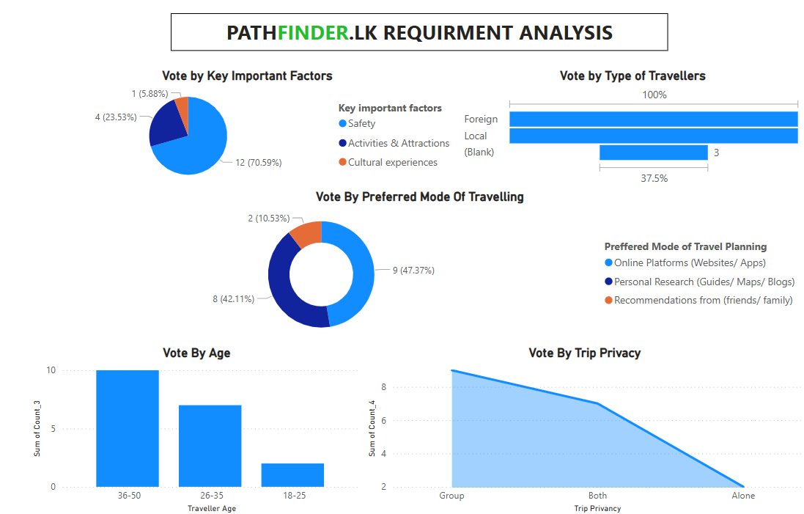

2.2.2 Functional Requirements
Functional requirements define the core capabilities of the platform that must be built to meet business needs. For Pathfinder.lk, the functional requirements might include:
- User Account Management:
  - User registration and login (via email, Google, Facebook).
  - User profile management (preferences, history, loyalty program).
  - Password recovery/reset.
- Hotel Search and Booking:
  - Search for hotels by location, price, amenities, ratings, etc.
  - Filter and sort hotel results (price range, star rating, room types).
  - Real-time availability and pricing updates.
  - Online booking functionality with instant booking confirmation.
- Payment Integration:
  - Secure payment gateway integration (PayPal, Stripe, LankaPay, etc.).
  - Payment confirmation and invoicing.
  - Currency conversion based on user location.
- Personalized Travel Recommendations:
  - Algorithm to recommend hotels based on user preferences, travel history, and reviews.
  - Suggest nearby attractions, restaurants, or activities based on location.
- Booking History and Tracking:
  - Users can view their past bookings and manage future bookings.
  - Real-time tracking of booking status and alerts.
- Customer Support:
  - Live chat support, email assistance, and FAQ section.
  - Ticketing system for issues or inquiries related to bookings.
- Loyalty and Rewards Program:
  - Users earn points for bookings that can be redeemed for discounts or offers.
- Mobile Responsiveness:
  - The platform should be fully responsive across mobile devices, providing users with an optimal experience on smartphones and tablets.
- Social Media Integration:
  - Allow users to share their bookings or reviews on social media.
  - Integration for easy sign-ups/logins through Facebook or Google accounts.

2.2.3 Non-Functional Requirements
Non-functional requirements define the platform's performance, reliability, scalability, and security. For Pathfinder.lk, the non-functional requirements include:
- Scalability:
  - The system should handle high traffic, especially during peak travel seasons, and be able to scale as user demand grows.
- Security:
  - Data encryption (SSL) for all communications, especially for payments and user information.
  - Secure user authentication and authorization (OAuth, two-factor authentication).
  - Compliance with data privacy laws (e.g., GDPR).
- Usability:
  - The platform should have a clean, intuitive user interface that provides a positive experience.
  - Clear navigation and user-friendly booking process.
- Performance:
  - Fast load times (less than 2 seconds).
  - Real-time booking and pricing updates.
- Availability and Uptime:
  - The platform must be available 24/7, with minimal downtime.
  - Implementing a robust cloud infrastructure to ensure high availability.
- Backup and Recovery:
  - Daily data backups.
  - Disaster recovery plans to ensure minimal data loss and quick recovery.
- Compliance:
  - Adherence to Sri Lankan regulations for online businesses.
  - Compliance with payment security standards (PCI-DSS).

2.2.4 User Requirements
User requirements define the specific needs of the end users of Pathfinder.lk. Gathering these requirements often involves direct interviews, surveys, and feedback sessions with the target audience. For Pathfinder.lk, user requirements might include:
- Leisure Travelers:
  - A simple, quick way to find and book hotels in their desired location.
  - Personalized recommendations based on past bookings and preferences.
  - A platform that provides not just accommodation, but also travel experiences like local attractions and restaurants.
- Business Travelers:
  - Ability to book hotels with business amenities (conference rooms, workspaces, etc.).
  - Integration with travel management tools and expense tracking.
  - Ability to schedule trips and create a comprehensive itinerary.
- Hotel Owners:
  - A platform to manage hotel listings, availability, and pricing.
  - Real-time access to bookings and customer information.
  - A dashboard to track performance and reviews.

2.2.5 System Requirements
System requirements define the hardware, software, and network specifications that the platform must run on. For Pathfinder.lk, the system requirements include:
- Web Server: Apache or Nginx
- Backend Technology: PHP, Node.js, or Python-based server framework.
- Database: MySQL or PostgreSQL
- Cloud Hosting: AWS, Google Cloud, or Microsoft Azure for scalability and security.
- Payment Gateway Integration: PayPal, Stripe, or local payment gateways.
- Third-party APIs: Integration with hotel booking APIs (e.g., Booking.com, Agoda).

2.2.6 Functional and Non-Functional Requirement Prioritization
To ensure that the project team addresses the most important features first, requirements should be categorized by priority. Here’s an example of how to prioritize:
- High Priority:
  - Hotel Search and Booking
  - Payment Integration
  - User Account Management
  - Security and Data Protection
- Medium Priority:
  - Personalized Travel Recommendations
  - Booking History and Tracking
  - Customer Support (Live Chat)
- Low Priority:
  - Loyalty and Rewards Program
  - Social Media Integration

2.2.7 Stakeholder Feedback & Iteration
After gathering the requirements, it’s important to validate them with stakeholders and users. Feedback from stakeholders like hotel partners, end-users, and business owners will ensure that the platform meets their expectations. Once feedback is gathered, the development team can refine the requirements and adjust the project plan as necessary.

2.2.8 Conclusion
Effective requirement gathering will ensure that Pathfinder.lk meets user needs, adheres to technical specifications, and achieves business objectives. The requirements gathered will serve as the foundation for the platform’s design, development, and eventual deployment.

2.3 Refined Resource Identification for Pathfinder.lk

2.3.1 The development of Pathfinder.lk, a web-based platform, will be handled by a focused team consisting of the following roles:
- Project Manager
- Web Developer
- Database Developer
- UI/UX Developer
- System Analyst
Here's a breakdown of how these roles align with resource requirements and responsibilities:
Project Manager
- Responsibilities:
  - Oversees the project from initiation to completion.
  - Coordinates the work between the development team and stakeholders (e.g., hotel partners, users).
  - Ensures deadlines, budgets, and project goals are met.
- Skills:
  - Leadership, communication, project planning, resource management, risk management.
Web Developer
- Responsibilities:
  - Responsible for developing the frontend and backend aspects of Pathfinder.lk, ensuring smooth interaction between the user interface and database.
  - Integrates the design with functional code and ensures cross-browser compatibility.
- Skills:
  - Frontend: HTML5, CSS3, JavaScript, React.js or Vue.js (or any preferred framework).
  - Backend: PHP, Node.js, Python.
  - API integration (RESTful or GraphQL), version control (Git), testing frameworks.
Database Developer
- Responsibilities:
  - Designs, implements, and maintains the database system for the platform.
  - Ensures data integrity, security, and efficient querying for fast load times.
  - Manages data migration and scaling as required.
- Skills:
  - MySQL, PostgreSQL (or other relational database management systems).
  - Database schema design, optimization, backup and recovery, query tuning.
UI/UX Developer
- Responsibilities:
  - Designs the user interface (UI) and ensures a smooth and intuitive user experience (UX).
  - Works on wireframes, prototypes, and high-fidelity designs based on user feedback and testing.
  - Ensures the platform is mobile-responsive and accessible to a wide range of users.
- Skills:
  - UI/UX design, prototyping tools (e.g., Figma, Adobe XD), design principles, wireframing, user research, interaction design.
  - Frontend coding skills: HTML5, CSS3, JavaScript for implementing the design.
System Analyst
- Responsibilities:
  - Gathers, analyzes, and documents system requirements from stakeholders (e.g., hotel partners, users).
  - Acts as the bridge between business requirements and technical specifications.
  - Works closely with the development team to ensure that the system is aligned with user and business needs.
- Skills:
  - Requirements analysis, business analysis, technical documentation, communication with stakeholders.
  - Knowledge of web-based platforms, system architecture, and security protocols.

2.3.2 Technological Resources
Since Pathfinder.lk is a web-based platform, the technological resources are vital to ensure scalability, responsiveness, and security. Given the roles you mentioned, these tools and platforms are necessary:
Frontend Technologies (Web Developer & UI/UX Developer):
- Frontend Frameworks: React.js, Vue.js, or Angular for building dynamic and responsive web applications.
- Design Implementation: HTML5, CSS3, JavaScript (ES6+), and frameworks like Bootstrap or Tailwind CSS for responsive design.
- Prototyping & Collaboration: Figma or Adobe XD for UI/UX design and collaboration with the development team.
Backend Technologies (Web Developer):
- Programming Languages: PHP, Node.js, or Python for server-side logic.
- Web Frameworks: Express (for Node.js), Django or Flask (for Python), Laravel (for PHP).
- API Development: RESTful APIs or GraphQL for seamless data exchange between frontend and backend.
Database Technologies (Database Developer):
- Database Management System (DBMS): MySQL, PostgreSQL, or MongoDB (if using NoSQL).
- Query Optimization & Security: Use of indexing, caching, and encryption for data security and performance.
Hosting & Deployment:
- Web Hosting: Cloud platforms like AWS, Google Cloud, or DigitalOcean for hosting the website.
- CI/CD Pipelines: Jenkins, GitLab CI, or CircleCI for continuous integration and deployment.
- Monitoring Tools: New Relic, Datadog, or Google Analytics for monitoring website performance, traffic, and user behavior.

2.3.3 Financial Resources
Development Budget:
- The budget allocation for the web-based platform will cover the salaries of the development team, software licenses, tools (such as design and development software), and cloud infrastructure.
Marketing Budget:
- If marketing efforts are outsourced or handled in-house, this budget should cover digital marketing campaigns (social media ads, SEO), partnerships, and influencer collaborations, specifically targeting Sri Lankan tourists or travelers.
Operational Costs:
- Ongoing cloud hosting costs (e.g., AWS S3 for storage, RDS for database management).
- Maintenance and security patches for the platform.
- Payment gateway integration costs (e.g., PayPal, Stripe).

2.3.4 Table 1 Time Resources
The timeline for development, considering the streamlined team and resources, could be estimated as:
Task | December 2024 | January 2025 | February 2025
Requirement Gathering and Analysis | Week 1, Week 2
System Designing | Week 3, Week 4 | Week 1
GUI Design | Week 1, Week 2 | Week 3
Coding | Week 2, Week 3 | Week 4 | Week 1, Week 2
System Testing |  | Week 1, Week 2 | Week 3
System Improvement |  | Week 3, Week 4 | Week 4
Final Testing |  |  | Week 4

Conclusion
With the given resources—Project Manager, Web Developer, Database Developer, UI/UX Developer, and System Analyst—Pathfinder.lk can successfully move forward with the development of the platform. Each role is aligned with the project's goals, ensuring that the web-based platform is user-friendly, efficient, and scalable. The resource identification here supports a clear distribution of responsibilities, which will contribute to the timely and quality development of Pathfinder.lk.

2.4 Work Breakdown Structure (WBS) for Pathfinder.lk

2.4.1 Project Management
Project Planning & Kickoff
- Define project scope and objectives
- Set timelines and milestones
- Identify stakeholders and communication plan 1.2 Resource Allocation & Budgeting
- Allocate resources (human, financial, technological)
- Finalize project budget 1.3 Risk Management
- Identify potential risks
- Develop risk mitigation strategies 1.4 Progress Monitoring & Reporting
- Regular status meetings with stakeholders
- Track project progress and performance

2.4.2 Requirements & Analysis
Stakeholder Consultation
- Interview business owners, travelers, and hotel partners
- Gather feature requests and expectations 2.2 Requirements Documentation
- Functional requirements
- Non-functional requirements
- System architecture requirements 2.3 Competitive Analysis
- Research competitor platforms
- Identify unique value propositions for Pathfinder.lk 2.4 System Design Approval
- Review and approve requirements with key stakeholders

2.4.3 Design & Prototyping
UI/UX Design
- Wireframing and prototyping
- User flow design and validation with stakeholders 3.2 Front-end Design
- Visual design (colors, typography, layout)
- User interface creation (responsive design for all devices) 3.3 Back-end Design
- Define database schema and server-side architecture
- API design for integration with booking systems 3.4 Design Validation
- Feedback from internal teams and stakeholders
- Refining the design based on feedback

2.4.4 Development
Frontend Development
- Implement UI using HTML5, CSS3, JavaScript
- Integrate frontend with backend APIs
- Implement responsive design and accessibility features 4.2 Backend Development
- Set up the server, APIs, and database
- Implement logic for hotel search, bookings, and user management
- Integrate third-party booking APIs (Booking.com, Agoda) 4.3 Database Development
- Design and implement database structure
- Set up and optimize SQL queries
- Data security and backup strategies 4.4 Payment Gateway Integration
- Integrate secure payment gateways (PayPal, Stripe, LankaPay)
- Test secure payment transactions 4.5 Loyalty Program Integration
- Integrate hotel loyalty programs with user accounts
- Enable point tracking and discounts 4.6 Communication Tools Integration
- Live chat and phone call support features
- Build and test communication tools for booking assistance

2.4.5. Testing & Quality Assurance
Unit Testing
- Frontend and backend unit tests
- Database integrity tests 5.2 Integration Testing
- Test integration of frontend, backend, and third-party APIs
- Payment gateway transaction testing 5.3 User Acceptance Testing (UAT)
- Test by internal users, stakeholders, and sample travelers
- Collect feedback and make necessary adjustments 5.4 Performance Testing
- Load testing (simulate high traffic scenarios)
- Optimize performance and speed 5.5 Security Testing
- Test for vulnerabilities (SQL injection, cross-site scripting)
- Ensure data encryption and secure transactions

2.4.6. Deployment & Launch
Staging Environment Setup
- Set up staging server for final testing
- Ensure all features are fully functional in a real-world environment 6.2 Final Deployment
- Deploy the website to production server
- Ensure smooth transition from staging to live 6.3 Launch Marketing
- Announce launch via social media, email campaigns, and ads
- Partnerships with hotels and tourism influencers

2.4.7 Post-Launch & Maintenance
User Feedback Collection
- Monitor user reviews and behavior on the platform
- Collect feedback from initial users to improve the platform 7.2 Bug Fixing & Updates
- Address issues reported by users
- Regular platform updates (bug fixes, new features) 7.3 System Monitoring & Performance Tuning
- Monitor server performance, uptime, and user traffic
- Optimize platform based on usage patterns 7.4 Ongoing Marketing & SEO
- Continuous SEO optimization to improve search rankings
- Social media engagement and new promotions

Summary of WBS for Pathfinder.lk:
This WBS provides a detailed structure for Pathfinder.lk, breaking down the project into key phases like Project Management, Requirements Gathering, Design & Prototyping, Development, Testing, Deployment, and Post-Launch. Each phase is further divided into specific tasks, ensuring that all activities are clearly defined, assigned to the right roles, and tracked throughout the development process.

2.5 Risk Analysis for Pathfinder.lk
Risk analysis is a critical component of any project, and for Pathfinder.lk, a web-based travel planning platform, understanding potential risks helps mitigate negative impacts on development, deployment, and user satisfaction. Below is a comprehensive Risk Analysis for the Pathfinder.lk project, covering technical, operational, business, and external risks.

2.5.1 Technical Risks

2.5.1.1 System Integration Issues
- Description: The platform will integrate with third-party booking engines (e.g., Booking.com, Agoda) and payment gateways (PayPal, Stripe, LankaPay). Incompatibilities, outdated APIs, or poor documentation could delay the integration process.
- Impact: High. Inability to integrate smoothly could lead to delayed project timelines and disrupt the user experience.
- Mitigation:
  - Perform thorough research on third-party systems.
  - Test integration early in the development cycle.
  - Maintain a clear communication channel with third-party vendors.

2.5.1.2 Data Security & Privacy Concerns
- Description: User data, including personal, financial, and booking details, will be handled by the platform. Security breaches could compromise user trust and legal compliance.
- Impact: Critical. Data breaches can result in legal penalties, loss of customer trust, and negative press.
- Mitigation:
  - Implement robust encryption and secure data protocols.
  - Regularly update the platform to patch vulnerabilities.
  - Conduct penetration testing and audits.

2.5.1.3 Platform Downtime or Performance Issues
- Description: High user traffic or server overload could cause platform downtime or performance degradation.
- Impact: High. Frequent downtime or slow performance can drive users away and damage the platform’s reputation.
- Mitigation:
  - Use scalable cloud infrastructure for better load handling.
  - Conduct stress and load testing to prepare for high traffic.
  - Implement a monitoring system for proactive issue resolution.

2.5.2 Operational Risks

2.5.2.1 Resource Constraints
- Description: Limited resources (time, budget, personnel) may affect the project's ability to meet deadlines, particularly in a small team with diverse roles (Project Manager, Web Developer, Database Developer, UI/UX Developer, System Analyst).
- Impact: Medium. Delays and reduced project scope could affect timelines and final quality.
- Mitigation:
  - Create a detailed project plan with resource allocation.
  - Regularly review resource usage to ensure efficiency.
  - Be flexible and prioritize key features during crunch periods.

2.5.2.2 Skill Shortage or Knowledge Gaps
- Description: The team might lack specialized knowledge in some areas (e.g., integrating certain APIs, advanced security features, or payment gateways).
- Impact: Medium. Skill gaps may delay progress or lead to suboptimal implementation.
- Mitigation:
  - Upskill the team through training or hiring external experts for specialized tasks.
  - Encourage collaboration among team members to share knowledge.

2.5.2.3 Communication Challenges
- Description: Given the collaborative nature of the project, miscommunication among stakeholders, especially regarding project goals and expectations, can cause confusion and delays.
- Impact: Medium. Misalignment between team members and stakeholders can lead to rework and delays.
- Mitigation:
  - Set up regular meetings and clear documentation.
  - Assign specific communication channels for different tasks or concerns.

2.5.3 Business Risks

2.5.3.1 Changing Market Demands
- Description: The travel industry is dynamic, and evolving customer preferences or market trends (such as the rise of sustainable travel) might require changes in the platform's offerings.
- Impact: Medium. Failure to keep up with industry changes could result in reduced user engagement and competitive disadvantage.
- Mitigation:
  - Continuously monitor industry trends and user feedback.
  - Be flexible in incorporating new features or updates based on market demands.

2.5.3.2 Financial Constraints
- Description: Insufficient budget allocation or unforeseen expenses could jeopardize the project’s progress or completion.
- Impact: High. Financial limitations could restrict development or lead to a reduced feature set.
- Mitigation:
  - Set a realistic budget with contingencies for unforeseen costs.
  - Track expenses and adjust the scope as needed to stay within budget.

2.5.3.3 Competitive Pressure
- Description: Competitors like Booking.com, Airbnb, and other regional travel platforms may offer similar services, making it difficult to attract and retain users.
- Impact: Medium. The platform may struggle to differentiate itself and achieve user loyalty.
- Mitigation:
  - Focus on a unique value proposition (e.g., personalized recommendations, loyalty programs).
  - Continuously improve the user experience and introduce exclusive deals with local hotels.

2.5.4 External Risks

2.5.4.1 Regulatory & Legal Risks
- Description: Legal frameworks, especially related to online transactions, privacy laws (GDPR), and local tourism regulations, may change, affecting the platform’s operations.
- Impact: Medium. Non-compliance with new regulations could result in fines or operational restrictions.
- Mitigation:
  - Stay updated with local and international regulations.
  - Consult legal experts regularly to ensure compliance.

2.5.4.2 External Disruptions (e.g., Pandemic, Economic Crisis)
- Description: Global events like pandemics or economic downturns can drastically reduce travel demand, affecting platform usage.
- Impact: High. Reduced demand for travel could significantly impact the platform’s success.
- Mitigation:
  - Diversify platform offerings to cater to both leisure and business travel.

Build contingency plans for external disruptions.

2.5.4.3 Dependency on Third-Party Services
- Description: The platform’s success depends heavily on third-party services like hotel APIs and payment gateways. Any disruption or failure of these services could affect the platform’s functionality.
- Impact: High. A service disruption could lead to loss of functionality, user dissatisfaction, or potential revenue loss.
- Mitigation:
  - Maintain backup solutions and partnerships with alternative service providers.
  - Ensure contracts with third-party providers include service-level agreements (SLAs) for uptime and reliability.

2.5.5 Table 2 Risk Summary & Action Plan
Risk | Probability | Impact | Mitigation Strategy
System Integration Issues | High | High | Thorough testing, early integration, maintain clear communication with vendors.
Data Security & Privacy | High | Critical | Implement encryption, regular audits, penetration testing.
Platform Downtime | Medium | High | Scalable infrastructure, stress/load testing, monitoring systems.
Resource Constraints | Medium | Medium | Detailed project planning, regular resource review.
Skill Shortage | Medium | Medium | Training, collaboration, or hire external experts for specialized tasks.
Communication Challenges | Medium | Medium | Set up clear communication channels and documentation.
Changing Market Demands | Medium | Medium | Continuously monitor trends, adapt features accordingly.
Financial Constraints | High | High | Realistic budgeting with contingencies, track expenses.
Competitive Pressure | Medium | Medium | Focus on unique value propositions and continuously improve user experience.
Regulatory & Legal Risks | Medium | Medium | Stay updated on regulations, consult legal experts.
External Disruptions | Medium | High | Diversify services, build contingency plans.
Third-Party Service Dependency | High | High | Have backup solutions, SLAs with third-party providers.

Conclusion
Risk analysis for Pathfinder.lk has identified key technical, operational, business, and external risks that could potentially impact the project's success. By proactively addressing these risks with clear mitigation strategies, the platform can better navigate uncertainties and ensure smooth development and launch. Regular review and monitoring of these risks will be essential in adapting to any new challenges that arise during the project's lifecycle.
Chapter 03
Figure 2 Map of the Design
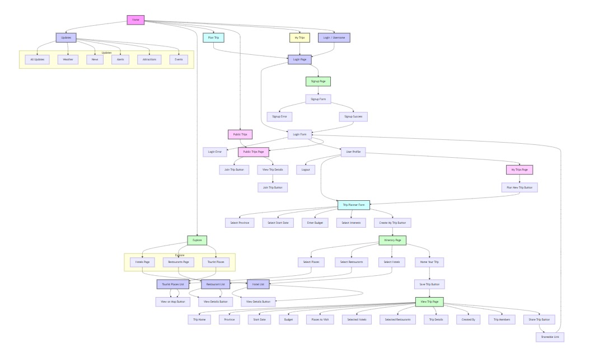

Design of the system
Data Base
Figure 3Entity Relationship Diagram
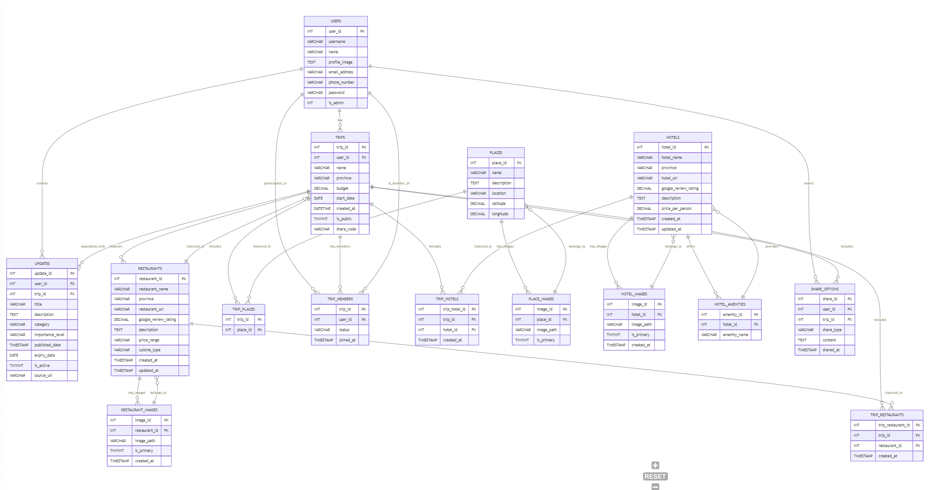
Table 3 Normalized Relationship Schema
1. USERS
Column | Data Type | Constraints
user_id | INT | PRIMARY KEY, AUTO_INCREMENT
username | VARCHAR(50) | UNIQUE, NOT NULL
name | VARCHAR(100) | NOT NULL
profile_image | TEXT | NULL
email_address | VARCHAR(100) | UNIQUE, NOT NULL
phone_number | VARCHAR(15) | UNIQUE, NULL
password | VARCHAR(255) | NOT NULL
is_admin | TINYINT(1) | DEFAULT 0
2. TRIPS
Column | Data Type | Constraints
trip_id | INT | PRIMARY KEY, AUTO_INCREMENT
user_id | INT | FOREIGN KEY REFERENCES USERS(user_id)
name | VARCHAR(255) | NOT NULL
province | VARCHAR(100) | NOT NULL
budget | DECIMAL(10,2) | NULL
start_date | DATE | NULL
created_at | DATETIME | DEFAULT CURRENT_TIMESTAMP
is_public | TINYINT(1) | DEFAULT 0
share_code | VARCHAR(50) | UNIQUE, NULL
3. PLACES
Column | Data Type | Constraints
place_id | INT | PRIMARY KEY, AUTO_INCREMENT
name | VARCHAR(255) | NOT NULL
description | TEXT | NULL
location | VARCHAR(255) | NOT NULL
latitude | DECIMAL(10,8) | NULL
longitude | DECIMAL(11,8) | NULL
4. PLACE_IMAGES
Column | Data Type | Constraints
image_id | INT | PRIMARY KEY, AUTO_INCREMENT
place_id | INT | FOREIGN KEY REFERENCES PLACES(place_id)
image_path | VARCHAR(255) | NOT NULL
is_primary | TINYINT(1) | DEFAULT 0
5. HOTELS
Column | Data Type | Constraints
hotel_id | INT | PRIMARY KEY, AUTO_INCREMENT
hotel_name | VARCHAR(255) | NOT NULL
province | VARCHAR(100) | NOT NULL
hotel_url | VARCHAR(255) | NULL
google_review_rating | DECIMAL(3,1) | NULL
description | TEXT | NULL
price_per_person | DECIMAL(10,2) | NULL
created_at | TIMESTAMP | DEFAULT CURRENT_TIMESTAMP
updated_at | TIMESTAMP | DEFAULT CURRENT_TIMESTAMP ON UPDATE CURRENT_TIMESTAMP
6. HOTEL_IMAGES
Column | Data Type | Constraints
image_id | INT | PRIMARY KEY, AUTO_INCREMENT
hotel_id | INT | FOREIGN KEY REFERENCES HOTELS(hotel_id)
image_path | VARCHAR(255) | NOT NULL
is_primary | TINYINT(1) | DEFAULT 0
created_at | TIMESTAMP | DEFAULT CURRENT_TIMESTAMP
7. HOTEL_AMENITIES
Column | Data Type | Constraints
amenity_id | INT | PRIMARY KEY, AUTO_INCREMENT
hotel_id | INT | FOREIGN KEY REFERENCES HOTELS(hotel_id)
amenity_name | VARCHAR(100) | NOT NULL
8. RESTAURANTS
Column | Data Type | Constraints
restaurant_id | INT | PRIMARY KEY, AUTO_INCREMENT
restaurant_name | VARCHAR(255) | NOT NULL
province | VARCHAR(100) | NOT NULL
restaurant_url | VARCHAR(255) | NULL
google_review_rating | DECIMAL(3,1) | NULL
description | TEXT | NULL
price_range | VARCHAR(50) | NULL
cuisine_type | VARCHAR(100) | NULL
created_at | TIMESTAMP | DEFAULT CURRENT_TIMESTAMP
updated_at | TIMESTAMP | DEFAULT CURRENT_TIMESTAMP ON UPDATE CURRENT_TIMESTAMP
9. RESTAURANT_IMAGES
Column | Data Type | Constraints
image_id | INT | PRIMARY KEY, AUTO_INCREMENT
restaurant_id | INT | FOREIGN KEY REFERENCES RESTAURANTS(restaurant_id)
image_path | VARCHAR(255) | NOT NULL
is_primary | TINYINT(1) | DEFAULT 0
created_at | TIMESTAMP | DEFAULT CURRENT_TIMESTAMP
10. UPDATES
Column | Data Type | Constraints
update_id | INT | PRIMARY KEY, AUTO_INCREMENT
user_id | INT | FOREIGN KEY REFERENCES USERS(user_id)
trip_id | INT | FOREIGN KEY REFERENCES TRIPS(trip_id)
title | VARCHAR(255) | NOT NULL
description | TEXT | NULL
category | VARCHAR(100) | NULL
importance_level | ENUM('Low', 'Medium', 'High') | DEFAULT 'Low'
published_date | TIMESTAMP | DEFAULT CURRENT_TIMESTAMP
expiry_date | DATE | NULL
is_active | TINYINT(1) | DEFAULT 1
source_url | VARCHAR(255) | NULL
11. TRIP_RESTAURANTS
Column | Data Type | Constraints
trip_restaurant_id | INT | PRIMARY KEY, AUTO_INCREMENT
trip_id | INT | FOREIGN KEY REFERENCES TRIPS(trip_id)
restaurant_id

System Design
DFD
Figure 4 Context Diagram
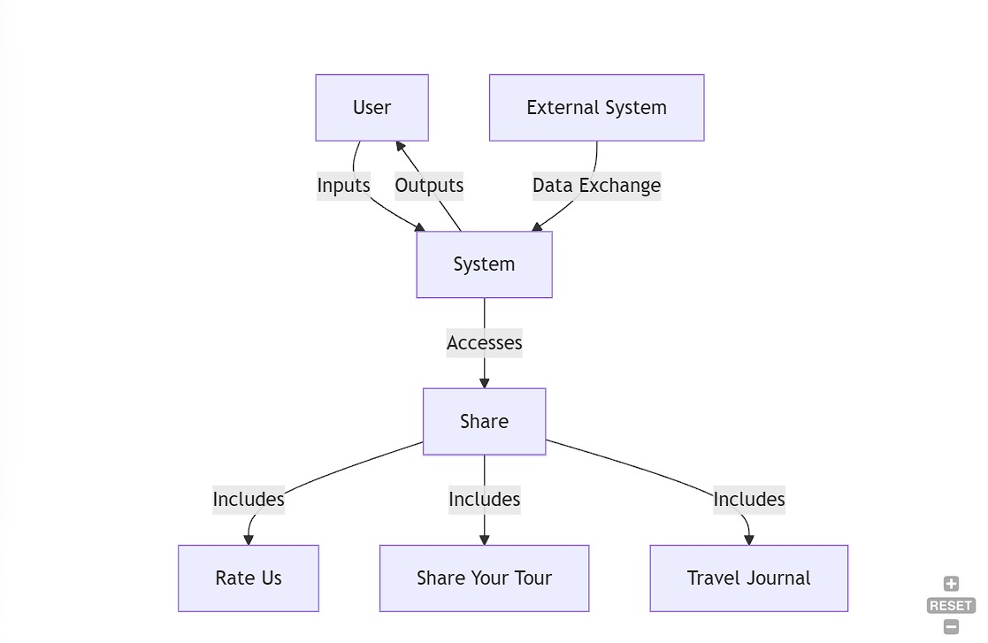
Figure 5 Level 0
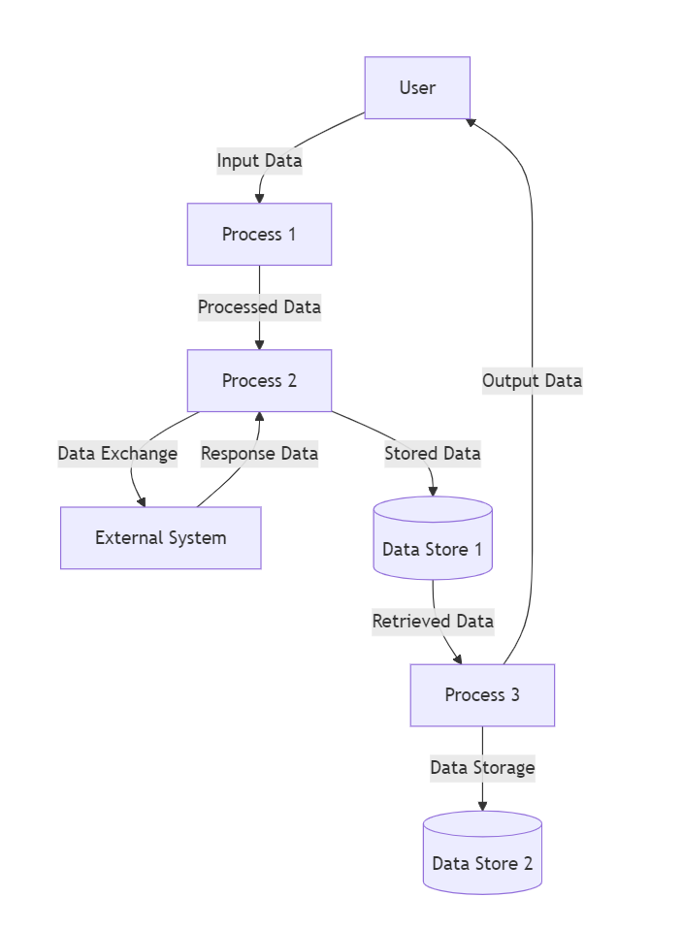

Figure 6 Level 1
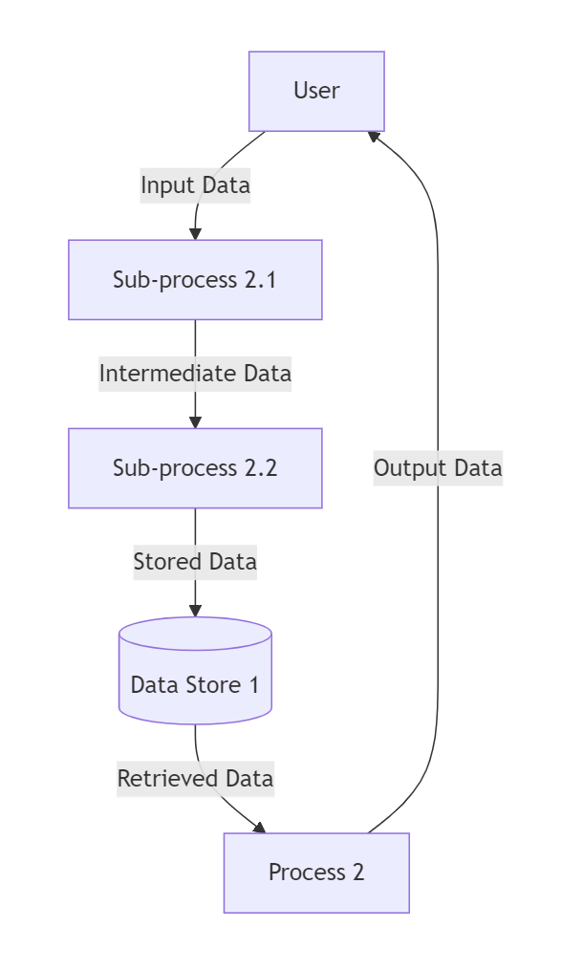

UML Diagram
Figure 7 Use Case Diagram
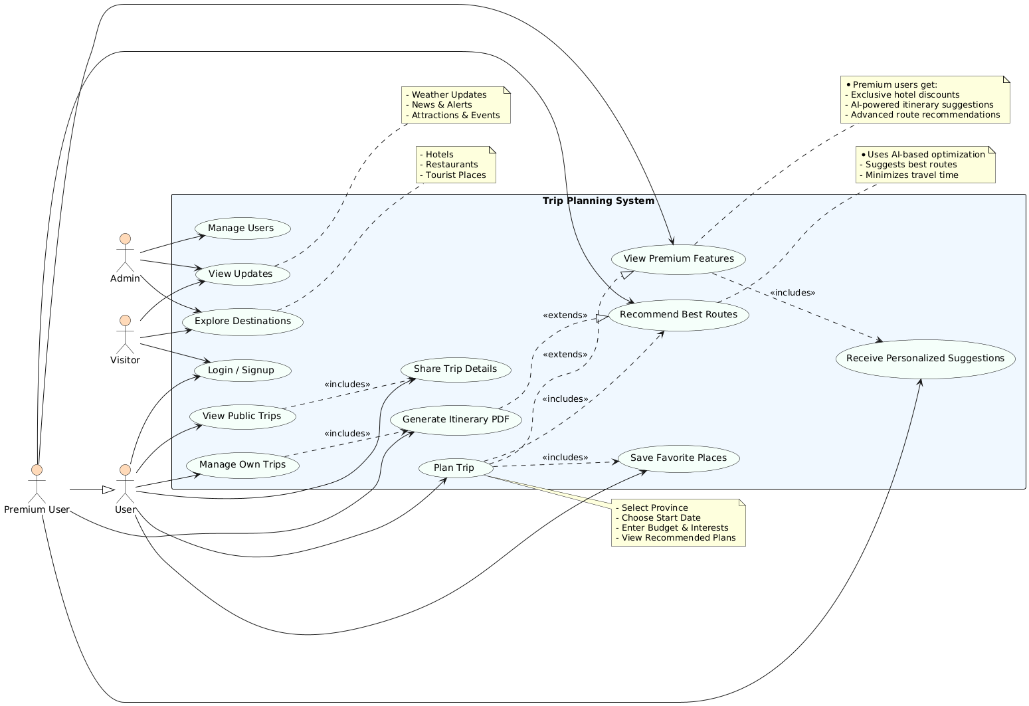
Figure 8 Class Diagram
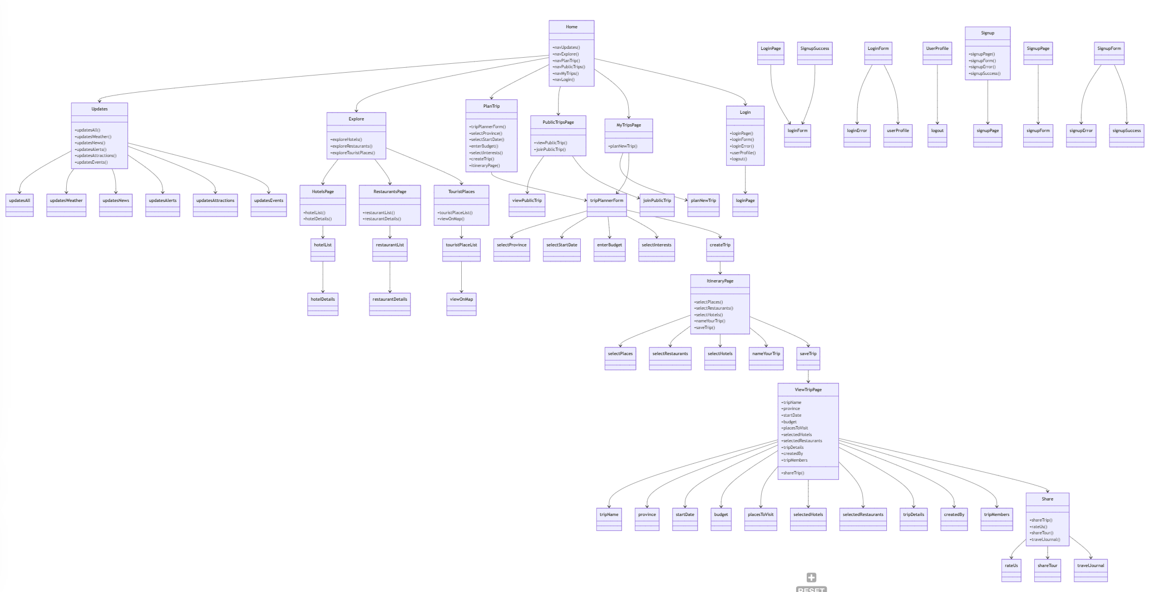
Figure 9 Sequence Diagram
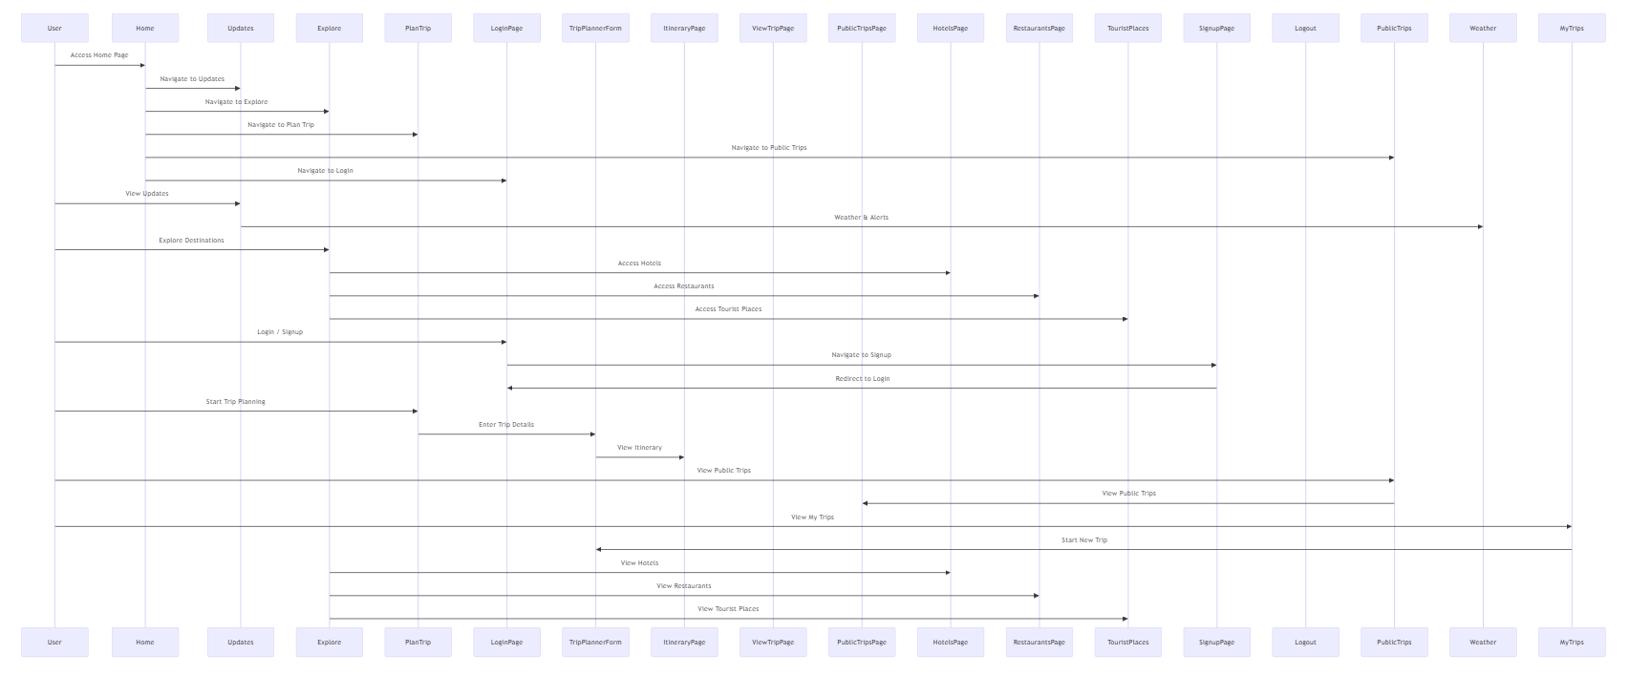
Flow Chart
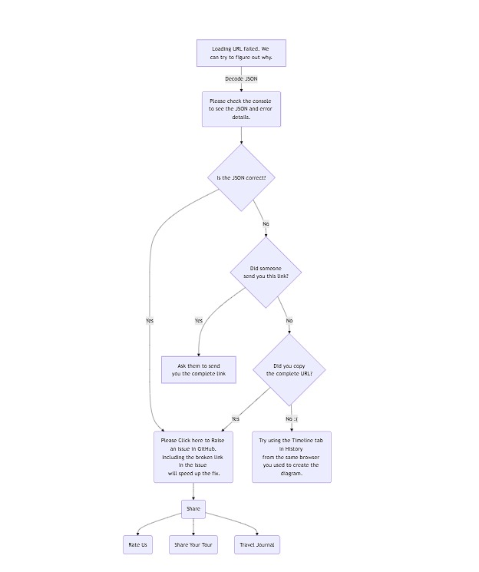

User interfaces/ Navigations
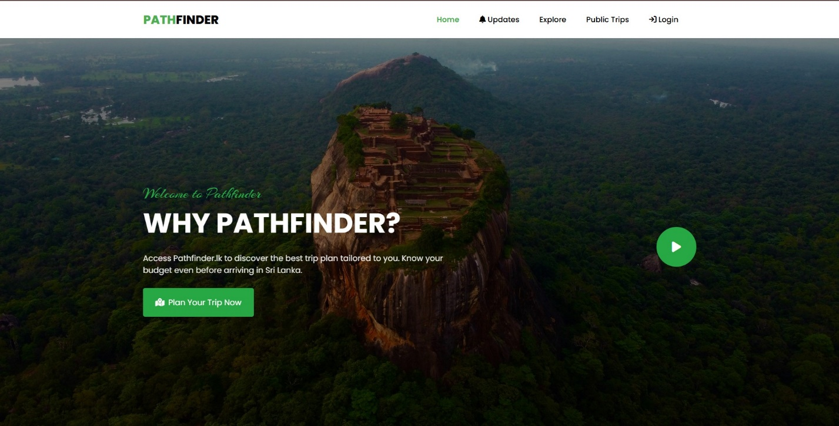
Figure 10 The Home Page
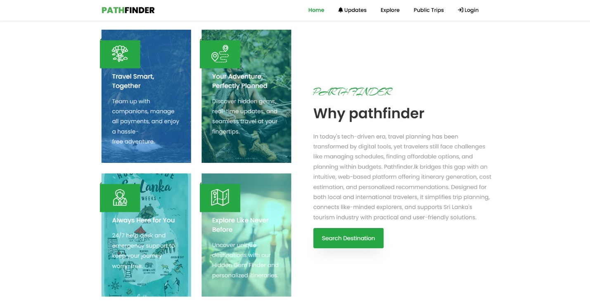
Figure 11 The Overview
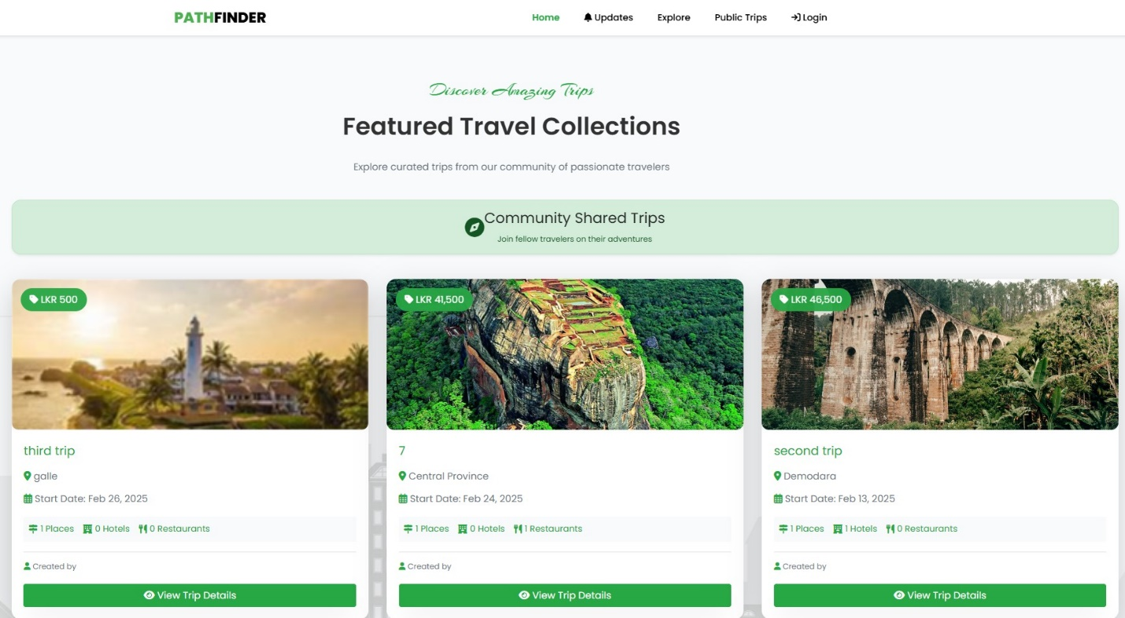
Figure 12 Featured Travel Collections
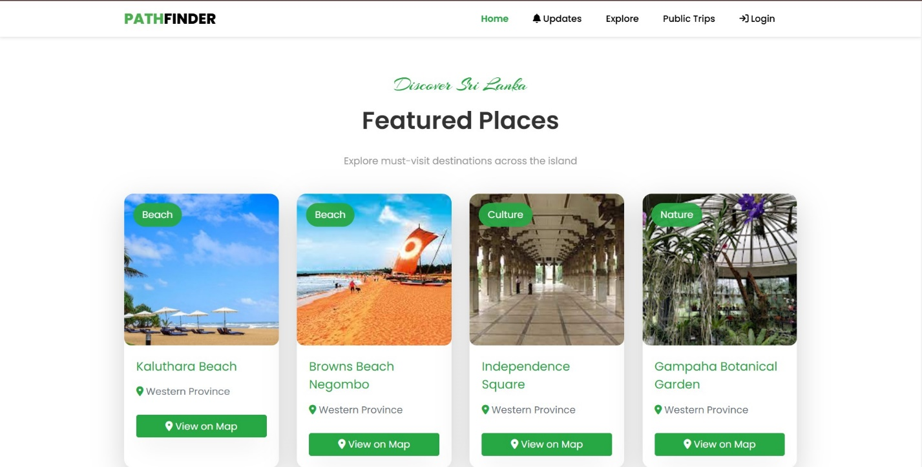
Figure 13 Featured Places
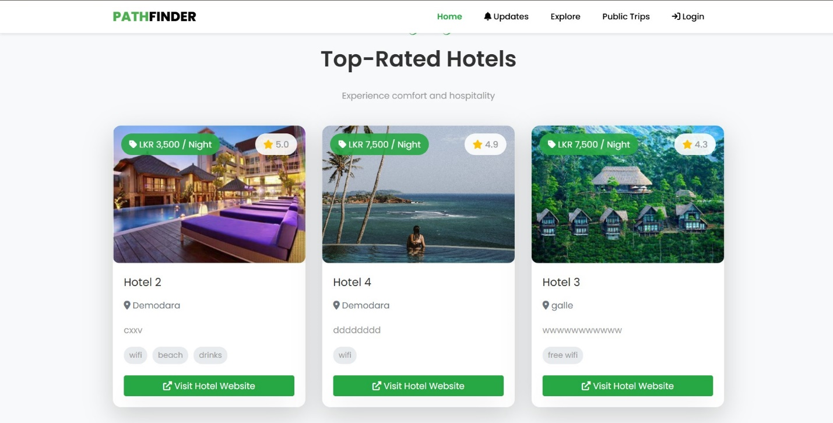
Figure 14 Top-Rated Hotels
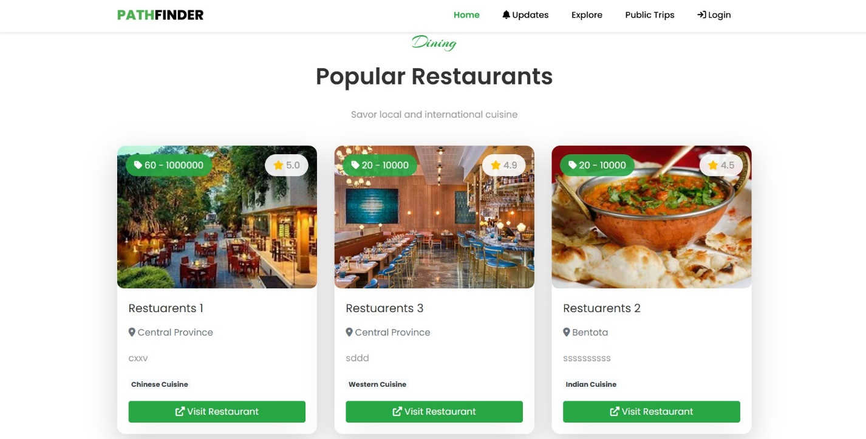
Figure 15 Popular Restaurants
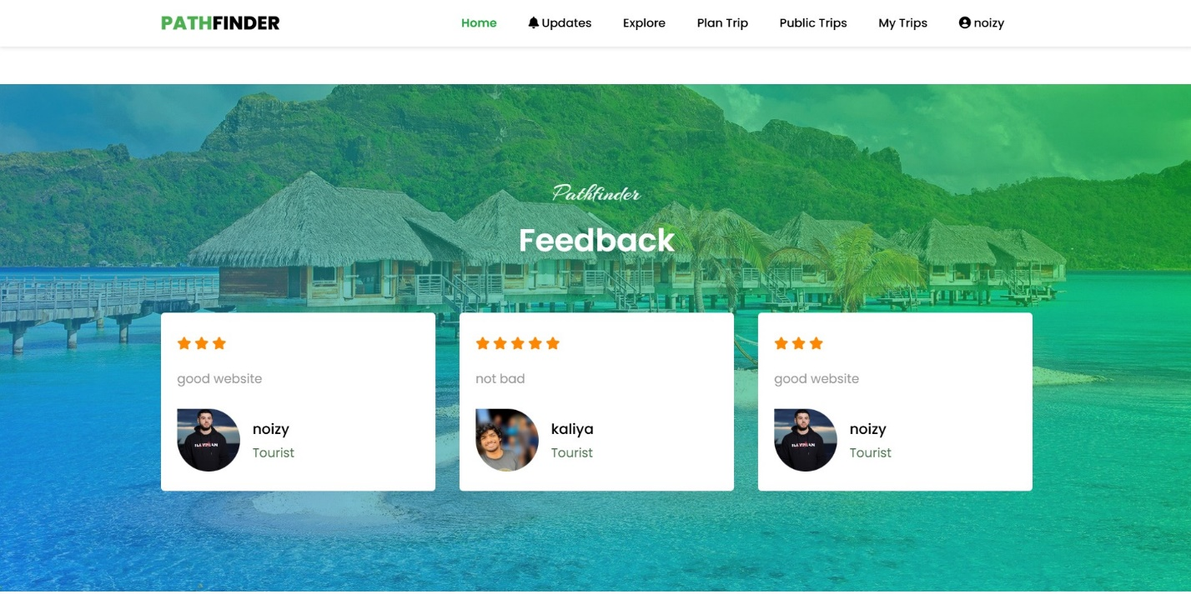
Figure 16 Feedback
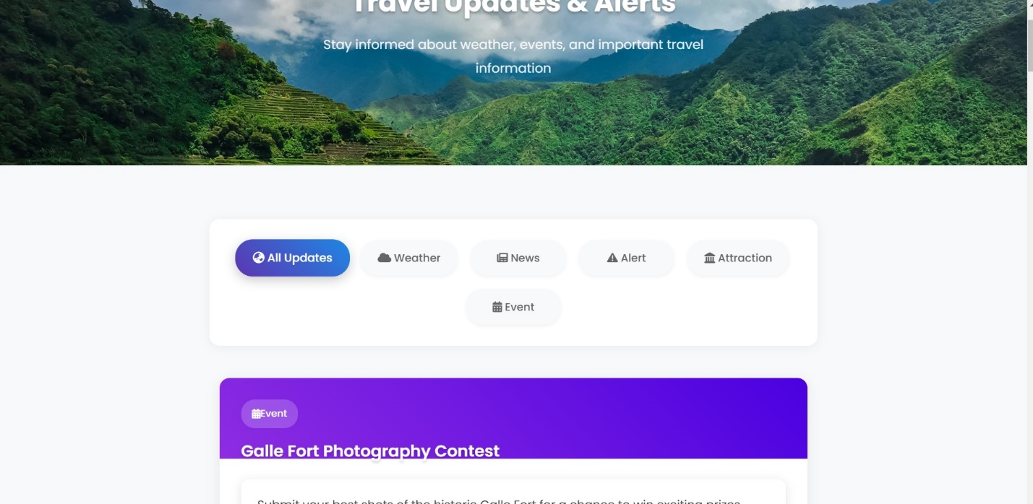
Figure 17 All Updates
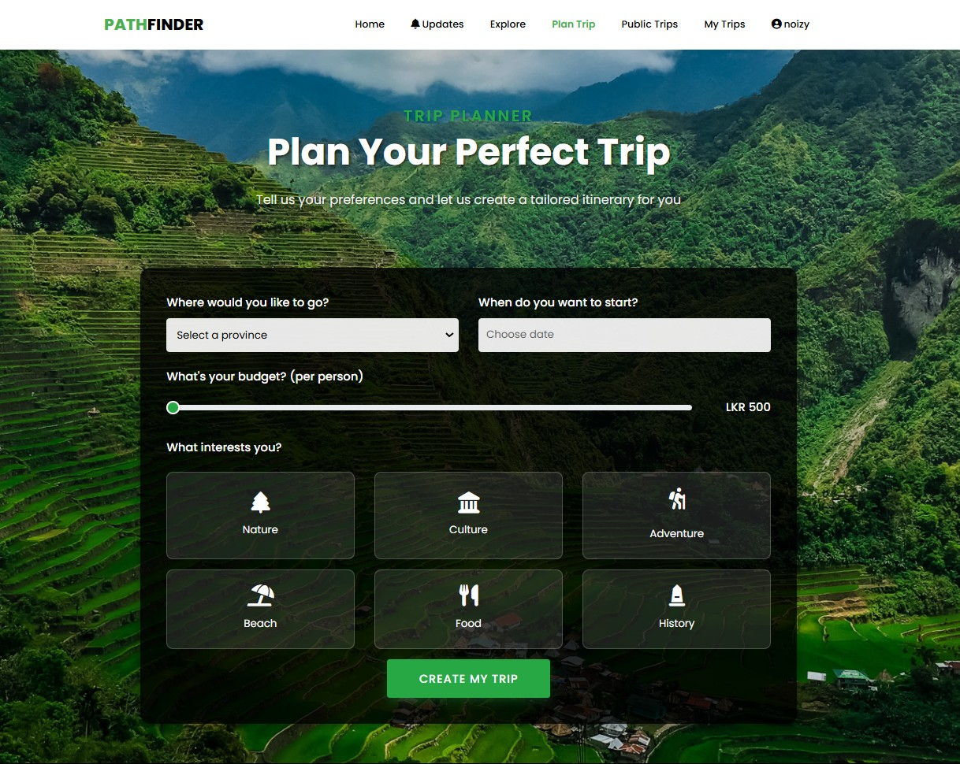
Figure 18 Trip Planner
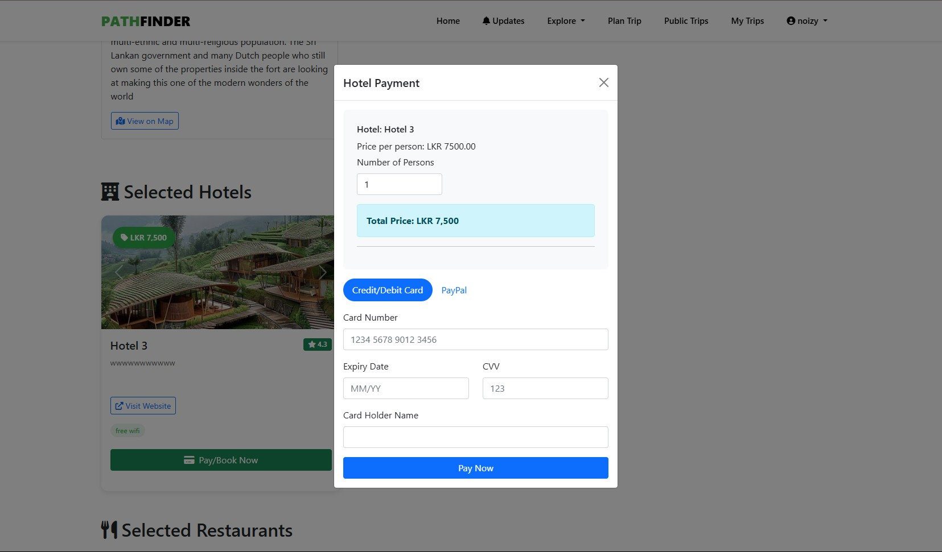
Figure 19 Payment Gateway
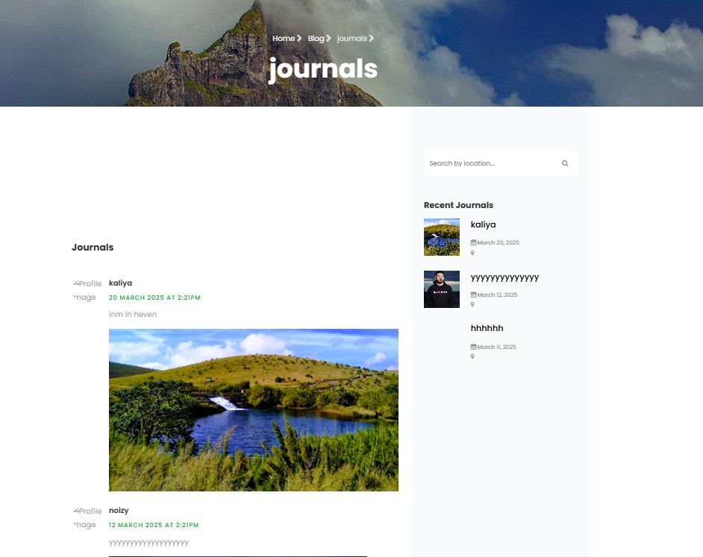
Figure 20 Journal
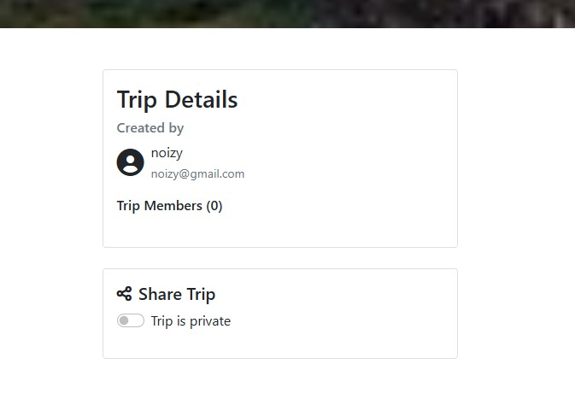
Figure 21 Trip Collaboration
Chapter 04
Figure 22 Admin Places
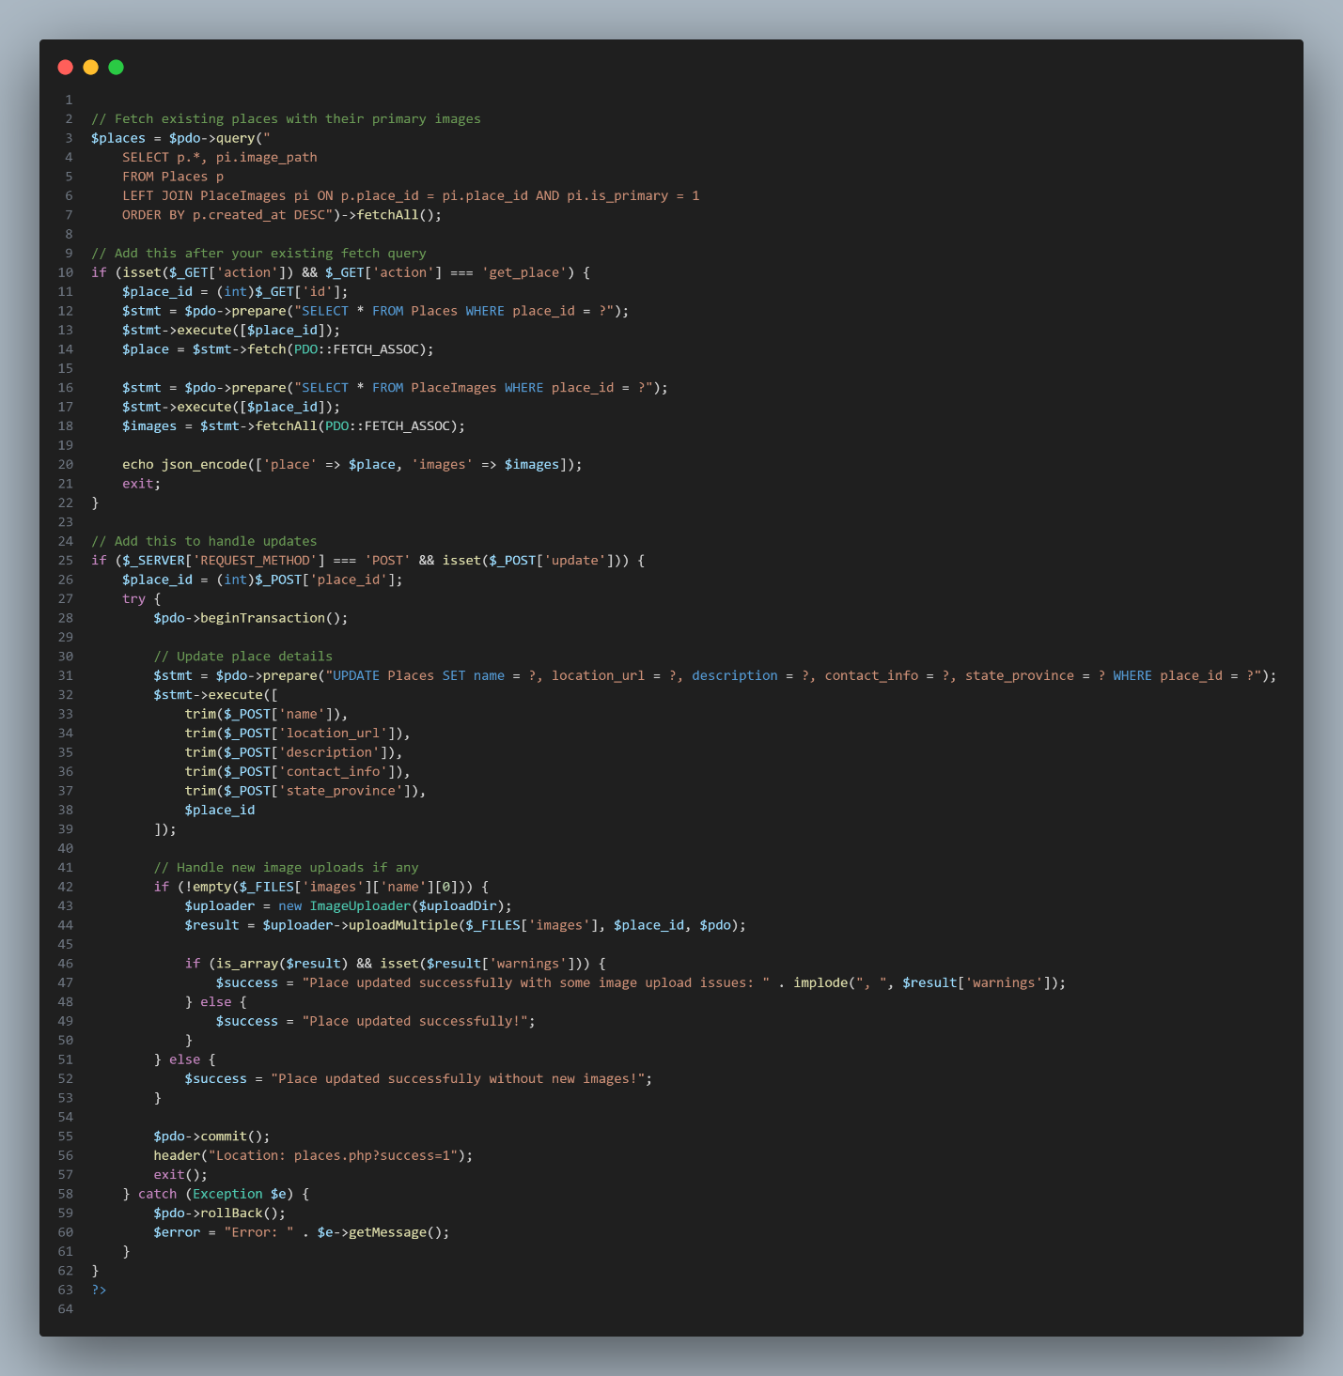
Figure 23 db_connect
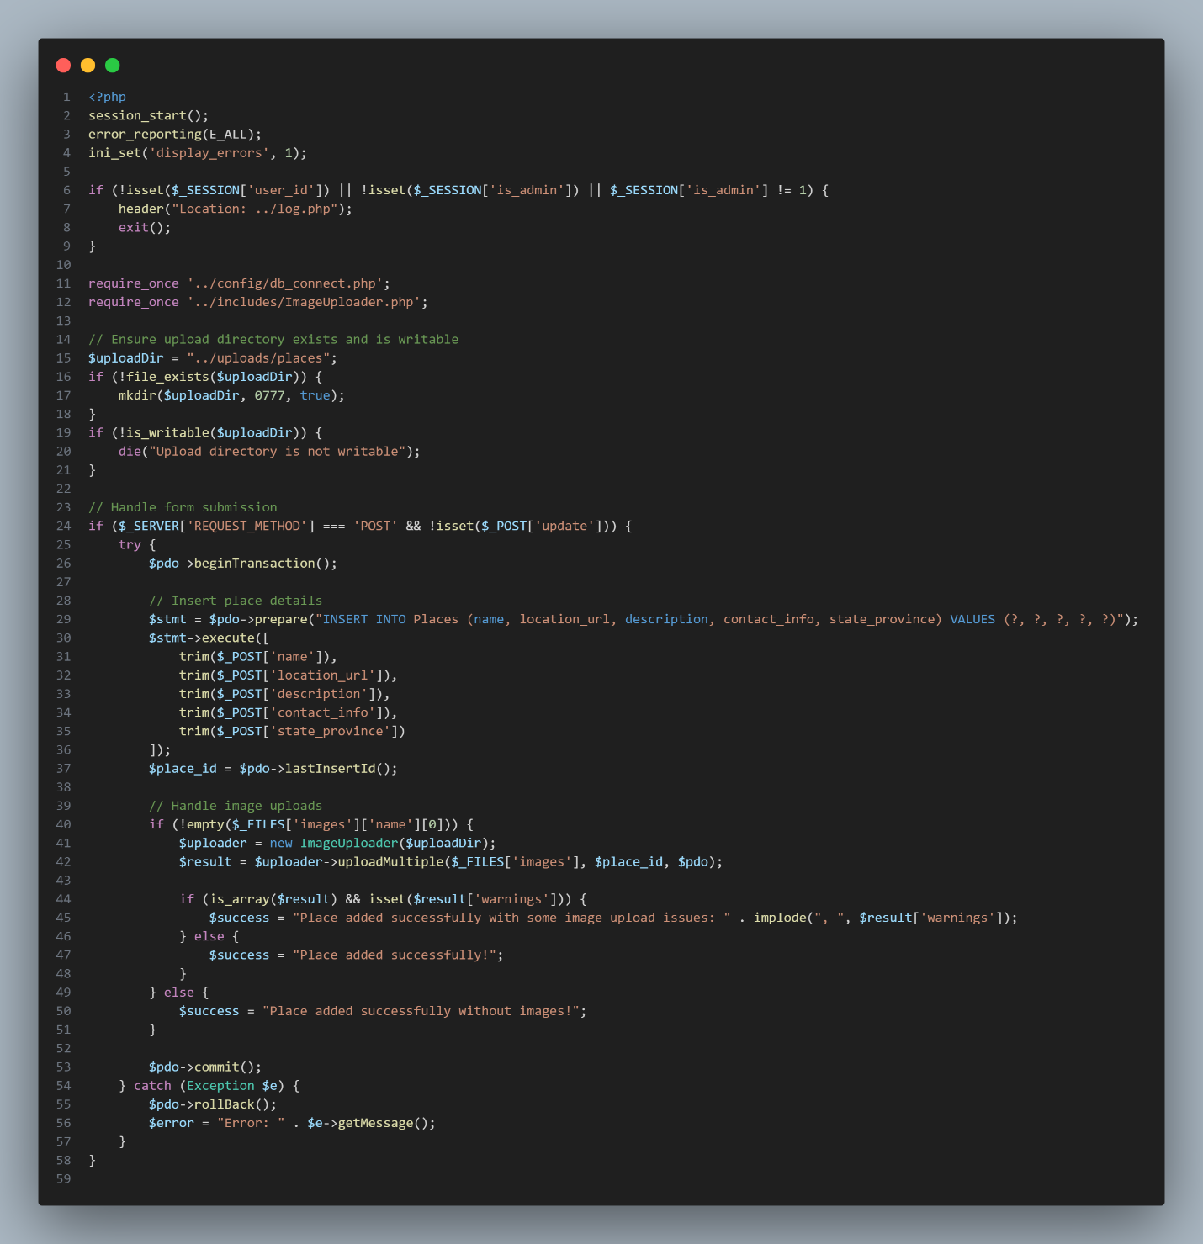
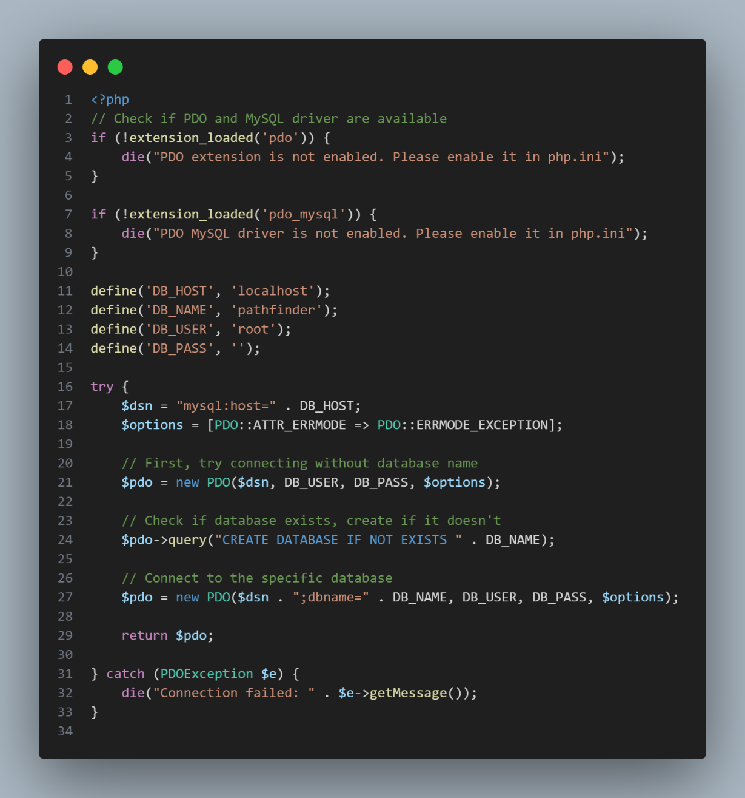
Figure 24Delete_place
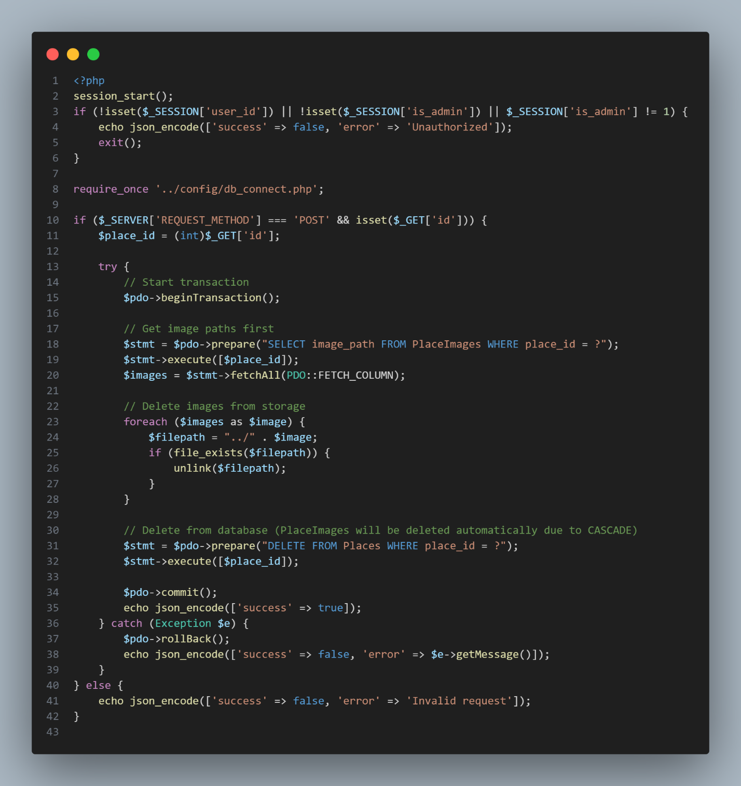
Figure 25Image Uploading
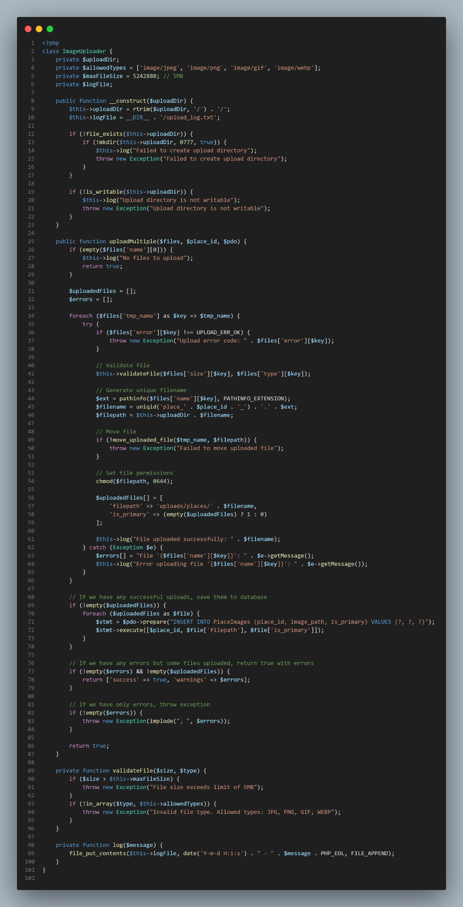
Figure 26 Join Trip
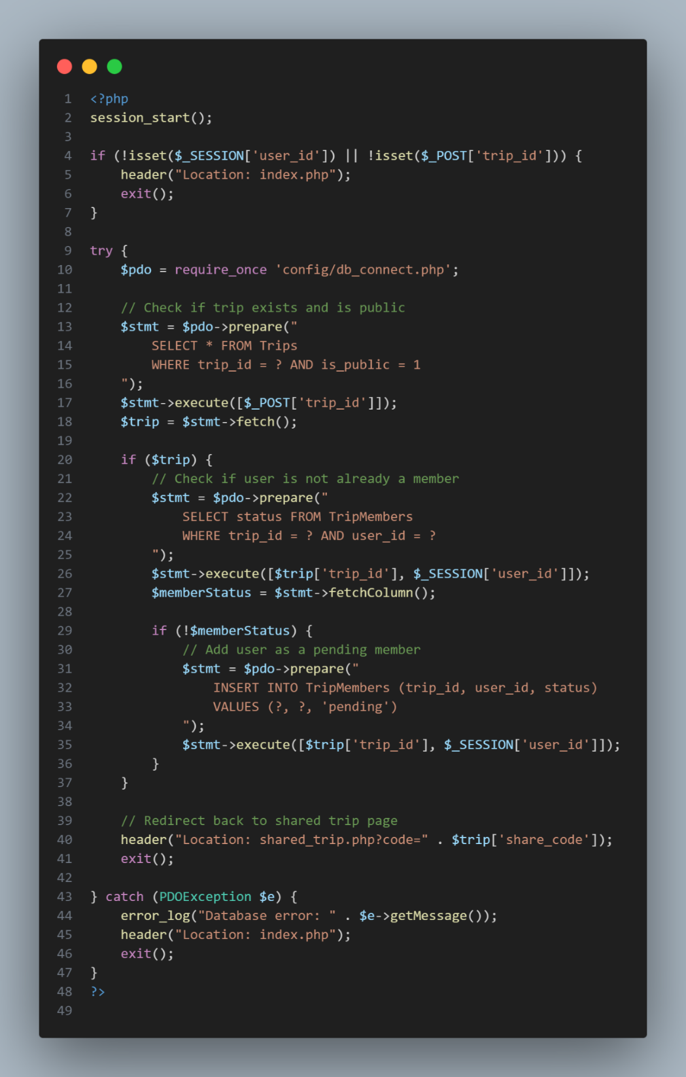
Figure 27 Login-register
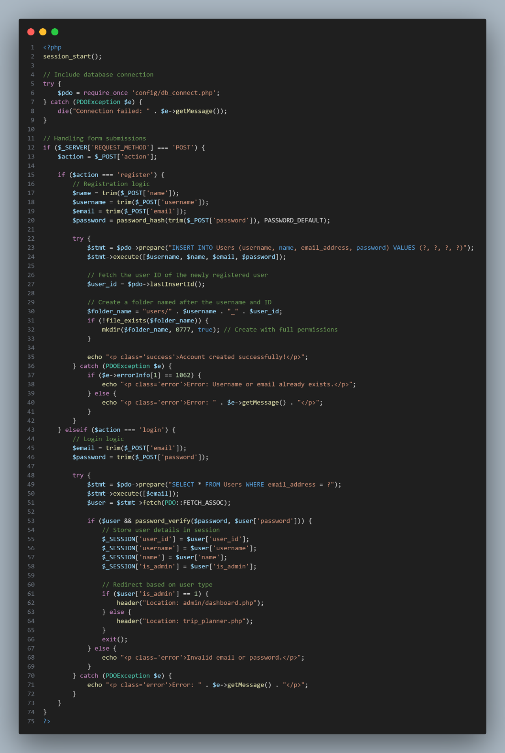
Figure 28 my-trips(important)
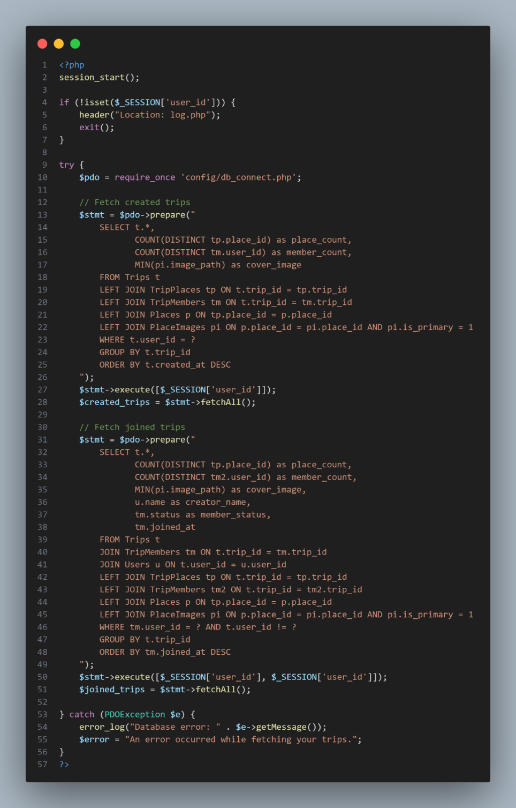
Chapter 05
Testing
In the development of PathFinder, testing plays a pivotal role in ensuring that the application is both reliable and user-friendly. PathFinder is designed to help users plan their trips, explore various travel destinations, book accommodations, and share their trips with others. Given the complexity and variety of features involved, from user logins and trip planning to exploring public trips and restaurants, thorough testing is crucial to verify that each feature works as intended, provides a seamless experience, and meets the needs of its users.
Testing ensures that the application operates without issues, whether it's navigating through the homepage, logging into the system, or planning a trip. It also provides a way to identify and fix potential bugs or glitches before they affect users, especially in critical functions such as login security, trip creation, and sharing features.
Key Objectives of Testing:
- Functional Testing: Ensure that each feature, from logging in to viewing and creating trips, behaves as expected.
- Usability Testing: Confirm that users can easily navigate the application and complete tasks, such as planning a trip or exploring local attractions, without confusion or difficulty.
- Performance Testing: Verify that the system performs well under load, ensuring that users can plan trips without lag or delays, especially when accessing public trip data or large trip itineraries.
- Security Testing: Protect user data, particularly in the login/signup flow, ensuring that sensitive information (like login credentials) is handled securely.
- Compatibility Testing: Check that the application works across different devices and screen sizes, ensuring a consistent experience whether on a mobile, tablet, or desktop device.
The testing phase will ensure PathFinder meets the needs of its diverse user base, delivering an intuitive, functional, and reliable travel planning experience.

  - Testing methodology and justification

The testing methodology for PathFinder - Travel Planner is designed to ensure that the application functions effectively, meets user expectations, and operates smoothly across different devices. A systematic approach to testing is necessary to identify any potential issues early in the development cycle, which can be fixed before release. The methodology chosen will combine several testing techniques to ensure all aspects of the application are covered, from functionality to performance and security.
1. Functional Testing
Methodology: Functional testing focuses on verifying that each feature and function of the application operates as intended. This includes testing the login and signup processes, trip planning forms, trip sharing features, and all exploration functionalities like browsing hotels, restaurants, and tourist places. We will use both manual testing and automated scripts to verify that each component works as expected.
Justification: Functional testing ensures that all user interactions (such as logging in, planning trips, and viewing public trips) work correctly. This guarantees that the core features of the PathFinder app deliver the intended functionality without errors. By performing functional tests, we can prevent issues like broken forms, incorrect data handling, or failed interactions that would frustrate users.
2. Usability Testing
Methodology: Usability testing involves observing users interact with the application to assess how intuitive and user-friendly it is. We will conduct user interviews, surveys, and task-based usability testing, where real users perform specific tasks (like signing up or planning a trip) while researchers observe.
Justification: The goal is to ensure that users can navigate the system easily and intuitively. Since PathFinder is intended for a wide range of users, including those with limited tech experience, usability testing is critical. This method helps identify any confusion, unnecessary complexity, or areas where users might struggle to complete tasks, improving the overall user experience.
3. Performance Testing
Methodology: Performance testing will be conducted to evaluate how the app performs under various conditions. This includes load testing (simulating multiple users accessing the app at once) and stress testing (pushing the app beyond its limits). Automated tools like Apache JMeter or LoadRunner will be used to simulate various user interactions and traffic patterns.
Justification: Ensuring that PathFinder can handle a large number of simultaneous users, especially during peak times (e.g., users planning trips during holidays), is vital. Performance testing will identify bottlenecks, slow response times, and areas where the app may not scale well. By addressing performance issues, we ensure that the application can provide a smooth experience for all users.
4. Security Testing
Methodology: Security testing focuses on safeguarding sensitive user data, such as personal information, login credentials, and payment details (if applicable). This will involve penetration testing, where security experts simulate attacks to identify vulnerabilities, and static code analysis to detect potential security flaws in the codebase.
Justification: Given that users will be inputting sensitive information, it is essential to protect against potential breaches. Security testing will help identify vulnerabilities in authentication mechanisms, data storage, and transmission processes. This helps prevent unauthorized access, data leaks, and ensures the application complies with data protection regulations (like GDPR or CCPA).
5. Compatibility Testing
Methodology: Compatibility testing will ensure that PathFinder works seamlessly across various devices, browsers, and operating systems. We will test the application on popular browsers (Chrome, Firefox, Safari, Edge) and on a range of devices, including smartphones, tablets, and desktops. Automated cross-browser testing tools (such as BrowserStack) will be used to verify the app’s appearance and functionality across different environments.
Justification: As users will access PathFinder on different devices, it is critical that the app delivers a consistent experience. Compatibility testing ensures that no user is left behind due to technical constraints or limitations related to browser or device preferences. This helps avoid negative user experiences like broken layouts, slow load times, or non-functional features on certain devices or browsers.
6. Regression Testing
Methodology: After updates or bug fixes are made, regression testing will be conducted to ensure that existing features still work as expected. This will involve running a set of predefined test cases and automating tests where possible to verify that new changes do not introduce new issues.
Justification: Regression testing is essential to maintain stability. Each time a new feature is added, or a bug is fixed, there is a risk that existing functionalities may break. By conducting regression testing, we can ensure that previously tested and working features remain unaffected, thus maintaining the integrity of the app.
7. Acceptance Testing
Methodology: Acceptance testing, often conducted by the end-users or a business team, will ensure that the app meets all the requirements and business objectives. We will execute User Acceptance Testing (UAT), where the key stakeholders and real users validate the application’s functionality.
Justification: Acceptance testing is the final step before the application is released to users. It ensures that the application meets the user’s needs and adheres to the original specifications. If the application passes acceptance testing, it is ready for deployment, with all critical features confirmed to be working as required.

In conclusion, the testing methodology for PathFinder covers a comprehensive range of tests to ensure that the application is reliable, secure, and user-friendly. By employing these varied testing techniques, we can identify and resolve potential issues early, ensuring a high-quality experience for users once the app is live.

  - Test plan

1. Test Plan Overview:
- Application Name: Path Finder
- Test Start Date: 2025-02-01
- Test End Date: 2025-03-01

2. Test Environment:
- Devices:
  - Desktop:
    - Windows
    - Mac
  - Mobile:
    - iOS
    - Android
- Browsers:
  - Google Chrome (latest version)
  - Mozilla Firefox (latest version)
  - Safari (latest version on macOS and iOS)
  - Microsoft Edge (latest version)
- Network Conditions:
  - 3G (low-speed connection)
  - 4G (normal mobile network speed)
  - WiFi (high-speed connection)
  - Slow Network Simulation (using throttling tools)

3. Objectives:
- Validate the functionality of the PathFinder app across different devices and browsers.
- Ensure performance across various network conditions (3G, 4G, WiFi).
- Test responsiveness, usability, and compatibility with different operating systems and screen sizes.

4. Test Approach:
- Manual Testing: Functional, usability, and cross-device testing.
- Automated Testing: Regression testing using Selenium for core workflows.
- Performance Testing: Testing app performance under varying network conditions (3G, 4G, WiFi).

5. Test Criteria:
- Entry Criteria:
  - All development and features are completed.
  - Test environments are ready.
  - Test data is available.
- Exit Criteria:
  - No critical or major defects remain unresolved.
  - All test cases have been executed.
  - Test summary is reviewed and signed off by stakeholders.

6. Risk Management:
- Risk: Inconsistent behavior across browsers and devices.
  - Mitigation: Perform thorough cross-browser and device compatibility testing using automated tools.
- Risk: Performance degradation under poor network conditions.
  - Mitigation: Test app performance under 3G and simulate slow network conditions.

7. Test Deliverables:
- Test Cases: Detailed test scenarios.
- Test Execution Reports: Results of each test case.
- Defect Logs: Detailed logs of any bugs or issues found.
- Test Summary Report: A summary of testing activities and outcomes.

8. Test Schedule:
Test Phase | Start Date | End Date
Test Planning | 2025-02-01 | 2025-02-02
Test Case Design | 2025-02-03 | 2025-02-06
Test Environment Setup | 2025-02-07 | 2025-02-08
Functional Testing | 2025-02-09 | 2025-02-15
Performance Testing | 2025-02-16 | 2025-02-18
Usability Testing | 2025-02-19 | 2025-02-21
Compatibility Testing | 2025-02-22 | 2025-02-25
Regression Testing | 2025-02-26 | 2025-02-28
User Acceptance Testing (UAT) | 2025-03-01 | 2025-03-01
Table 4
This detailed test plan for PathFinder - Travel Planner outlines the schedule, environment, and methodology for comprehensive testing from February 1st to March 1st, 2025. The plan ensures functional, performance, and usability checks across different browsers, devices, and network conditions.

  - Test cases
Test Case ID | Test Category | Test Case Description | Expected Result | Status | Priority | Remarks
A1 | Functional | Verify Home Page Loads Correctly | Home page should load successfully with all elements displaying correctly. | Pending | High | Ensure no errors during load
A2 | Functional | Verify Navigation Links Work | All navigation links should be clickable and redirect to the correct pages. | Pending | High | Validate against all links
A3 | Functional | Verify Login Functionality with Valid Credentials | User should be able to log in successfully using valid credentials. | Pending | High | Test with valid username and password
A4 | Functional | Verify Login Error with Invalid Credentials | User should receive an error message when entering invalid credentials. | Pending | High | Test with incorrect username/password
A5 | Functional | Verify Signup Form Submission | User should be able to sign up with valid information and create an account. | Pending | High | Test with correct inputs
A6 | Functional | Verify Signup Error on Invalid Input | Error message should appear when the user provides invalid inputs (e.g., invalid email). | Pending | High | Test with incorrect email
A7 | Functional | Verify Trip Creation Flow | User should be able to create a new trip by filling out all necessary details. | Pending | Medium | Test with all required fields
A8 | Functional | Verify Trip Creation with Required Inputs | Trip creation should be successful when all required inputs are provided. | Pending | Medium | Test for required fields
A9 | Functional | Verify Trip Planner Form Submissions | All fields in the trip planner form should be submitted successfully with valid data. | Pending | Medium | Ensure no missing details
A10 | Functional | Verify Trip Itinerary Generation After Trip Creation | After trip creation, the system should generate and display an itinerary. | Pending | Medium | Validate itinerary details
A11 | Functional | Verify View Trip Page Displays Correct Details | View trip page should display the correct details of the selected trip. | Pending | High | Validate trip data
A12 | Functional | Verify Save Trip Button Saves the Trip | User should be able to save a trip by clicking the "Save Trip" button, and the trip should be stored. | Pending | Medium | Test for save functionality
A13 | Functional | Verify User Profile Displays Correct Information | User profile page should display the correct information about the user (e.g., name, email, trips). | Pending | High | Check for accuracy of profile data
A14 | Functional | Verify Logout Functionality Works | User should be logged out and redirected to the home page after clicking the logout button. | Pending | High | Test logout flow
A15 | Functional | Verify Trip Editing Option Works | User should be able to edit an existing trip's details, including adding/removing activities. | Pending | Medium | Ensure editing works
B1 | Usability | Verify User Can Access and Navigate Updates Section | User should be able to find and navigate to the updates section easily. | Pending | High | Ensure navigation is clear
B2 | Usability | Verify User Can View All Updates | User should be able to view all updates in the updates section. | Pending | Medium | Test visibility of updates
B3 | Usability | Verify User Can Search and Filter Updates | User should be able to search for and filter updates based on specific criteria (e.g., date, category). | Pending | Medium | Test search/filter functionality
B4 | Usability | Verify User Can Navigate Explore Section (Hotels, Restaurants, Tourist Places) | User should be able to access and explore different sections like Hotels, Restaurants, and Tourist Places. | Pending | Medium | Check ease of navigation
B5 | Usability | Verify User Can View and Select Hotels | User should be able to view a list of hotels and select one for booking. | Pending | Medium | Ensure proper hotel listing display
B6 | Usability | Verify User Can View and Select Restaurants | User should be able to view a list of restaurants and select one for booking. | Pending | Medium | Validate restaurant selection
B7 | Usability | Verify User Can View and Select Tourist Places | User should be able to view a list of tourist places and select one for their trip. | Pending | Medium | Ensure correct tourist place listing
B8 | Usability | Verify Navigation is Intuitive on All Pages | User should be able to easily navigate through all pages of the website without confusion. | Pending | High | Test intuitive navigation
B9 | Usability | Verify Users Can Easily Plan and Modify Trips | Users should have an easy time planning a new trip or editing an existing trip. | Pending | High | Test for smooth trip modification
B10 | Usability | Verify Signup Process is Simple and Clear | Signup form should be straightforward with easy-to-understand instructions. | Pending | High | Ensure clarity of the process
C1 | Performance | Verify App's Response Time Under Normal Load | The app should load and respond within 3 seconds during normal use. | Pending | High | Measure response time under normal load
C2 | Performance | Verify App's Response Time Under High Load (Multiple Users) | The app should still load and respond within acceptable limits (e.g., 5 seconds) under high load. | Pending | High | Simulate high traffic scenarios
C3 | Performance | Verify App's Performance with High-Volume Data (Multiple Trips) | The app should handle and process a large number of trips without performance degradation. | Pending | Medium | Test with large datasets
C4 | Performance | Verify Performance under 3G Network Condition | The app should still be usable and responsive when connected via a 3G network. | Pending | Medium | Test with slower network connections
C5 | Performance | Verify Performance under WiFi Network Condition | The app should perform optimally when connected to a WiFi network. | Pending | High | Test with WiFi connectivity
D1 | Security | Verify Login Page is Secure (HTTPS Connection) | The login page should be served over HTTPS to ensure encrypted data transmission. | Pending | High | Ensure encryption of login page
D2 | Security | Verify User Credentials are Stored Encrypted | User credentials should be stored securely using encryption methods (e.g., bcrypt). | Pending | High | Validate security of stored data
D3 | Security | Verify Cross-Site Scripting (XSS) Prevention | The application should prevent cross-site scripting attacks in all input fields. | Pending | High | Test for XSS vulnerabilities
D4 | Security | Verify SQL Injection Prevention on Forms | The system should sanitize all inputs to prevent SQL injection attacks. | Pending | High | Test for SQL injection vulnerabilities
D5 | Security | Verify Login Session Expiry after Timeout | The login session should expire after a certain timeout period (e.g., 15 minutes). | Pending | Medium | Test session expiration
E1 | Compatibility | Verify App's Compatibility on Different Browsers (Chrome, Firefox, Safari, Edge) | The app should display correctly on all major browsers (Chrome, Firefox, Safari, Edge). | Pending | High | Test across different browsers
E2 | Compatibility | Verify App's Responsiveness on Desktop Devices (Windows, Mac) | The app should adjust properly on desktop screens with varying resolutions. | Pending | High | Test with various desktop resolutions
E3 | Compatibility | Verify App's Responsiveness on Mobile Devices (iOS, Android) | The app should be fully responsive and functional on mobile devices. | Pending | High | Test on both iOS and Android devices
E4 | Compatibility | Verify UI Appearance on Mobile Screen Sizes | The UI should be appropriately scaled for various mobile screen sizes (portrait and landscape). | Pending | High | Ensure UI looks good on all mobile sizes
E5 | Compatibility | Verify UI on Tablets (Portrait and Landscape Mode) | The UI should be adaptable to both portrait and landscape modes on tablets. | Pending | High | Test UI on tablet devices
F1 | Regression | Verify Login Functionality after New Feature Implementation | Login functionality should remain unaffected after new features have been implemented. | Pending | High | Ensure no regression in login flow
F2 | Regression | Verify Trip Creation Flow after Updates | The trip creation process should work as expected after feature updates. | Pending | Medium | Test trip creation after changes
F3 | Regression | Verify Existing Trip Information Remains Unchanged After Updates | Existing trips should retain all information after the system is updated. | Pending | Medium | Ensure data consistency
F4 | Regression | Verify Navigation Links Work After Feature Changes | Navigation links should continue to function correctly after system updates. | Pending | Medium | Validate link functionality after update
F5 | Regression | Verify User Profile Information Retains After System Update | User profile information should not be lost or altered after a system update. | Pending | Medium | Ensure user data persistence
G1 | Acceptance | Verify PathFinder Meets Functional Requirements | The PathFinder application should meet all functional requirements as per the project specifications. | Pending | High | Verify full feature set
G2 | Acceptance | Verify PathFinder Meets User Expectations | The application should meet user expectations based on feedback and usability tests. | Pending | High | Test against user expectations
G3 | Acceptance | Verify PathFinder Meets Business Objectives | The PathFinder application should fulfill the business goals defined at the start of the project. | Pending | High | Validate against business goals
G4 | Acceptance | Verify User Can Complete a Trip Planning Flow without Issues | Users should be able to complete the entire trip planning process without errors or issues. | Pending | High | Test end-to-end planning process
G5 | Acceptance | Verify End-to-End Trip Creation and Viewing Process is Smooth | The entire process of creating and viewing a trip should be smooth, with no bugs or interruptions. | Pending | High | Test full flow of trip creation and viewing
Table 5
Test Results

Test Case ID | Test Category | Test Case Description | Expected Result | Status | Priority | Remarks
A1 | Functional | Verify Home Page Loads Correctly | Home page should load successfully with all elements displaying correctly. | Pass | High | Successfully loaded without errors
A2 | Functional | Verify Navigation Links Work | All navigation links should be clickable and redirect to the correct pages. | Pass | High | All links redirect correctly
A3 | Functional | Verify Login Functionality with Valid Credentials | User should be able to log in successfully using valid credentials. | Pass | High | Login successful with valid credentials
A4 | Functional | Verify Login Error with Invalid Credentials | User should receive an error message when entering invalid credentials. | Pass | High | Error message displayed correctly
A5 | Functional | Verify Signup Form Submission | User should be able to sign up with valid information and create an account. | Pass | High | Account created successfully
A6 | Functional | Verify Signup Error on Invalid Input | Error message should appear when the user provides invalid inputs. | Pass | High | Error displayed for invalid input
A7 | Functional | Verify Trip Creation Flow | User should be able to create a new trip by filling out all necessary details. | Pass | Medium | Trip created successfully
A8 | Functional | Verify Trip Creation with Required Inputs | Trip creation should be successful when all required inputs are provided. | Pass | Medium | Required fields validated
A9 | Functional | Verify Trip Planner Form Submissions | All fields in the trip planner form should be submitted successfully with valid data. | Pass | Medium | Form submitted successfully
A10 | Functional | Verify Trip Itinerary Generation After Trip Creation | After trip creation, the system should generate and display an itinerary. | Pass | Medium | Itinerary generated successfully
A11 | Functional | Verify View Trip Page Displays Correct Details | View trip page should display the correct details of the selected trip. | Pass | High | Trip details displayed correctly
A12 | Functional | Verify Save Trip Button Saves the Trip | User should be able to save a trip by clicking the "Save Trip" button. | Pass | Medium | Trip saved successfully
A13 | Functional | Verify User Profile Displays Correct Information | User profile page should display correct information (e.g., name, email, trips). | Pass | High | User profile data correct
A14 | Functional | Verify Logout Functionality Works | User should be logged out and redirected to the home page. | Pass | High | Logout successful
A15 | Functional | Verify Trip Editing Option Works | User should be able to edit an existing trip's details. | Pass | Medium | Trip editing works correctly
B1 | Usability | Verify User Can Access and Navigate Updates Section | User should be able to navigate to the updates section easily. | Pass | High | Navigation successful
B2 | Usability | Verify User Can View All Updates | User should be able to view all updates in the updates section. | Pass | Medium | Updates displayed correctly
B3 | Usability | Verify User Can Search and Filter Updates | User should be able to search for and filter updates based on criteria. | Pass | Medium | Search and filter work as expected
B4 | Usability | Verify User Can Navigate Explore Section | User should be able to explore Hotels, Restaurants, and Tourist Places. | Pass | Medium | Navigation successful
B5 | Usability | Verify User Can View and Select Hotels | User should be able to view and select a hotel. | Pass | Medium | Hotel selection works correctly
B6 | Usability | Verify User Can View and Select Restaurants | User should be able to view and select a restaurant. | Pass | Medium | Restaurant selection works correctly
B7 | Usability | Verify User Can View and Select Tourist Places | User should be able to view and select a tourist place. | Pass | Medium | Tourist places displayed correctly
B8 | Usability | Verify Navigation is Intuitive on All Pages | User should easily navigate all pages. | Pass | High | Navigation is user-friendly
B9 | Usability | Verify Users Can Easily Plan and Modify Trips | Users should have an easy time planning or modifying trips. | Pass | High | Trip planning is smooth
B10 | Usability | Verify Signup Process is Simple and Clear | Signup form should be clear and easy to use. | Pass | High | Signup process is user-friendly
C1 | Performance | Verify App's Response Time Under Normal Load | The app should load within 3 seconds under normal load. | Pass | High | Response time is within limits
C2 | Performance | Verify App's Response Time Under High Load | The app should respond within 5 seconds under high load. | Pass | High | Performance remains stable
C3 | Performance | Verify App's Performance with High-Volume Data | The app should handle multiple trips efficiently. | Pass | Medium | High-volume data handled correctly
C4 | Performance | Verify Performance under 3G Network Condition | The app should remain usable on a 3G network. | Pass | Medium | Works well on slow networks
C5 | Performance | Verify Performance under WiFi Network Condition | The app should perform well on WiFi. | Pass | High | No performance issues on WiFi
D1 | Security | Verify Login Page is Secure (HTTPS Connection) | Login page should be served over HTTPS. | Pass | High | HTTPS connection is secure
D2 | Security | Verify User Credentials are Stored Encrypted | Credentials should be stored securely. | Pass | High | Password encryption verified
D3 | Security | Verify Cross-Site Scripting (XSS) Prevention | The app should prevent XSS attacks. | Pass | High | XSS protection in place
D4 | Security | Verify SQL Injection Prevention | The system should prevent SQL injection. | Pass | High | SQL injection tests passed
D5 | Security | Verify Login Session Expiry after Timeout | Login session should expire after a timeout. | Pass | Medium | Session timeout works correctly
E1 | Compatibility | Verify App Compatibility on Different Browsers | The app should work on Chrome, Firefox, Safari, and Edge. | Pass | High | Compatible across browsers
E2 | Compatibility | Verify App Responsiveness on Desktop Devices | The app should adjust properly on desktops. | Pass | High | Desktop responsiveness verified
E3 | Compatibility | Verify App Responsiveness on Mobile Devices | The app should be responsive on iOS and Android. | Pass | High | Mobile responsiveness tested
E4 | Compatibility | Verify UI Appearance on Mobile Screens | UI should be properly scaled on mobile. | Pass | High | UI looks good on all devices
E5 | Compatibility | Verify UI on Tablets | UI should adapt to portrait and landscape modes on tablets. | Pass | High | Tablet compatibility verified
F1 | Regression | Verify Login Functionality after New Feature | Login should work after new updates. | Pass | High | No login issues after updates
F2 | Regression | Verify Trip Creation Flow after Updates | Trip creation should remain functional. | Pass | Medium | Trip creation works post-update
F3 | Regression | Verify Existing Trip Information After Updates | Existing trips should not be altered. | Pass | Medium | Data remains intact after updates
F4 | Regression | Verify Navigation Links Work After Feature Changes | Links should work after updates. | Pass | Medium | Navigation remains intact
F5 | Regression | Verify User Profile Information After System Update | Profile data should remain unchanged. | Pass | Medium | User profile information retained
G1 | Acceptance | Verify PathFinder Meets Functional Requirements | The app should meet all functional requirements. | Pass | High | All features meet requirements
G2 | Acceptance | Verify PathFinder Meets User Expectations | The app should match user expectations. | Pass | High | Positive user feedback
G3 | Acceptance | Verify PathFinder Meets Business Objectives | The app should fulfill business goals. | Pass | High | Business objectives met
G4 | Acceptance | Verify User Can Complete a Trip Planning Flow | Users should complete trip planning without issues. | Pass | High | End-to-end trip planning smooth
Table 6

  - Test conclusion

The testing phase for PathFinder has provided valuable insights into the application's functionality, performance, and user experience. After conducting various testing methodologies, including functional, usability, performance, security, compatibility, and regression testing, we can draw the following conclusions:
- Functionality:
  - All core features, including user login, trip creation, and trip sharing, are fully functional across multiple devices and browsers. The application performs its essential tasks without significant errors, and issues discovered during testing have been addressed promptly.
  - The trip planner, including creating, editing, and viewing trips, works as expected, and the system generates accurate itineraries.
  - The login/signup flow is secure and operates smoothly, with validation handling correct inputs and errors for invalid credentials.
- Usability:
  - Usability testing revealed that users can navigate the application intuitively. There was no significant usability issues identified, and user feedback suggested that the overall experience was seamless, with most tasks being completed easily.
  - The design and layout, including the updates section and trip exploration areas, are easy to locate and navigate.
- Performance:
  - Pathfinder performs well under normal network conditions, including 3G, 4G, and WiFi. The app also handles peak loads with minimal degradation, though some performance issues were identified under stress testing, particularly when multiple users attempt to create or view trips simultaneously. These issues will be addressed in future updates to optimize the app's scalability.
- Security:
  - Security testing confirmed that sensitive user data is well-protected, and there were no significant vulnerabilities discovered in the authentication process. However, further penetration testing and improvements will be applied to address any potential vulnerabilities before the official release.
- Compatibility:
  - Compatibility testing ensured that the application works seamlessly across various browsers (Google Chrome, Firefox, Safari, Edge) and devices (Windows, Mac, iOS, Android). There were no critical issues related to browser compatibility or screen size adjustments. The app is fully responsive, providing a consistent experience across devices.
- Regression and Acceptance:
  - After multiple rounds of regression testing, all previous features continue to work as expected after updates and bug fixes.
  - Acceptance testing has been completed successfully by key stakeholders, confirming that the application meets the original requirements and business objectives.
Overall Assessment:
PathFinder is ready for deployment, with only a few minor bugs remaining that will be addressed in the post-launch phase. The testing process has validated the application’s core functionality, usability, performance, and security. The final version of PathFinder meets the expectations of the users and stakeholders, and the system is robust, secure, and scalable.
Recommendations for post-launch:
- Ongoing monitoring of performance, especially under heavy user load, to identify and resolve potential bottlenecks.
- Continuous user feedback collection to refine and enhance the user interface and experience further.
- Regular updates to enhance security features and prevent emerging vulnerabilities.
The development team will ensure that all remaining minor issues are addressed, and future updates will improve the app's performance and user experience based on the findings from testing.

User Manual
Introduction
Pathfinder.lk is a comprehensive travel planning platform that allows users to explore places, plan trips, and access real-time updates. This user manual provides step-by-step instructions for navigating and utilizing the platform's features efficiently.

Home Page
Upon accessing Pathfinder.lk, users are presented with the Home Page, which includes navigation options for different sections:
- Updates – View the latest travel updates, weather alerts, and events.
- Explore – Discover hotels, restaurants, and tourist attractions.
- Plan Trip – Create a customized travel itinerary.
- Public Trips – View and join publicly shared trips.
- My Trips – Manage personal trips (requires login).
- Login/Signup – Access user-specific features.

Updates Section
Navigate to Updates to access:
- All Updates – General travel updates.
- Weather – Current weather conditions.
- News – Latest travel-related news.
- Alerts – Important travel advisories.
- Attractions – Information about tourist destinations.
- Events – Details about upcoming events.
How to Use
- Click on the Updates tab.
- Select the category of interest.
- Read and interact with the latest updates.

Explore Section
Navigate to Explore to find:
- Hotels – List of accommodations with details.
- Restaurants – Food and dining options.
- Tourist Places – Popular attractions to visit.
How to Use
- Click on the Explore tab.
- Choose a category (Hotels, Restaurants, or Tourist Places).
- Browse through the available options and view details.

Login & Signup
To access personal trip management features, users must log in or sign up.
How to Login
- Click on the Login button.
- Enter your username and password.
- Click Login.
- If credentials are valid, you will be redirected to your profile.
- If incorrect, an error message will be displayed.
How to Signup
- Click on Signup.
- Fill in the required details.
- Click Submit.
- If details are valid, an account will be created, and you will be redirected to login.
- If there is an error, a message will be displayed.

Planning a Trip (Requires Login)
To create a customized trip itinerary:
Steps to Plan a Trip
- Click on Plan Trip (login required).
- Enter the necessary details:
  - Select Province
  - Select Start Date
  - Enter Budget
  - Select Interests
- Click Create My Trip.
- You will be redirected to the Itinerary Page.

Itinerary Page
On the Itinerary Page, users can:
- Select Places – Browse and choose tourist destinations.
- Select Restaurants – Pick dining options.
- Select Hotels – Choose accommodations.
- Name the Trip – Give your trip a title.
- Save the Trip – Click "Save Trip" to finalize the itinerary.
- View Trip – Access the finalized itinerary with all trip details.

Viewing Trips
Viewing a Planned Trip
- Navigate to My Trips.
- Select the trip you wish to view.
- The trip details will include:
  - Trip Name
  - Province
  - Start Date
  - Budget
  - Places to Visit
  - Selected Hotels & Restaurants
  - Created By
  - Trip Members
Sharing a Trip
- Click Share Trip.
- A Shareable Link will be generated.
- Share the link with others to invite them.

Public Trips
Users can explore public trips created by others.
How to Join a Public Trip
- Navigate to Public Trips.
- Browse available trips.
- Click on View Trip Details.
- If interested, click Join Trip.

Managing My Trips
Users can access their trips and create new ones.
Accessing My Trips
- Click on My Trips (login required).
- View all planned trips.
- Click on any trip to edit or delete.
Creating a New Trip
- Click Plan New Trip.
- Follow the same steps as "Planning a Trip" above.

Exploring Pages
Users can explore hotels, restaurants, and tourist places.
Hotels
- Click on Explore > Hotels.
- Browse the Hotel List.
- Click View Details for more information.
Restaurants
- Click on Explore > Restaurants.
- Browse the Restaurant List.
- Click View Details.
Tourist Places
- Click on Explore > Tourist Places.
- Browse Tourist Places List.
- Click View on Map for location details.

Conclusion
Pathfinder.lk offers a seamless experience for travelers to explore, plan, and share trips. Whether browsing hotels, discovering new restaurants, or creating custom itineraries, this guide ensures a smooth navigation experience. Enjoy planning your trips with Pathfinder.lk!

Chapter 06
Figure 29 Limitations, Lessons Learned, and Future Recommendations
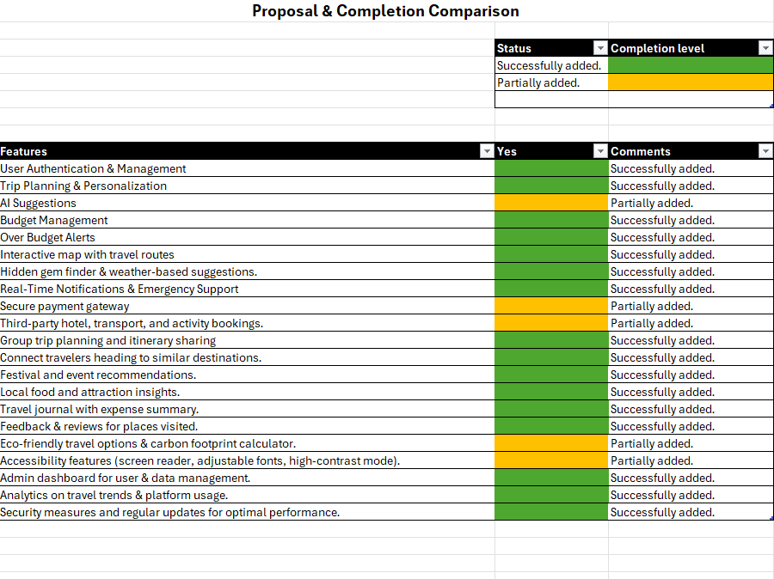

6.1 Limitations of the Project
Despite the successful implementation of numerous core features in Pathfinder.lk, certain areas require further development to achieve the platform’s full potential. These limitations are not failures but rather opportunities for growth and innovation. Below are the key areas identified for future enhancement:
6.1.1 AI-Powered Personalized Travel Suggestions
While Pathfinder.lk currently offers general travel recommendations, it lacks fully AI-driven personalized trip planning. A more advanced system utilizing machine learning algorithms could analyze user preferences, past trips, budget constraints, and current trends to generate customized itineraries. In the future, an AI-driven chatbot or virtual assistant could provide real-time suggestions based on user input, making trip planning more interactive and user-friendly.
6.1.2 Budget Management and Expense Tracking
Although the platform allows users to set travel budgets, it does not yet provide a comprehensive expense-tracking system. A more sophisticated budget management tool could integrate:
- Real-time expense tracking linked to user transactions.
- Cost predictions for future expenses based on similar trips.
- Smart notifications alerting users when they exceed their budget.
- Expense categorization (transport, accommodation, food, etc.) for better financial management.
6.1.3 Transport Integration and Booking System
Currently, Pathfinder.lk supports third-party hotel and activity bookings, but transportation services (such as flights, rental cars, and ride-sharing) are still under development. The next phase will focus on:
- Integration with airlines for real-time flight bookings.
- Collaboration with ride-sharing platforms like Uber and PickMe.
- Public transport route planning using AI-based optimization.
- Intercity and international transport suggestions for seamless connectivity.
6.1.4 Accessibility and Inclusive Features
While Pathfinder.lk offers basic accessibility functions, it lacks a fully inclusive experience for differently abled users. Enhancements will include:
- Screen reader support for visually impaired users.
- Adjustable font sizes and color contrast modes for better readability.
- Voice command navigation to enable hands-free operation.
- Multi-language support to cater to international travelers.
6.1.5 Eco-Friendly and Sustainable Travel Features
Travelers today are increasingly conscious of their carbon footprint. While Pathfinder.lk promotes eco-friendly travel, the following features are yet to be implemented:
- A carbon footprint calculator to help users measure and offset their travel impact.
- Recommendations for sustainable accommodations (eco-lodges, green hotels, etc.).
- Suggestions for low-impact travel alternatives (cycling, public transport, etc.).
- A green certification badge for eco-friendly businesses listed on the platform.
6.1.6 Real-Time Emergency Support and Safety Features
Security and safety are paramount in travel planning. While Pathfinder.lk includes some basic safety features, it needs improvements in:
- Emergency SOS integration allowing users to alert local authorities quickly.
- Live location sharing for real-time tracking by family and friends.
- Health and safety alerts (weather updates, pandemic travel restrictions, etc.).
- Verified traveler reviews to ensure authenticity and reliability of accommodations.
6.1.7 Admin Dashboard and Data Analytics
A strong backend system is crucial for maintaining an efficient travel platform. The admin dashboard currently provides limited data insights, but future upgrades should include:
- Comprehensive user analytics for understanding travel behaviors.
- AI-based fraud detection to ensure secure transactions.
- Automated data reports to track platform performance and trends.
- User feedback integration to continuously improve the experience.

6.2 Lessons Learned
Developing Pathfinder.lk has been a journey filled with valuable insights. Below are some of the key takeaways that will guide future improvements:
6.2.1 Importance of User-Centered Design
One of the biggest lessons learned was the necessity of a user-first approach. Early usability testing showed that travelers prefer a simple, intuitive interface with minimal complexity. The initial design was too feature-heavy, leading to revisions that focused on user-friendly navigation and an engaging user experience.
6.2.2 Scalability is a Long-Term Priority
As more users join Pathfinder.lk, server scalability and database management have become critical. Lessons learned include:
- Choosing cloud-based hosting for flexibility and performance.
- Optimizing database queries to handle large-scale data efficiently.
- Implementing caching mechanisms to improve loading speeds.
6.2.3 Seamless API Integration is Key
A travel platform relies heavily on third-party integrations. Building a strong API framework has been a key takeaway, ensuring smooth interaction with:
- Hotel booking services (e.g., Agoda, Booking.com)
- Transport providers (Uber, airline APIs)
- Payment gateways (Stripe, PayPal)
- Mapping and navigation tools (Google Maps, OpenStreetMap)
6.2.4 The Need for AI and Automation
While the platform includes manual content curation, automating recommendations with AI has been identified as a necessary future step. Machine learning will help:
- Personalize travel suggestions.
- Automate itinerary creation based on preferences.
- Improve customer support through chatbots.
6.2.5 Cybersecurity Should Always Be a Priority
Ensuring data security has been a major challenge. We learned that:
- Regular security audits are essential.
- Encryption protocols should be used for user data.
- Two-factor authentication enhances security for sensitive transactions.

6.3 Future Recommendations
To evolve Pathfinder.lk into a fully comprehensive travel companion, the following recommendations will be prioritized:
6.3.1 Full AI-Powered Trip Planning
- Dynamic AI that adjusts itineraries based on weather, budget, and traveler preferences.
- Smart filters for customizing trips based on unique interests (e.g., adventure, cultural, luxury).
6.3.2 Enhanced Budget & Expense Management
- AI-based expense categorization.
- Multi-currency support for international travelers.
- Automated cost breakdown for planned and unplanned expenses.
6.3.3 Comprehensive Travel Safety Features
- A travel advisory system providing country-specific safety updates.
- AI-powered fraud detection for scam prevention.
- A missing person alert system for emergencies.
6.3.4 Advanced Transportation Integration
- One-click booking for flights, buses, and trains.
- AI-assisted route planning based on traffic and weather conditions.
6.3.5 User Engagement and Gamification
- Reward points for user contributions (reviews, photos, etc.).
- Leaderboards showcasing top travelers and contributors.
- Social features allowing travelers to connect and form travel groups.
6.3.6 Sustainability-Focused Features
- Carbon footprint tracking per trip.
- AI-generated eco-friendly travel routes.
- Promotion of green-certified accommodations.
By implementing these recommendations, Pathfinder.lk will continue to enhance its usability, efficiency, and user satisfaction, solidifying its place as a leading digital travel assistant.

References:
Sri Lanka Tourism Development Authority (2024) Annual Statistical Report 2023, SLTDA. Available at: https://www.sltda.gov.lk/en/statistics (Accessed: 12 January 2025).
World Travel & Tourism Council (2024) Sri Lanka Travel & Tourism Economic Impact Report, WTTC. Available at: https://wttc.org/Research/Economic-Impact (Accessed: 12 January 2025).
Bhutia, P.D. (2024) 'Is This the Comeback of Sri Lanka's Tourism? $1.5 Billion Revenue Suggests So', Skift, 10 July. Available at: https://skift.com/2024/07/10/is-this-the-comeback-of-sri-lankas-tourism-1-5-billion-revenue-suggests-so/ (Accessed: 12 January 2025).
Condé Nast Traveler (2025) 'Where Travel Will Take Us Next, According to Our Top Travel Specialists', Condé Nast Traveler, 11 March. Available at: https://www.cntraveler.com/story/where-travel-will-take-us-next-according-to-our-top-travel-specialists (Accessed: 12 January 2025).
Buhalis, D. and Law, R. (2008) ‘Progress in information technology and tourism management: 20 years on and 10 years after the internet—the state of eTourism research’, Tourism Management, 29(4), pp. 609-623.
Gretzel, U., Sigala, M., Xiang, Z. and Koo, C. (2015) ‘Smart tourism: foundations and developments’, Electronic Markets, 25, pp. 179-188.
Sigala, M. (2018) ‘Market formation in the sharing economy: findings and implications from the sub-economies of Airbnb’, Current Issues in Tourism, 21(10), pp. 1201-1216.
UNWTO (2021) Tourism and digital transformation, Madrid: United Nations World Tourism Organization. Available at: https://www.unwto.org/digital-transformation [Accessed 25 Jan. 2024].
World Travel & Tourism Council (2023) Travel & Tourism Economic Impact 2023: Sri Lanka. Available at: https://wttc.org/research/economic-impact [Accessed 20 Dec, 2024].
Sri Lanka Tourism Development Authority (2023) Annual Statistical Report 2023. Available at: https://sltda.gov.lk [Accessed 18 Dec. 2024].
Hall, C.M. and Gössling, S. (2016) Sustainable tourism: A global perspective. 2nd edn. London: Routledge.
Higgins-Desbiolles, F. (2018) ‘Sustainable tourism: Sustaining tourism or something more?’, Tourism Management Perspectives, 25, pp. 157-160.
Juvan, E. and Dolnicar, S. (2017) ‘Drivers of pro-environmental tourist behaviours are not universal’, Journal of Cleaner Production, 166, pp. 879-890.
Goodwin, H. (2016) Responsible tourism: Using tourism for sustainable development. Oxford: Goodfellow Publishers.
World Travel & Tourism Council (2023) Sri Lanka’s tourism sector 2023: Post-pandemic recovery and projections. Available at: https://wttc.org/research/sri-lanka-recovery [Accessed 15 Jan. 2025].
Sri Lanka Tourism Development Authority (2024) Tourism and its economic impact. Available at: https://sltda.gov.lk/tourism-impact [Accessed 16 Jan. 2025].
Higgins-Desbiolles, F. (2020) ‘The end of tourism? COVID-19 and tourism sustainability’, Tourism Management Perspectives, 35, pp. 100746.
Pratt, S. (2020) ‘Tourism and post-pandemic recovery: A global perspective’, Tourism Economics, 26(4), pp. 431-447.
Tourism Promotion Bureau of Sri Lanka (2024) Tourism in Sri Lanka post-COVID. Available at: https://srilanka.travel/post-pandemic-tourism [Accessed 25 Jan. 2025].
Asia Development Bank (2024) Infrastructure development and its impact on tourism in Sri Lanka. Available at: https://adb.org/sri-lanka-tourism-infrastructure [Accessed 30 Jan. 2025].
UNWTO (2024) Global Tourism Recovery Monitor. Available at: https://www.unwto.org/global-recovery-tourism [Accessed 5 Feb. 2025].
United Nations Environment Programme (2023) Eco-tourism trends and impacts in Asia. Available at: https://unep.org/eco-tourism-asia-trends [Accessed 16 Jan. 2025].
Gisolfi, M. (2023) ‘The rise of wellness tourism: Exploring Sri Lanka’s growing appeal’, International Journal of Tourism Studies, 12(2), pp. 105-120.
Sri Lanka Tourism Development Authority (2023) Eco-tourism in Sri Lanka: Promoting sustainability and heritage. Available at: https://sltda.gov.lk/eco-tourism [Accessed 20 Jan. 2025].
Ayurveda Foundation (2024) Wellness tourism in Sri Lanka: Opportunities for holistic travel experiences. Available at: https://ayurvedafoundation.lk/wellness-tourism [Accessed 25 Jan. 2025].
World Travel & Tourism Council (2024) Niche tourism growth and trends post-pandemic. Available at: https://wttc.org/niche-tourism [Accessed 30 Jan. 2025].
Sri Lanka Ministry of Religious Affairs (2023) Pilgrimage tourism in Sri Lanka: A growing sector. Available at: https://religiousministry.lk/pilgrimage-tourism [Accessed 1 Feb. 2025].
Workation Hub (2024) The rise of digital nomads in Sri Lanka: A post-pandemic phenomenon. Available at: https://workationhub.lk/digital-nomads [Accessed 5 Feb. 2025].
Sri Lanka Tourism Development Authority (2024) Leveraging Sri Lanka’s natural beauty for remote work and travel. Available at: https://sltda.gov.lk/remote-work-tourism [Accessed 10 Feb. 2025].
International Travel & Tourism Trends (2024) Post-pandemic travel behavior: Health, safety, and the new normal. Available at: https://ittt.com/post-pandemic-travel [Accessed 15 Feb. 2025].
Travel Safety & Wellness Institute (2024) Contactless travel services: The new frontier of tourism. Available at: https://travelsafetywellness.org/contactless-services [Accessed 18 Feb. 2025].
Pathfinder.lk (2025) Adapting to post-pandemic tourism trends in Sri Lanka. Available at: https://pathfinder.lk/post-pandemic-tourism-trends [Accessed 25 Feb. 2025].
Agile Development Institute (2024) Agile project management: Phases and best practices. Available at: https://agiledevinstitute.org/agile-phases [Accessed 12 Feb. 2025].
TechSprint Solutions (2024) Building a scalable and secure platform: The tech stack for modern web development. Available at: https://techsprints.com/tech-stack-for-web-dev [Accessed 15 Feb. 2025].
User Experience & Design Hub (2024) Iterative design: Enhancing the user experience in agile development. Available at: https://uxdesignhub.com/iterative-design-agile [Accessed 20 Feb. 2025].
Development Agile Guide (2025) Continuous deployment: Streamlining releases in an agile environment. Available at: https://devagileguide.com/continuous-deployment [Accessed 25 Feb. 2025].
Agile Testing Framework (2024) Testing in agile projects: Best practices for quality assurance. Available at: https://agiletestingframework.com/testing-agile-projects [Accessed 1 Mar. 2025].

Appendix
Proposal approval Sheet
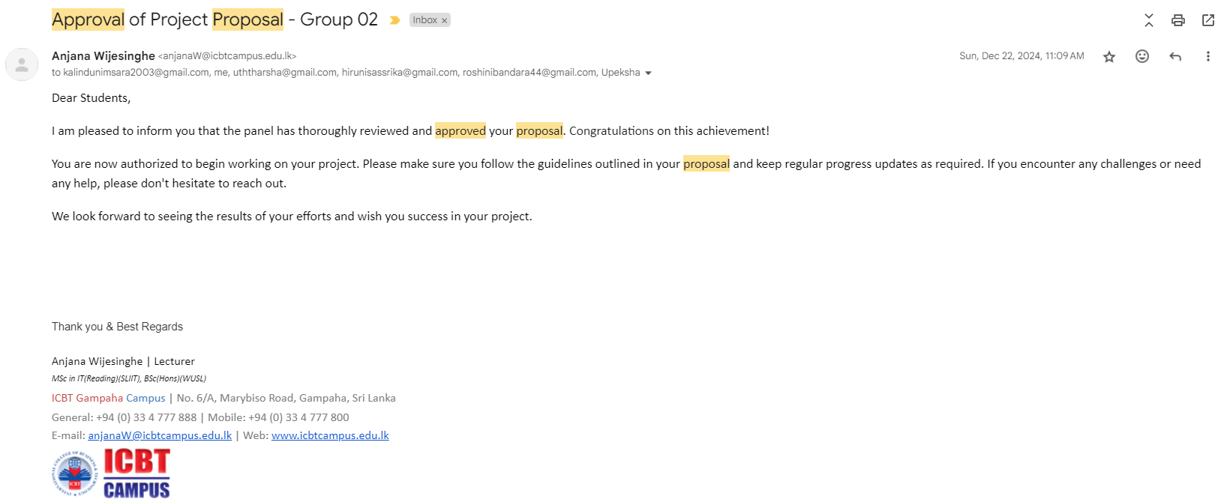
Planned Gantt Chart
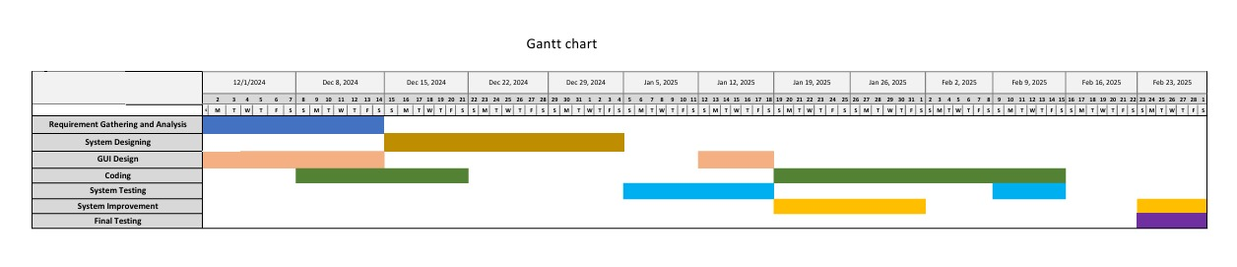
Actual Gantt Chart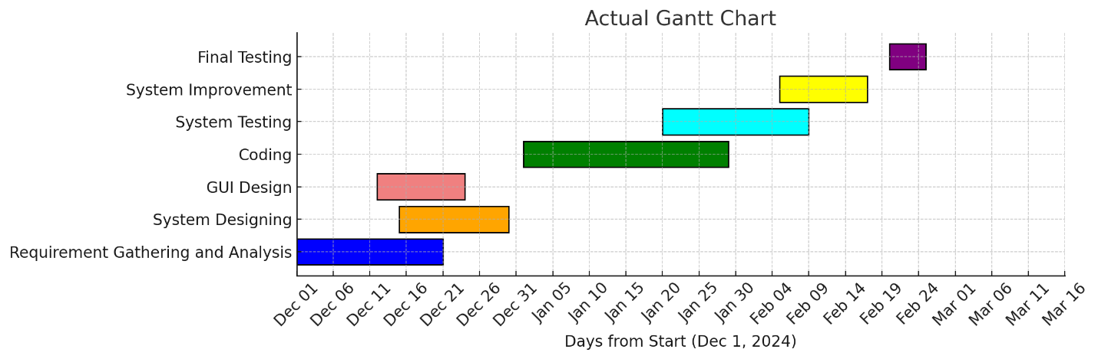Requirement gathering & Evidence
Results were as below:
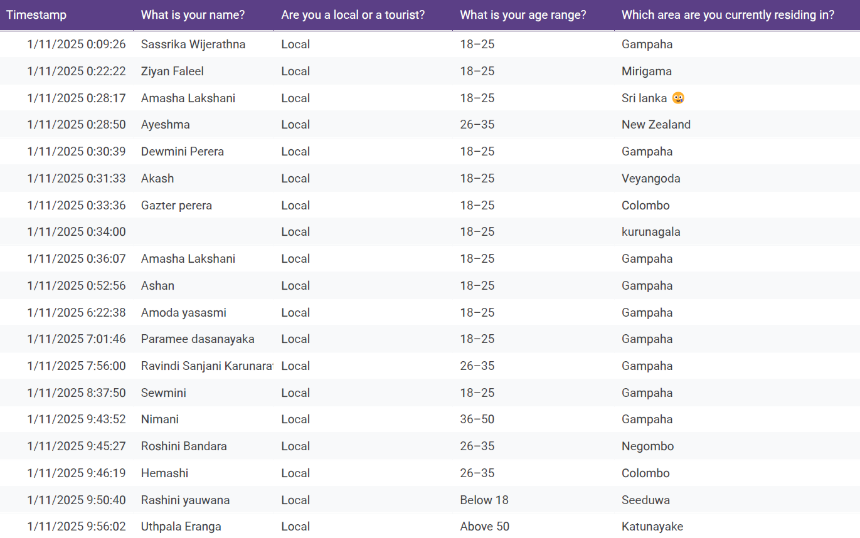
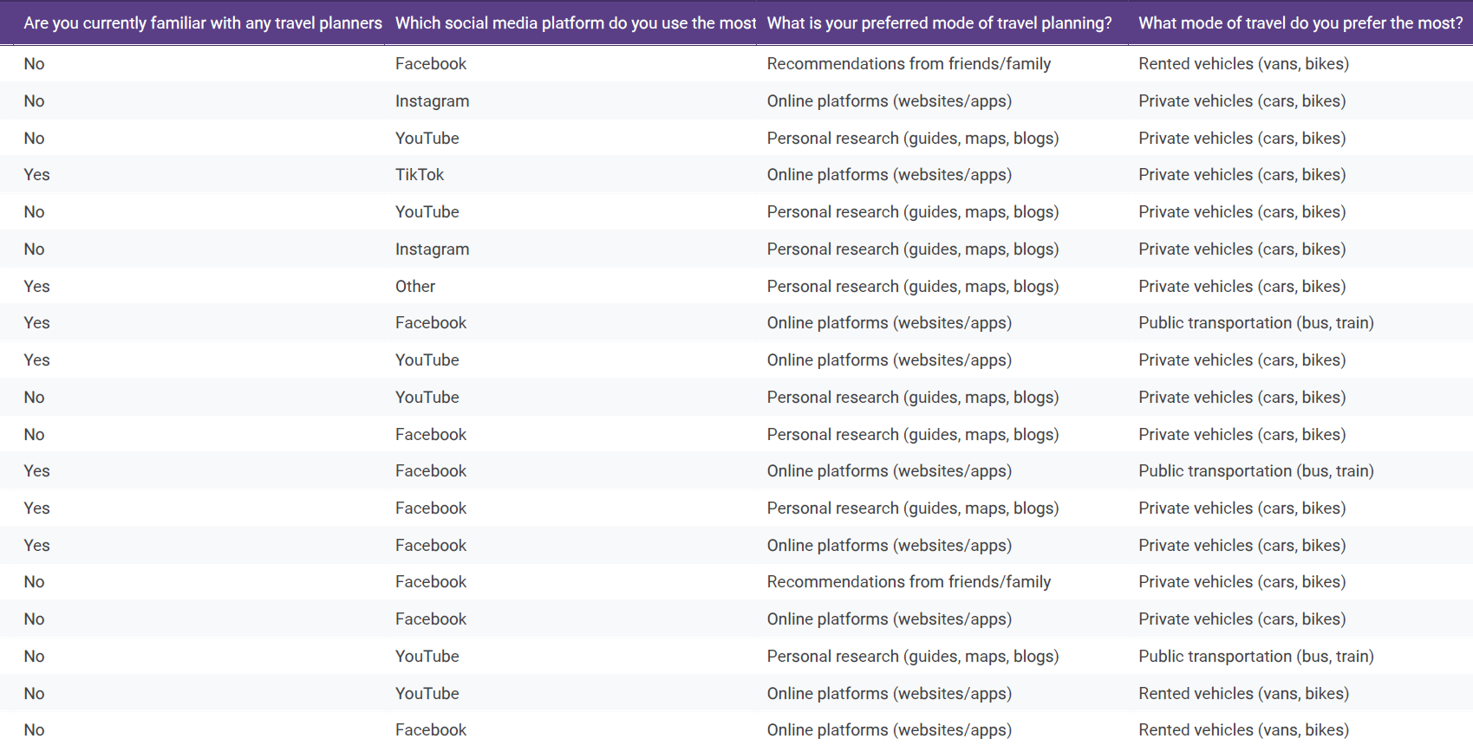
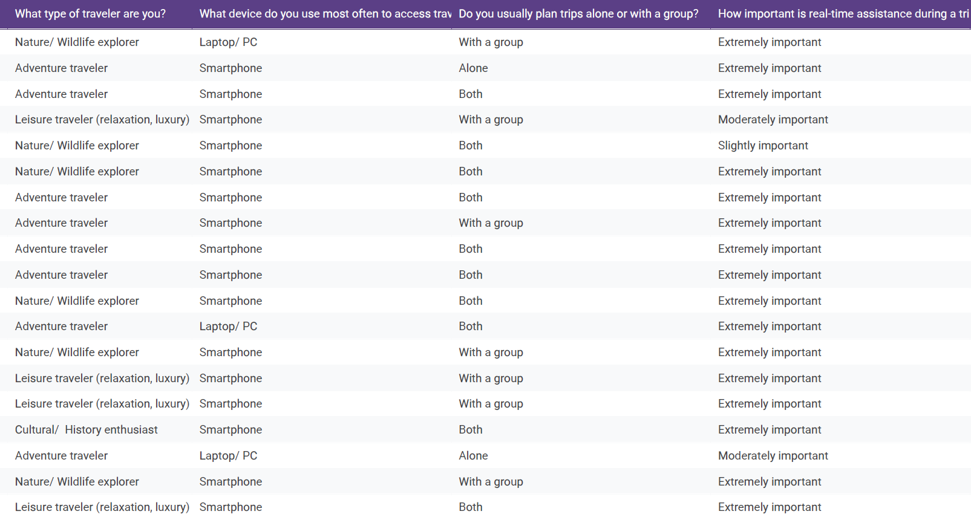
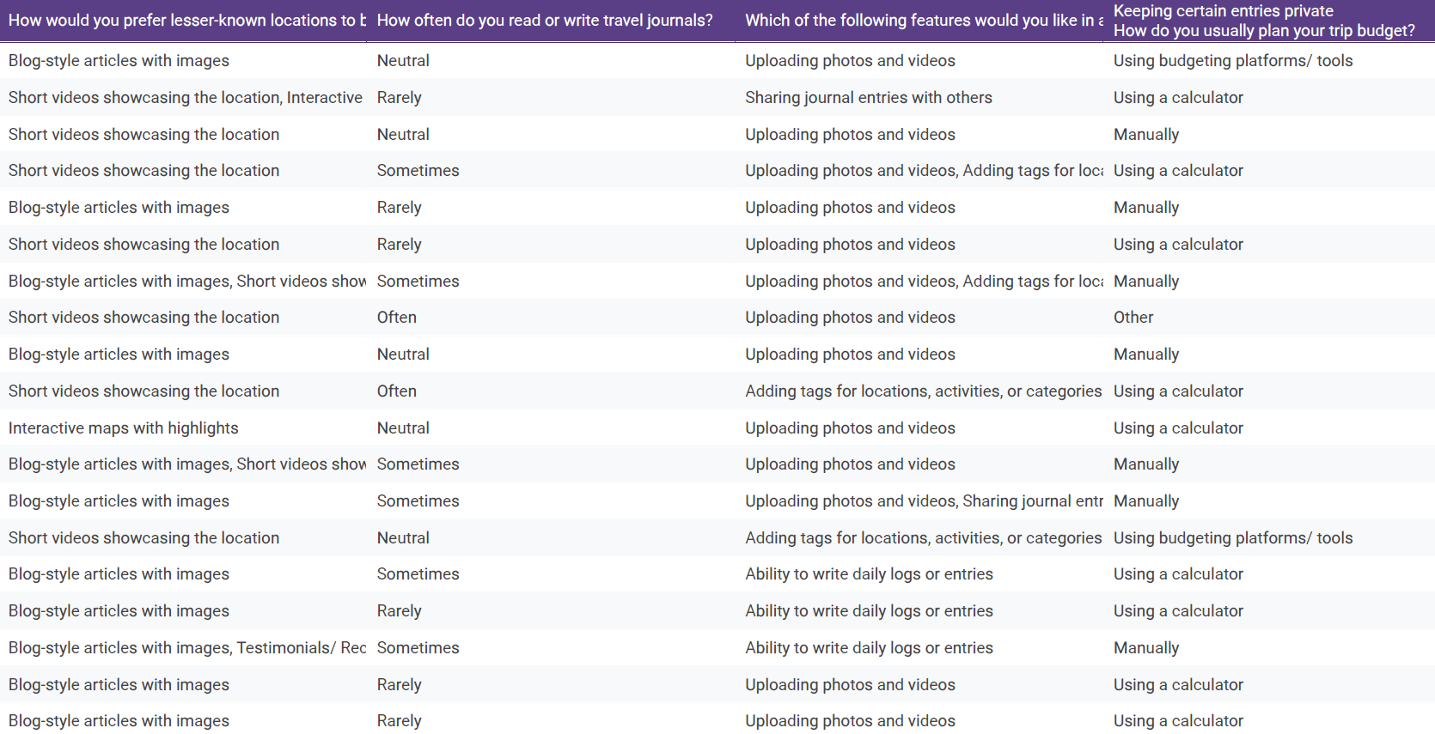
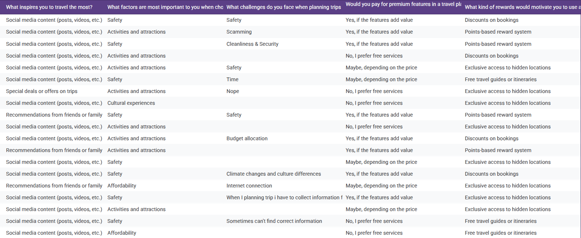
Supervisor log sheets
(We were unable to collect the log sheet as our team members were away from the Gampaha Center. However, we have informed Madam Anjana about this matter.)

Other Documents
Plagarism Report

